« Imagine… »
Climate change and management

Jacques Martin, University of Toulon (Hon), ESOE
jma.martin@wanadoo.fr

Claudio Baccarani, University of Verona (Hon)
claudio.baccarani@univr.it

Federico Brunetti, University of Verona
federico.brunetti@univr.it

Abstract: Climate change has now been debated for many years, and in spite of different viewpoints, analyses and opinions, is a phenomenon that is accepted by all. There are thousands of studies on the nature of climate change and its consequences on the planet earth and its inhabitants. However, there are few studies investigating the consequences of climate change on the founding tenets and practices of management. This paper aims to contribute to this facet of the issue and propose some guidelines for management in the coming natural environment.
Purpose: Show how management is affected by climate change.
Methodology: Cartesian.
Findings: management will have to adapt to climate change and to be revolutionized for its survival and the survival of mankind.
Practical implications: Developing new management foundations.
Originality/value: a guide for future managers.
Type of paper: prospective.

“Tempus edax, homo edacior” Ovid

Overture:

Imagine all the people
Sharing all the world
You may say that I'm a dreamer
But I'm not the only one
I hope someday you'll join us
And the world will live as one
(John Lennon, 1971)

First movement (allegro): Climate change

For a number of years scientists and politicians disagreed about the reality of climate change, but today everybody agrees that climatic patterns are changing even though there are still disagreements on the causes and consequences of these changes, and, as a result, on the actions that are and will be necessary to cope with them. It is not our purpose here to debate on the causes of climate change and their validity but to take climate change as a fact that nowadays nobody can seriously challenge and see how it can affect management and how management can reconfigure itself to bring some answers to this change with the aim of maintaining a level of well-being for the human populations.
Climate change fundamentally manifests itself by a rise in temperatures over the surface of the globe. Since the beginning of the 20th century the average temperature has increased by 1.5°C (NASA) in a steady way.

Figure 1: Temperature increase

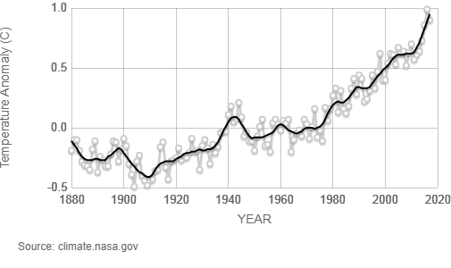

It is estimated that human activities are predominantly causal in this increase (IPCC, 2013). This increase is mainly due to the growing emissions of “greenhouse gases” among which carbon dioxide plays the major part. Since the industrial revolution in the 19th century, emissions of CO2 have regularly grown, especially since the 1940s (CEDIAC-IEA).

Figure 2: CO2 emissions

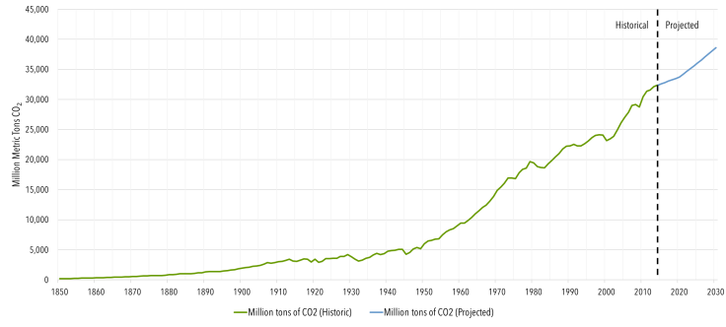

As CO2 is mainly due to the burning of fossil fuels (coal, oil, gas), and as the use of them by men has greatly increased since the beginning of the 20th century, there is little doubt that this rise in emissions has been predominantly caused by human activities.
Coal is the main culprit for CO2 emissions and although its use is on the wane in several countries, mainly Western Europe, it still represents more than a quarter of the global energy mix, and its share will only slightly decrease in the coming years. It has actually increased in the last year. Therefore we will have to live with coal and the related emissions for some time to come (IEA, 2017).
Oil use, the second major source of CO2, is forecast to continue to increase in the coming years. The demand will be mainly led by china and India (IEA, 2017).
Gas is the third main source of CO2 from fossil fuels and although its polluting power is smaller relative to coal and oil, the steady increase in demand in the coming years, here again mainly from China and other Asian economies, will not improve the global level of emissions (IEA, 2017).
This rise in temperatures around the globe has and will have dire consequences on our living environment and call on the one hand for actions to mitigate them and on the other hand on actions to integrate them into the ways we manage ourselves.
The range of negative consequences is very wide and each type of impact interacts with the others so that they re-enforce one another. We can mention among them more frequent heat waves, heavier precipitation, more frequent droughts, rising sea levels (IPCC, 2018).
We can take the example of rising sea levels to realize the criticality of the situation:

Figure 3: rise in sea level

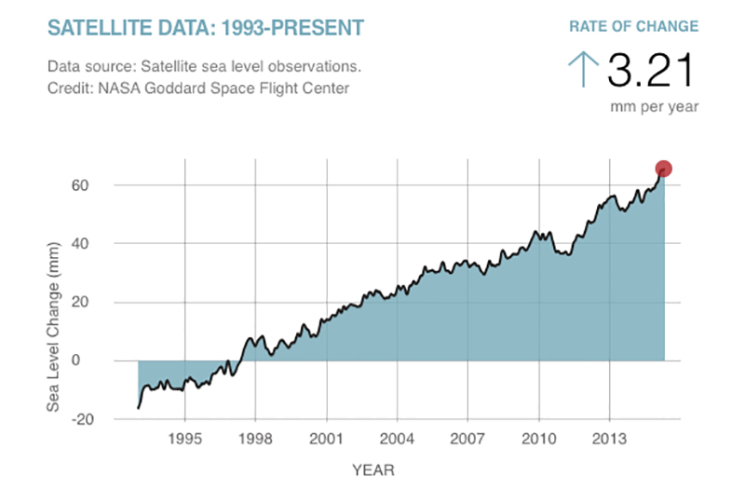

Considering that nearly two thirds of the world population lives by the sea at about sea level, this means that around 2050, these people will live underwater. It is then easy to understand that the development paths that have been followed until now and that the management of habitats, in a broad sense, will have to radically change, and urgently, to merely ensure the survival of humankind, not to mention the well-being of the people.
The range of the evolution of temperatures is very wide depending on the actions that are undertaken by governments, firms and individuals:

Figure 4: Greenhouse gas emissions scenarios

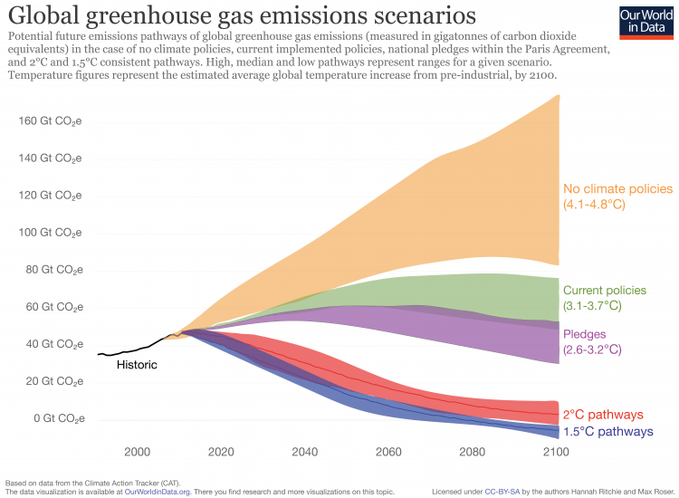

If we want to reduce emissions, it is clear that strong actions are needed. The current policies pursued could only stabilize emissions at the end of the 21st century. As there is no agreement about global policies and significant resistance to vigorous action by sections of the population, we will have somehow to learn to live with increasing temperatures. The possible management actions that will be developed in the next part, are even more needed as there is a clear positive correlation between ‘economic development’ in its classic sense and CO2 emissions.

Figure 5: GDP and CO2 emissions

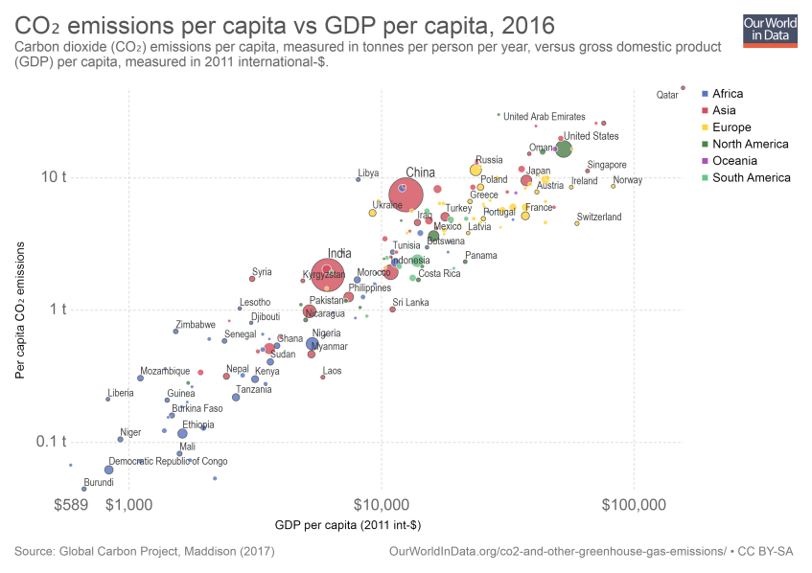

Therefore, either the notion of economic growth is altogether abandoned, which is advocated by some but rejected by the huge majority of people, or new economic development ways and means are adopted to reconcile economic growth and the preservation (probably more apt to say the survival) of the environment.
Moreover, we cannot re-start from zero. We have to bear the consequences of past action, or inaction, and we will have to do it for years and years to come. “Even if emissions are stopped immediately, temperatures will remain elevated for centuries due to the effect of greenhouse gases from past human emissions already present in the atmosphere. Past, present and future emissions of carbon dioxide represent a substantial multi-century climate change commitment.” (IPCC, 2013). We do not even know if it is possible to reverse the trend.
Governments and international organizations have not remained idle in front of climate change and a number of decisions have been made, policies adopted and in part implemented. Awareness was first aroused with the Club of Rome’s reports on “Limits to growth” (1972) which was more focused on the non-sustainability of economic growth as had been known since the Industrial Revolution than on climate issues. Then came the Brundtland report entitled “Our common future” (1987) which gave the definition of sustainable development still commonly accepted today. The focus on the climate issue came to the forefront with the Rio Summit and the “Declaration on environment and development” (1992). The first, in theory, binding decision about the question of global warming was made with the adoption of the “Kyoto Protocol” at the Kyoto conference in 1997, whose main objective was the reduction in CO2 emissions. However, this decision was much less effective than it had intended to be as the United States of America and the People’s Republic of China shunned this protocol. Things getting steadily worse, the Johannesburg Summit with the “Johannesburg Declaration” (2002), where president Chirac of France famously declared “the house is burning and we are looking elsewhere”, urged countries and governments to take strong and urgent action to combat global warming. However, nothing much took place. “Business as usual” as some would say.
The latest important move was the COP 21 conference in Paris in 2015. The agreement binds the 195 member States and the European Union, together with a number of Non-Governmental Organizations, to limit global warming to 2°C and to move towards the objective of 1.5°C with reference to the pre-industrial era. The agreement also sets rules to control the efforts undertaken and creates a green fund for the climate of 100m dollars from 2020. However, the reach of this agreement was quickly limited as President Trump of the United States of America shortly after his election decided to withdraw from it. The USA being the second biggest polluter on earth, the effectiveness of the agreement was very quickly reduced. Moreover, three years after the signing of the agreement, a good number of countries, including the European Union, are behind their pledges. “Limiting warming 1.5°C above pre-industrial by 2100 means that the emissions of greenhouse gases need to be reduced rapidly in the coming years and decades, and brought to zero around mid- century.[…]Currently implemented policies are not strong enough to achieve the pledges governments have made under the Paris Agreement framework. Therefore, the gaps between current policy projections and the 1.5°C and 2°C benchmarks are higher” (Climate Action Tracker, 2017).
It is therefore all to obvious that temperature increase will not be limited to 1.5°C and probably not even 2°C by the middle of the 21st century. Hence firms, and societies, will have to adapt their management and behaviours in the coming years under three types of constraints; the first one is of course changes in climate patterns and the new business environment that they imply, the second is national and international regulations aiming, notwithstanding their shortcomings, at limiting global warming, the third is the pressure of customers developing new expectations.

Second movement (andante): Towards a new management

The adaptation, to use a mild word, of management concepts and practices to the new business and social environment created by climate has to integrate the phenomenon of global warming, new governmental and supra-governmental laws and regulations and the evolution of customer/consumer behaviours.
Global warming changes the conditions in which firms have been operating since the industrial revolution in the 19th century. From a general point of view, firms will have to face a more variable, largely unpredictable environment with some extreme situations. More practically, they will have to develop new practices to be able to ensure the continuation of operations under these largely random environmental conditions. This means, as will be seen, that production modes and supply chains will have to be re-engineered.
Governmental and supra-governmental actions through an array of laws and regulations, albeit at different paces and with different levels of effectiveness, will increasingly affect modes of management and operations of businesses.
The amount of laws and regulations concerning the environment has been rampant over the last twenty years (The French Code of the environment for example contains 1196 articles.)

Figure 6: Laws about the environment

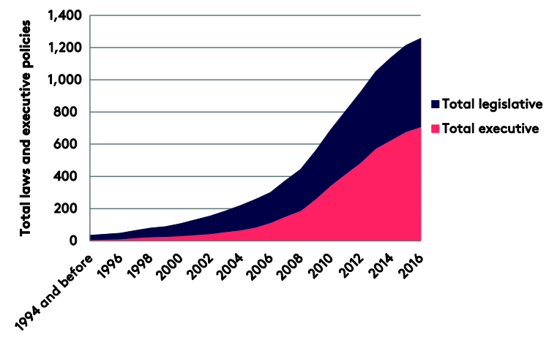
About 75% of countries have got laws and regulations which are specifically related to the climate (M. Nachmany, S. Fankhauser, J. Setzer, A. Averchenkova, 2017).
The most emblematic action by governmental authorities in this field is the issue of carbon pricing. The rationale behind taxing carbon is based on the principle that the polluter must be the buyer. Taxing CO2, hopefully, will entice the polluter to change habits and production methods either by reducing the use of fossil fuels or, better, moving to non-carbon-emitting renewable sources of energy. The intention is laudable, but the implementation meets a number of obstacles.
To date (2018), 88 countries are committed to taxing carbon, representing 56% of global greenhouse gases emissions. However there are huge differences between the rate of taxation applied or to be applied from one country to another, from 1 to 139 US$ per ton of CO2 emission; for example hardly 1 for Poland (where the last COP took place!) to 139 for Sweden. Even inside a largely integrated economic zone like the European Union, we have for example 2 for Estonia and 8 for Portugal, 25 for Spain and Ireland, 55 for France (largely suspended), 77 for Finland and 139 for Sweden (World Bank Group, 2018).
These discrepancies between the level of taxation, plus the fact that many countries do not tax carbon at all, including the USA (barring from some States), Russia, India and about the whole of Africa, lead a good number of firms to consider that it is a distortion of competition in a globalized world and that it gives some an undue competitive advantage. Moreover, a tax on carbon induces an increase in the price of products containing carbon emitting elements, which gives rise to protests by consumers who in the end bear the largest part of the cost. So, everybody agrees that green house gases must be controlled and reduced but hardly anyone is ready to pay the price for it; the usual NIMBY (not in my back yard).
Thirdly, consumer behavior has significantly changed over the last twenty years. From the advent of mass consumption in the 1960s until the end of the 20th century, customers and consumers were not, or little interested, in the negative externalities related to the production of what they consumed both in terms of industrial products and food products. This period was the heyday of disposable unrecyclable products and wasted foodstuffs. Waste management was inexistent or very limited. The first recycling program in the USA, for example was put in place in 1973 (Bradbury M,2014). It is only in the late 1980s that the issue of waste treatment and the adverse effects on health of what was to be called ‘junk food’ began to be of concern to consumers. In the USA about 40% of the population is obese, 30% in Australia, 25% in Canada, 30% in England, 20 to 25% in other European countries, but also in less economically developed countries such as Egypt, Saudi Arabia, Iraq, Mexico or Paraguay (Worldobesity, 2019). Nonetheless the production and consumption of ‘organic food’ has been growing steadily over the last twenty years, though it still only represent 1.2% of agricultural land (Finnian O’ Luasa, Irish Food Board, 2018).

Figure 7. Organic sales

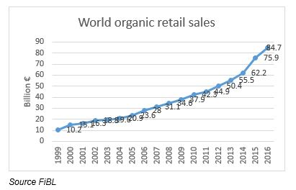

Today for example still only about a third of municipal trash is recycled in the USA (Bradbury, 2014). And a stunning 33 to 50% of the food produced in the world is wasted. It is the most inefficient market in any economic activity. Moreover, this waste of food induces the waste of a number of other resources. For example, it represents 25% of the global fresh water consumption (OLIO, 2019). However, in spite of the growing awareness of consumers and sundry initiatives by governments, organizations and individuals to reduce waste in all its guises, we still are very far from a zero waste society. Nevertheless, in the context of climate change, it will be imperative to drastically curb that waste.

Under these three types of constraints – climate change, regulations, consumer behavior – firms have no choice in the coming years to alter fundamentally their management to ensure their survival, maybe the survival of the human species and of the planet earth altogether.

It is, of course, to be noted that all the factors mentioned do not operate and have effects independently. A systemic approach is needed. All the factors are interrelated and interact, and reinforce one another.

We are going to examine now two main aspects of management to explore these needed changes: production in agriculture, industry and services, and supply chain management.

- Production:

First of all we would like to remind that our perspective is not for companies, and organizations in general, to primarily fight against climate change, but to investigate how companies can survive in the context of climate change. Therefore the mitigating effects on climate change of companies’ actions are considered as a consequence of those companies’ actions. In this perspective, the primary motivation of companies is to adopt a type of management that can ensure their survival and, if possible, continued development under the constraints of climate change that have been exposed above. This means that production modes and processes have to be adapted to the direct impacts of climate change, to the regulations imposed at national and international levels and to the pressure of customers and consumers.

Let us first examine the situation of the production of agricultural products.

- Agriculture:

Obviously agricultural activities are basic for the survival of societies and mankind in general. Consequently organizations and people involved in agricultural activities must be the first ones to adapt to the changing environment if not only they but the whole of mankind are to survive.
Agriculture is evidently linked to demographics. So, let us have a look first at the evolution of the demography.

Figure 8. World population growth

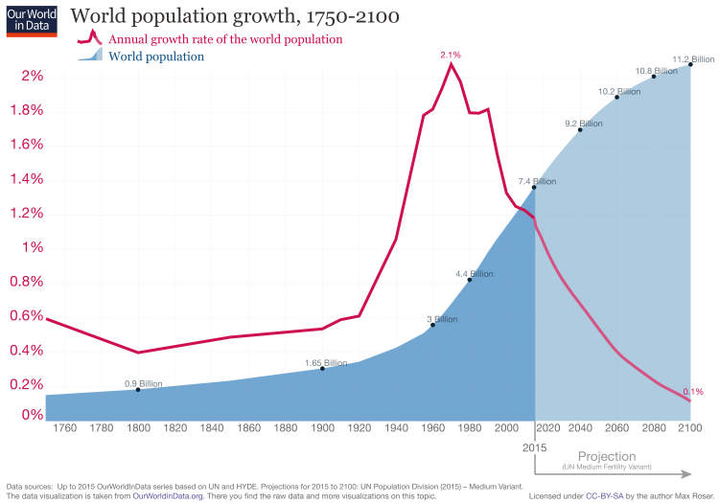

The above graph shows that since the 1940s there has been a sharp increase in the number of people living on earth. This increase has been due to a combination of factors such as an improvement in living conditions and health conditions. Simultaneously the growth rate has been plummeting since the 1960s, the result of which is that the total population is expected to reach a plateau around the end of the 21st century and then stabilize or even maybe somewhat decline. Of course, we are not exempt from some ‘black swan’ in the coming years such as an extreme natural disaster or a lethal epidemic. However, even if millions of people were affected, the effect on the global population would remain marginal. Consequently we have to live with fact that around 2050 agriculture will have to feed about 9 billion people and more than 11 billion be the end of the 21st century.
To start with, we believe that there are some misunderstandings to dispel about the present situation of agricultural production. There is a lot of talk about the capacity of agricultural activities to produce enough foodstuffs to feed and an ever-growing population. The underlying tenet of this questioning is implicitly, most of the time, or more rarely explicitly the traditional Malthusian attitude towards the conundrum of agricultural production that tends to grow linearly, if everything goes well, and demographic evolution that grows exponentially (Malthus, 1798). The solution to this conundrum has been, since Malthus, that population growth should be checked and curbed in order to establish a balance between the productive capacity of agriculture and the number of people to feed. Until now, Malthus has been proven wrong, but it is no guarantee that it will continue to be so in the future. Our purpose when examining agricultural production is not to abide by nor to challenge Malthus’ theory but to take population growth as a fact, just as we take climate change as a fact.
It is true that today there are places in the world where some populations suffer from hunger. But this is not due to a shortage of food, it is due to a problem of distribution. In purely management terms, it is a logistics issue.
Today the world population is about 7.5 billion people. According to the FAO 2,700 kcal/capita/day is a satisfactory level of food supply. Considering that the world average today is around 3,000, it means that the actual production today is capable of feeding more than the present population. We are not very far from 8.5 bn people, the projected population in the 2030s. Of course there are significant disparities between countries, which creates the apparent food shortage, but globally there is no shortage. Even with a population expected to be about 9.2 bn in 2050, if the production capacity trend is to continue, there would be no problem to feed all these people (Hunter et al., 2017, Tvede, 2016), although around 9 to 10 bn is considered by a number of researchers as the maximum earth’s capacity of food production (Wolchover, 2011). Consequently, ceteris paribus, volume should not be a problem until the 2080s, but allocation will be an increasing problem, as countries with increasing populations are the ones with below average production (Hunter, 2017). There is no guarantee of course that ceteris will remain paribus, they rarely do. And here we fall back on climate change, as will be seen. Moreover, if we take into account the problem of waste, the outlook, as far as volume is concerned, is not particularly bleak. If we rely on the assumption that 30 to 50% of the food produced is wasted (see above), there is a huge margin for improvement. Let us imagine that waste is reduced to 20% of production, which may seem reasonably attainable, this means that 80% of the production would be available, instead of 60% at present (if we take an average waste of 40%). Consequently by reducing waste by that amount, the present agricultural production is already able to feed about 10 billion people. Then, the question of volume is not the key issue, as many want us to believe. The key issue is one of management.
However, here again, we must be cautious. There is no guarantee that this volume of production is sustainable in the long term, precisely because of climate change. Therefore there is an imperative need to alter production conditions and methods.
According to FAO (2016), under present conditions, crop yields are set to decrease by 3 to 10% by degree of warming and potential fish catch by 5 to 10%. The countries most affected will be in Africa and south Asia. Agriculture accounts for between 10 and 15% of greenhouse gas emissions, which is relatively low, but with big disparities depending on the region of the world (European environment Agency, 2015). Water is most probably the fundamental input in agricultural production that needs to be controlled. Agriculture is by far the biggest user of water. About 70% of the water pumped from rivers and aquifers is used for agricultural activities, compared to 20% for industrial uses and 10% for domestic uses (OECD). Therefore the control of water resources and uses is a determining factor in the management of agriculture.
Another key issue is the use of pesticides. Until now the big majority of pesticides that have been used, have been synthetic pesticides (i.e. chemical). Their advantages are undeniable. They can increase yields by 20 to 50%. But the hazards related to them are also undeniable.
They affect human health in various ways, they contaminate soil, water and other vegetation, thus having a long term negative impact on soil fertility, and if they kill harmful organisms, they also kill useful ones and alter in a negative way the ecological balance of the environment (Aktar et al., 2009). Nowadays with the development of organic farming, synthetic pesticides can be gradually replaced by systemic pesticides, of which much smaller quantities can be used or natural pesticides produced by plants and organisms themselves a defense against insects and diseases.
As seen above, laws and regulations about the effects of climate change and production practices have burgeoned over the recent years. Similarly food security has become a major concern for governments and various bodies and has given and is giving rise to tighter rules for agricultural production. Based on the ‘precautionary principle’, today not only proven harmful substances must be reduced and eventually phased out, but potentially harmful ones also need to be closely monitored or banned. Apart from the Ministries of Agriculture, there are scores of agencies, bodies, organizations regulating food production and processing starting the Codex alimentarius of FAO.
Finally, we have the role played by customers and consumers. Organic food sales are growing at a steady pace (see. Figure 7 above) and demand is growing by 15%20% per year, with great variations depending on countries. In spite of these differences, the trend is clear. Therefore, there is no other way in the future for agricultural producers but to shift to new production methods if they want to keep their customers.
The combination of all the factors stated above make up a cluster of constraints that are compelling for change, and this even if the motivation of farmers is not to fight against climate change.
Almost twenty years ago already Smith and Skinner proposed a typology for ‘agricultural adaptation options’ under four non-exclusive categories:
(1) technological developments,
(2) government programs and insurance,
(3) farm production practices,
(4) farm financial management. (B. Smith, M.W. Skinner; 2002).
These categories are as valid as ever and can be used as founding elements of a new management of agriculture in the context of climate change.
We can try and devise a general model on the basis of the analysis developed above and integrating this typology.
The model can be built around three questions to answer for agricultural production in the context of climate change:
- What are the constraints agricultural producers are submitted to?
- What are the inputs required to integrate these constraints?
- What are the practices required to produce in a durable way in the new climate environment?

The first set of constraints is linked to the phenomenon of climate change itself: global warming, at the same time shortage of water and extreme weather events (e.g. floods), severe droughts in several parts of the world.
The second set of constraints is linked to governmental actions to regulate and mitigate climate change: carbon tax, prohibition of certain products (e.g. synthetic pesticides), inspection and control of production methods and produces.
The third set of constraints is linked to the evolution of customer/consumer expectations: ‘safe’ products, innocuous for health, organic, traceable.

The inputs to meet these constraints are to develop crops and seeds requiring less water and to optimize the use of water, and to move to systemic and natural pesticides, not forgetting the training of farmers.

The agricultural practices involve a rotation and a mix of crops and plantations that does not exhaust the soil, a tilling and plowing of the soil that preserves beneficial organisms, a use of pesticides just as needed, a preservation of water resources by controlling them and recycling them, a limitation of waste and their recycling for agricultural purposes (e.g. fertilizers) or other purposes (e.g. energy production).

It is to be noted that most of these elements are already existent here and there, but they are used in a piecemeal way and not in a systemic one, which is what is needed.

Figure 9: A general model for agriculture
At the end of the production process, we move to another key process, that of the management of the supply chain, which will be examined later.

We have not included here ‘animal production’ for clarity of purpose, but obviously the same applies to it.

- Industry:

The production conditions in the context of climate change basically the same for industrial activities as for agricultural ones. However, in terms of greenhouse gases effects, especially carbon dioxide emissions, industry is by far the bigger emitter. Industrial activities account for between 45 and 55% of emissions.
The main source of emissions comes from the energy resources that are used. Fossil fuels are still predominant in the world are will remain so for at least a couple of decades even with sustained efforts to replace them with non CO² emitting renewable sources. The level of emissions varies significantly from one type of resource to another. Coal is the main culprit, followed by oil and gas.

Figure 10: CO² emissions by type of fuel

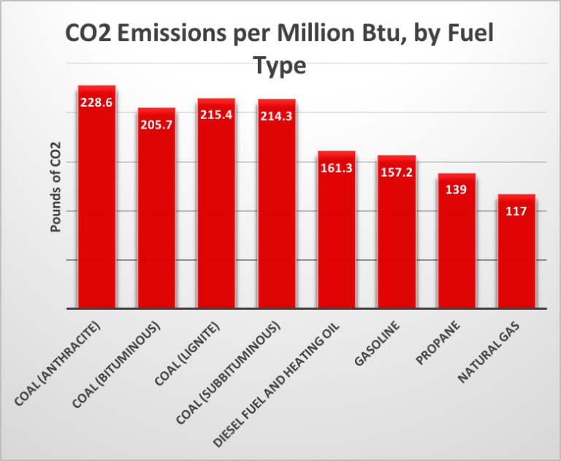

As we have seen, the use of coal is only dwindling very slowly and it has even increased in 2018. Disregarding the negative externalities for the environment, the reason is that it is abundant and cheap. That is the very reason why countries put in place ‘carbon taxes’ to ‘encourage’ companies to shift from coal, and other fossil fuels to ‘clean’ renewable sources. But we have seen that for lack of an international consensus, these ‘carbon taxes’ have been until now relatively ineffective. When the cost of using CO² emitting energy resources becomes higher than using non-CO²-emitting ones, out of a purely economic calculation, and without the necessity of a will to combat global warming, industrial actors turn to choosing non-CO²-emitting sources. It is assumed that by 2050, 80% of the energy used could come from low (or no) carbon technologies that already exist (solar, wind, hydropower, biomass, nuclear) (BCG, 2018). And of course these technologies constantly improve. From the point of view of regulators, it is therefore necessary to find a consensus on the issue of carbon taxing.
Like for agricultural products, the main constraint for industrial companies to change their policies and practices may well come from customers and consumers. Thanks to fast and widespread information about companies’ practices, albeit unfortunately not always true, available to consumers, the latter’s behavior can change rather rapidly and oblige producers to adapt to the new expectations. It is most probable that the trend that has emerged in recent years for low-carbon, non-polluting, more lasting (the reaction against ‘programmed obsolescence’), reusable and/or recyclable products will continue to strengthen in the future. If producers persist in marketing products not expecting consumers’ expectations, they will be subject to boycotts and then simply lose their customers.
So, here again we find the same sets of constraints: climate change itself through the effects of global warming, regulations and consumer pressure.
What can then be a sustainable development path for companies under these constraints?
First of all there is one element that tends to be overlooked but that has an undeniable impact on the operations and performance of companies, that of the location. We have seen that around 70% of the world population lives on coastal areas, it is the same for companies, and of course the two are linked. So, just as populations are submitted to floods and other natural phenomena, so are companies with consequences that are not anticipated. One may remember that some years ago, the production at the Honda Swindon factory in England had to be stopped. The reason for this stoppage had nothing to do with the Swindon factory. The cause had to be found more than 6,000 miles away in Thailand. The factory supplying a big proportion of the parts used for the assembly of the cars in England were produced in a factory in Thailand which had been severely flooded causing production to stop for several months. Such an event also challenges the organization of supply chains as will be seen later.
Therefore companies should make sure that their location protects them from natural phenomena linked to climate change so that they can continue production in spite of them.
Second comes the choice of resources made by companies to operate. We know that both for reasons of regulations and consumer behavior, fossil fuels, especially coal, will have to be phased out. But it is not because companies will use ‘clean energies’ that they will be out of danger. The control of the use of energy is and will remain central to competitiveness. Consequently, companies will have to be wary of reducing and optimizing their use of energy. In order to do that, it is necessary to engineer production processes which get as much as possible out the energy used. The answer to that is basically to have shorter and lean processes. Third there is the use of the materials used by companies to produce. We have seen that some materials are in the process of being banned and more will be in the future. In short, all material derived from fossil sources will eventually be outlawed. Therefore companies have to turn to natural, renewable and recyclable materials. The application of the concept of circular economy should become the rule. Fourth, there is the integration of environmental impacts into production processes in order to preserve the natural environment. Traditionally, negative externalities have not been taken into account in cost calculation methods and accounting information systems (think for example of the dismantling of a nuclear power station). In this respect, inspiration can come from the guidelines of standards like ISO 14004 and the plethora of already existing standards for various industrial activities, but which are not, partly or badly used by companies.
Then, like for agricultural activities, we can propose a general model for industry.

Figure 11: A general model for industry

After agriculture and industry we can turn to services and try and see how they can adapt to the new environment created by climate change.

- Services
We must first remember that services represent 70 to more than 80% of economic activity. Even though, there is much more talk about the relations between agricultural or industrial activities and climate change, services, due to their mere weight in the economy, undoubtedly play a key and central role in the sustained performance of organizations.
Obviously, the constraints bearing on service activities are the same as the ones bearing on agriculture or industry even though people, and companies, may be less aware of them due to the immaterial nature of services.
We can here focus on service as what accompanies a product in its transfer from the producer to the consumer, in which case the material aspect and the immaterial one make one, and as something purely immaterial, for example financial services, but behind which there is always something material, even if the consumer is not really aware of it.
In the first case, the service provided is one way or another linked to the distribution of the product. This is for example the case of an insurance policy, a warranty, some assistance given through a hot line. In such cases the way to limit environmental negative externalities and to remain competitive is to fully adopt what has for decades been called in quality management ‘zero paper’, i.e. the digitalization and dematerialized processing of all documents. In other words, the service is completely cut off from all tangible elements. Although digitalization is well on the way today, the situation is somewhat paradoxical as in many cases we have both dematerialization and materialization of documents. Thus the result is at best a zero sum game, as dematerialization is not without negative consequences as will be seen. But zero paper is far from being enough. The relationship with the customer needs to be as close as possible, which means that customer relationships management (CRM) has got to be reviewed. Customer closeness implies ‘customization’, that is the service is tailored to a particular customer to establish a one-service-one-customer relationship, meaning that the provider has the ‘knowledge’ of the customer. The reason for that is that undifferentiated service is a source of waste. When a service is targeted at a big number of customers (i.e. undifferentiated), most of the communication content is noise and not information, consequently most of the content is waste. It may not be easy to see the link between noise in communication and climate change, but it is there.
In the second case, the service provided is not related to any physical product. It is for example the case of financial services or consulting. Here also, of course dematerialization is the first objective, and customization of the service even more important. No customer having the same expectations and requirements, which is the main difficulty in achieving service quality, the provision of the service needs to be perfectly tailored to the individual customers.
Therefore, what is globally needed is to design ‘lean service processes’, eliminate noise, and answering the expectations of the customer, all the expectations and only the expectations.
Now we can make the relation between service provision and climate change explicit.
Dematerialization is all very well, as is customization, but they are big consumers of energy. The so called ‘big data’ is voracious in energy resources. “Global data centers used roughly 416 terawatts (4.16 x 10¹⁴ watts) (or about 3% of the total electricity) last year. And this consumption will double every four years.” (Danilak, 2017). And consequently, as this electricity must come from somewhere, this consumption contributes to global warming and climate change. “According to a paper to be published by US researchers before the end of the year, the ICT industry is posed to be responsible for up to 3.5% of global emissions by 2020, with this value potentially escalating to 14% by 2040” (Marques Lima, 2017). Therefore, what is gained on one side must not be lost on the other. Hence the necessity to have a service model which eliminates noise as much as possible – noise cannot be totally eliminated because it is ambivalent: what is noise for some is information for others, but noise in a one-to-one relationship can be eliminated – and thus optimizing the use of energy.
On this basis, a model for services can be proposed.

Figure 12. A general model for services

Production is but a first phase in the global process of B to C, or B to B, or even C to C. We need now to examine the ‘to’, that is the link between B and C, B and B or C and C. This is in other words the nature and management of the supply chain.

- Supply chain management:

Taken globally, the supply chain starts with the procurement of the resources needed for production to the disposal of the product after its use by the consumer (Mentzer JT. Supply chain management. United States of America: Sage Publications, Inc; 2001). We have already dealt with the production phase, so we can focus on the transfer of the product to the consumer and the disposal of the latter after use.
With regards to climate change, the adaptation of the supply chain to the latter, is to make the supply chain ‘green’ and set up what is now commonly called a ‘green supply chain’ (GSM). Although, like for many other concepts, we can find several definitions of GSCM, they all express the same idea, which is the integration of environmental issues into the design of the supply chain. We can for example take the definition of Srivastava (Srivastava, S.K., 2007) “Green supply-chain management: a state-of-the-art literature review”, International Journal of Management Reviews, Vol. 9, No. 1): “integrating environmental thinking into supply chain management, including product design, material sourcing and selection, manufacturing process, delivery of the final product to the consumers as well as end-of-life management of the product after its useful life”. To ‘environmental thinking’ we could of course add ‘environmental practices’.
Like for agricultural, industrial and service production, SCM is constrained by climate change effects themselves, laws and regulations and consumer behavior.
We can consider three key activities in the design of a green supply chain: the packaging of the product, the transport of the product, the disposal of the product.
Packaging has traditionally been considered as a means to facilitate the transport of the product and, most importantly, as a means to persuade the consumer to buy the product, in other words a key marketing tool. Its impact on the environment was long overlooked or ignored. Today under the pressure of laws and regulations and consumer behaviors, which reinforce each other, companies cannot but act on the way packaging is operated. ‘Greening’ packaging first means reducing the use of materials, which can represent a non-negligible part of the weight of the whole product. It means replacing materials made with fossil fuels and whose disposal is harmful for the environment – one of course immediately thinks of all sorts of plastic and the ‘6th continent’ – with natural materials which can either be re-used and recycled or are bio-degradable. As for the marketing use of packaging, it can be largely streamlined as the ‘information’ it is supposed to give to the consumer is in fact largely ‘noise’. It can even be totally suppressed for some products (e.g. rice, pasta) without any loss of custom, on the contrary as changing consumer behaviors make consumers move to un-packaged goods.
The transport of the goods is big source of environmental damage that, here again, consumers accept less and less. Transport (including people transport) accounts for about a quarter of global energy-related carbon emissions, and, if no action is taken, will double by 2050 (Climate change: implications for transport, Intergovernmental panel on climate change, 2014). ‘Greening’ transport first simply means reducing it. And reducing it challenges the now well-established ‘fragmented globalized supply chain’ where almost each activity in the global process takes place in a different place obliging to move the product as it is produced, as it is consumed, as it disposed of from one location in the world to another location in the world. In other words, it means that the distance between the production place of the product and the consumption place of the product must be reduced as much as possible, implying a relocation of activities. It is of course not possible for all products, but look around you and you will find many for which it is. A revised logistics chain challenges the adoption of the just-in-time procurement method which implies an extensive use of transportation means. Either these means are adapted to the new environment or companies will have to reconsider the management of their supplies.
Globally companies will have to turn to more efficient, non-carbon means of transport. Some of them are already operational (electric vehicles), some are being developed (wind and/or solar powered cargo ships, use of bio-fuels).
There is another aspect to take into account, which is the consumer’s “internal supply chain”. This refers to how consumers purchase the goods they consume, how they stock them and what they do with the waste generated. If consumers want companies to change their practices, they also have to change theirs to minimize adverse environmental effects.
The disposal of the product has become a key environmental issue. Products should be designed so as to be easily re-usable, repaired and recycled. Here again a durable and circular outlook of the life cycle of the product needs to be adopted.
Dealing with the supply chain from beginning to end as a whole implies that the supply chains are fully integrated. Today only part of them are, leaving ‘gaps’ at some interfaces, which can be disruptive causing losses of performance and increasing negative externalities for the environment. This integration of supply chains requires the collaboration of all the actors along the whole supply chain (Thoo Ai Chin, Huam Hon Tat, Zuraidah Sulaiman, 2015).

Figure 13. A general model for the supply chain

We can now combine Figures 9, 11, 12, 13 to have a global view of a sustainable, competitive model integrating the impacts of climate change.

Figure 14: A global model for sustainability and competitiveness

SUPPLY CHAIN
Packaging : materials, information, suppression
Transport :
distances, procurement
Means
Disposal :
Reuse, repair, recycle
Circular life cycle
CUSTOMER
CONSUMER
SERVICES
Inputs : data, knowledge, energy
Practices : customer closeness, customization,
Noise reduction, lean processes, use of energy
INDUSTRY
Inputs : location, energy, materials
Practices : lean processes, less energy, preservation, recyclability, circularity
AGRICULTURE
Inputs : crops, seeds, water, pesticides, training
Practices: rotation, preservation, control, waste
CONSTRAINTS
Climate change, laws & regulations, customer expectations

Third movement (scherzo): A revolution in management thinking and practices

The new environment created by the phenomenon of climate change calls for companies and organizations in general to undertake a management revolution if they want to have a chance of surviving and remaining competitive.
As noted in the previous pages, climate change requires a radical revolution in management for competitive purposes, or the company will no longer be able to survive in its current institutional form. This form is in fact increasingly perceived as directed at transforming the use and destruction of natural resources into profit and benefits for the few. The company, in reality, will not be able to maintain its centrality "if it turns out that the market is widely perceived as a tool that benefits a few without contributing to general happiness" (Csíkszentmihályi, 2003).
Thus, a real revolution in the way of being a company appears to be necessary. Such a revolution is possible only with a change in the rules of the competitive game that underlie the current functioning of the market and consequently the appreciation of the company's success.
Indeed, the size and speed of the ongoing environmental damage are incompatible with minor adjustments in the functioning of the market or with typical alternatives only of science fiction such as the transfer of life to other planets with imaginary interstellar journeys. Neither the fantasy and the innovativeness of Elon Musk would arrive in time in the realization of the transfer on Mars of a part of the humanity if the conditions on earth were such as not to allow the continuation of the species (https: //www.businessinsider. com / elon-musk-SpaceX-mars-plan-timeline-2018-10? IR = T).
We have only one planet and at this speed of climate change we will not be able to find another one in time (Mancuso, 2018). Of course, space explorations in the uncontrollable tension of humanity to discover are magnificent and challenging to learn about new worlds, but not to plan a possible escape from a "consumed" land. Soon, in fact, new realities would also be consumed if people’s culture, attitudes and actual behaviors do not change.
What then are these necessary new rules of the game and who has the power to define and disseminate them? The question becomes even more serious, if we consider that codified rules are often experienced as almost unchangeable, made to remain and not able to be changed.
Let us first seek an answer to this second question relating to who can initiate the necessary metamorphosis of the system, so as to avoid tracing imaginary changes placed outside the forces that govern the economy and therefore experienced as simple suggestions supported by mere hope.
We could think of two subjects that act in the environmental context in which the company moves: the world of politics and that of people in the guise of consumers, citizens and members of a community.
In reality, however, there do not seem to be forces capable of radically moving the current system for two powerful reasons. On the one hand, the short-term horizon adopted by politics, linked to electoral mandates in turn often closely linked to economic interests, empties the word sustainability of content. In the short term the damages will not be felt, or will be in a small part, so a number of agreements are signed in international forums which are in fact always postponed, not to say denied in some cases.
On the other hand, the strong psychological domination exercised over the person by a culture and a communication that encourages the value of appearing combined with a widespread negative egoism of individuals aimed at researching and safeguarding personal well-being, homo homini lupus (Plautus – Asinaria - and Hobbes - Leviathan), make the widespread attempts to organize a coherent response in this regard not very incisive.
However, the issue of sustainability has gained great momentum from consumers over the years. It is said that consumers are really interested in the sustainability of the products they buy and in the commitment companies show towards environmental friendliness. Two out of ten Global Consumer Trends for 2019 deal with sustainability: “Conscious consumer” and “I want a plastic free world” (Euromonitor International, 2019). Pressure towards green products is made across different industries: energy, automotive, clothing, fast moving consumer goods, food, just to name a few. There is nearly no product category exempt from this big shift.
Consumers, however, are not all of the same kind. Several researches, in particular, proved that in the domain of sustainability, attitude is not the same as actual behavior. That is, the majority of consumers declare themselves in favour of the protection of the environment, but few of them are consistent with such pronouncements. Attitude means a general feeling towards something. Attitude is important since it is considered a reliable antecedent of behaviour. Behavior means what people actually do.
From this point of view, there is no doubt that, according to several sources, consumers are involved in the sustainability issues and ask for green products and services sold by both private and public organizations. The effects of climate change, after all, started to be not just small figures in scientists’ and institutions’ reports but directly affect ever growing numbers of people. Natural disasters are no more exceptional and natural events are more and more catastrophic.
Consumers’ awareness towards safeguarding the environment– in the various facets such a phenomenon can assume (plastic free, renewable energy, electric vehicles, no meat diet) – has become mainstream and a perceived green product and company orientation nowadays is no more matter of differentiation among industry competitors but simply a matter of survival for companies. For any company, today it is simply impossible not to display itself as respectful of the environment.
When it comes to actual behaviour, though, the number of consumers actually willing to change their own way of living and to comply with the limitations a green approach towards consumption requires, is for sure lower. Apart from “green activists”, people subjectively deeply involved in the green cause, the rest of the population does not show the same consistency in behavior. Modifying one’s own behavior – and mostly in terms of more constraints and less airiness – is not an easy task, even when it’s for personal healthy reasons (food, tobacco, sedentarity), let alone for social benefits.
So, there is a gap between what consumers preach and what they practice. A general favorable attitude towards sustainability doesn’t convert at the same rate in consequent purchasing decisions and behaviors. A lot of literature is available on this very topic.
Combining attitude (low and high) and behaviour (low and high) in the field of sustainability results in four different clusters of consumers:
- low sustainable attitude and low sustainable behaviour
- high sustainable attitude and low sustainable behaviour
- high sustainable attitude and high sustainable behaviour
- low sustainable attitude and high sustainable behaviour
A simple matrix (dubbed the 4Ws) can be drawn to illustrate this situation:

The first group can be termed as “green-indifferent consumers”, because they are not only behaving in an unsustainable manner, but also more or less distant from sustainability issues. They are the WASTERS
The second cluster can be termed as “lukeward-green consumers”, since they show interest towards sustainability but, for various reasons, are not able to put in practice their beliefs and convictions. They are the WAIVERERS.
The third cluster can be termed as “actively-green consumers” because they behave accordingly to their beliefs and convictions. They are the WILFULS.
The fourth group (low in attitude and high in behaviour) can be termed “constrained-green consumers” and basically looks like an oxymoron. This situation can be either found in so called ‘primitive’ communities where people have sustainable behaviours but no proper awareness of the notion of sustainability; for them it is something ‘natural’. Or, it can be found – though less frequently – in developed countries when consumers are forced to adopt sustainable practices regardless of their awareness and interest in the notion. They are the WILDS.
The ideal path is from WASTERS to WAIVERERS to WILFULS in the so-called ‘advanced economies’. But to date the three clusters co-exist and the WILFULS are very far from being a majority.
So, before examining the changes management could deploy towards sustainability with respect to consumers, it is important to distinguish between the specific categories of consumers we are referring to.
Beyond all these assessments, it is clear that consumers alone do not seem able to change the general cultural attitude towards environmental protection which in most cases seems to be someone else's problem.
Thus, the statements of the Brundtland commission on sustainability and the subsequent developments of the same carried out by Amartya Sen (in some way understood in the Pellerossa words "we have not received the world as an inheritance from our fathers, but on loan from our children") remain vain declarations of principle that fail to remedy the situation that has been determined and is being determined.
In this way we continue to proceed on a path that pretends not to see "the nothing" approaching threateningly on the horizon, as in the famous film "The never-ending story".
An effective response to the problems identified could, however, be initiated by a third party. Paradoxically, this change can be sustained by those who have contributed to generating a large part of the damage: capital in the productive and market forms with which it has expressed itself in the name of seeking its own maximum possible remuneration.
This can happen because capital, through the people who interpret its role, can be short-sighted, shrewd, selfish but certainly not stupid. Capital can have predatory behaviors, denote incapacity or have intelligent but certainly not stupid behaviors, that is, aimed at also causing harm to oneself as well as others. This reasoning can be more easily explained by looking at the matrix of stupidity constructed with reference to the behavior of individuals but which can also be extended to organizations (Cipolla, 1976) shown below.

If we consider the matrix reported above, the capital - with the company that represents it - we can find it in three of the quadrants that compose it, but not in that of stupidity but in a small part. Without venturing quantitative estimates, we could hypothesize that the companies in the market system have so far been mainly concentrated in quadrant B, which welcomes the "banditized" behaviors aimed at procuring advantages for themselves regardless of the disadvantages for the others, partly in the U quadrant which welcomes behaviors that denote incapacity and, to a lesser extent, quadrant I which reveals intelligent behavior that produces advantages for oneself and for others. The quadrant of stupidity with companies that produce disadvantages for themselves and for others we could imagine as empty or at least almost empty (Companies do not commit suicide, at least willfully).
Now, considering the horizon of a more stringent threat of pressure from stakeholders and the state regardless of their current level of effectiveness, it can be assumed that the most advanced capital will tend to move in the direction of intelligent behavior with subsequent imitative effects as shown in the figure.
On the other hand, companies that act to create advantages for themselves and others have already appeared on the market horizon (e.g. Patagonia, Davines, Pedrollo, Loccioni, Cucinelli, Alisea) and this further strengthens the emergence of strong pressures on the world of companies in general to move in the direction of behaviors that create advantages for themselves and for others.
Thus the capital-enterprise is gradually acquiring the awareness that it must change its way of acting in order to continue to reproduce with its own remuneration associated with respect and reconstitution for the environment and the production of well-being for the community of stakeholders, overcoming the managerial forms that have followed one another so far in the various stages of development of market capitalism.

- means firms are seeking the MAXIMIZATION OF PROFIT, this is a stage of LIBERAL CAPITALISM.
- means firms and governments are seeking the MAXIMIZATION OF ECONOMIC GROWTH, this is stage of STATE CAPITALISM
- means firms are seeking the MAXIMIZATION OF STAKEHOLDER SATISFACTION, this is a stage of TQM
- means firms and governments are seeking the MAXIMIZATION OF COLLECTIVE VALUE CREATION. This a stage of a WELL-BEING ECOSYSTEM.
This is largely a historical development, though like for consumers, the four behaviours co-exist. So, we find ourselves in a phase of confused transition to new rules of the game that will involve a radical transformation of being a business and with it being a consumer.
In this transition companies will be able to move in three different directions.
On the part of the company, there are three different levels of action and accordingly three domains where a company can deploy its sustainable behavior.
In an increasing order of difficulty, the first level is that of communication, the second level is that of the products sold and the third one refers to leading by example.
A company communicates in different ways, channels and with different contents. Though sometimes communication is all a company does (greenwashing), nonetheless communication is the first step in a comprehensive sustainable behavior. Especially if a company turns its communication towards an educational course, providing information and knowledge about sustainability, its effectiveness and relevance is even bigger.
What a company sells, and above all, to what extent the products are environmentally friendly, is no doubt of the keenest importance. Providing the marketplace with an offer which is inherently sustainable is simply the best way to prove its orientation towards sustainability.
Not only what a company says or does is important, but also what it is and how it behaves. The company culture, its ethos, its way of acting as a social actor nowadays are more and more inescapable. Consumers demand companies to be accountable, transparent and consistent in their behaviors.
Communicating sustainability or/and selling sustainable products is not enough any more. Companies do have to play an active role to solve the problems they contributed to create and to make the world a better place to live in. Companies are asked to complement public policies and to proactively act in order to overcome many problems that once upon a time used to be out of their scope, but that now are or should be on the agenda at least of the biggest companies, though it might be easier for smaller – and younger – ones to act sustainably. Companies can be helped in this journey by referring to various standards, for example ISO 26000, as long as they do it genuinely and not just to appear ‘socially responsible’.
Companies cannot confine themselves within the perimeter of producing and selling good products at a fair price, creating jobs, paying taxes and generating profits. What once used to be enough, now is a necessary but not sufficient condition. Companies are asked or, better, urged to take a stand on sustainability issues, to patronize good causes, to be active in tackling problems on a global scale.
Governments, institutions and public administrations seem more and more in trouble when it comes to face the big challenges of our times. Corporations are quite seen as more powerful agents able to take the lead. It is enough to have a look at Procter & Gamble’s or Unilever’s website home pages to understand the new role these companies are playing. P&G or Unilever – assuming they are honest and sincere – appear not as fast moving consumer goods producers but as true heralds of social commitment.
So, a management revolution in customer relationships can be different depending on the group of consumers it refers to. With actively-green customers, proper key-words are engagement, harnessing the power of consumers, co-creation. With lukewarm-green consumers, proper key-words are motivation and example. With green-indifferent consumers, proper key-words are example and nudge.
As for actively-green customers, the company should leverage their interest, motivation and willingness to participate. Companies could benefit from user-generated contents in the communication domain, from crowdsourcing in the product domain, from co-evolution in the institutional domain.
This means giving customers a voice and integrating consumers in the definition of communication policies and acts. In the product domain, companies should allow if not invite the more active customers to take part in the design process. As it is becoming more and more evident, the tacit knowledge consumers have about the products they use is a valuable asset to capture and to rely on. At the institutional level, actively green customers can be involved in different ways in the corporate governance: from actual presence on the board, to a role as a staff organism, to consultancy from the outside as a third party when needed.
As for lukewarm-green consumers, they already have a favourable attitude towards sustainability, but for different reasons they are not always able to behave accordingly. This implies that corporate communication should evolve from persuasion to education, giving consumers evidence of the difference they can make; products should always have a green option and the proper reasons-why; the company as a whole should act as a trustworthy leader, showing and practicing its real commitment and willingness to take the higher road.
As for green-indifferent consumers, it can first be argued that they can be somehow touched by a trickle-down effect, so that they will over time adapt their behaviors to the ones of their more virtuous colleagues. Complementing this relatively passive course of action, companies could put in place some nudges, to “naturally” drive consumers towards more sustainable behaviors. With respect in particular to the product domain, companies could make it easier and more convenient for consumers to choose the green version of a product.
As for the “constrained-green consumers” companies could provide consumers information about the importance of sustainability and reinforce their sense of doing something positive. Being sustainable for the lack of a consumption culture and practice due to economic underdevelopment or for the action of severe limitations by laws and regulations, they could better bear the burden of the circumstances they are living in thanks to the awareness of the good made possible by their sacrifice.
But the transformation will have to be more radical in order to be incisive and will be defined according to the choice that some companies are making with the adoption of the welfare of the community instead of mere profit as an objective. This can happen on the basis of the increasingly evident principle that holds true for profit, that is the more you seek it, the less you find it. Profit is actually the result of the action of the company aimed at creating and spreading well-being.
The imitative effect and the diffusion of these approaches by academics and the mass media will facilitate the metamorphosis of the management that will move according to new concepts, new words and new parameters.
Indeed, in this [r]evolution, the rules of the game by their nature will change and evolve in the direction of overcoming profit in the evaluation of success with the establishment of reputation as an indicator of success. The performance measurement system will become closer to that of the Benefit Corporation, where a Well-being Index (IW) is a result of the measurement of the various variables that measure the sustainability of action in economic, environmental and social terms.
In this perspective the company will return to being the most creative human construction in support of development and progress through the transformation of dreams into ideas and ideas into projects aimed at solving people's problems on the way to the quality of life as it was at the origins of the industrial revolution when the awareness of the finiteness of natural resources was by no means widespread.

Envoi: Rondo

In spite of the promises made at the COP 21 (2015), four years later, it is clear that these promises will not be kept. Even if we forget about the case of the USA, the most committed countries, for example Germany and France, are not reaching the intermediary goals set, and will not reach the ultimate goals. So, if we are lucky – if luck has a part to play in this matter -, the temperature increase in the 2030-2050 period will be beyond 2°C, not to speak of the 1.5°C target, and probably around 3°C at least. Mankind will therefore have to live with it, and, as we have seen, companies of all guises will have to revolutionize their management if they are to survive in this environment, and they will have a key role to play, at last, to check the harmful consequences.
Paradoxically companies could achieve this goal just by playing their own classic game. And this not a scherzo (joke)! Business is a big game that managers play, where until now, albeit with some variations, making money has been the final goal. If the rules of the game are changed in the sense that human progress and wellbeing become the goals of the game, they can continue to play their favourite game based on maximization. But this time maximization of well-being is the overriding goal. As we have seen, companies are not stupid. If it is in their interest, like Adam Smith’s butcher, they will do it. Of course this implies that the emphasis is shifted from one type of maximization to another. In the relationship between the financial balance sheet and the non-financial one (i.e. social) has to be inverted.
Just like macro-economists have been debating about and replacing the GDP by other metrics (and one country has done it: Buthan), a new set of metrics is required for management.
Such an approach requires that we change our vocabulary to speak of management. The words we use are the reflection of our perception of reality, but conversely they also contribute to shaping a certain perception of reality and engrain it into the culture (Austin, 1962).
The metamorphosis of management could follow this path: pioneer companies and activist consumers take the lead, act as avant-garde and break the existing mould, then policy makers can inscribe the new rules in laws and regulations, and finally companies and consumers follow, even though it is at different paces.

We started by paying homage to John Lennon. Let us finish by paying homage to Mickael Jackson:

Heal the world.
Make it a better place.
For you and for me and the entire human race.

(Some) References:

There is of course a huge literature on climate change. Most of it is of a scientific nature, some of it deals with the economic and social impact of climate change. Very little tackles the management issues. Here are some works that inspired us.

Aslinda Abu Seman N., Zakuan N., Jusoh A., Shoki M. (2012): Green supply chain management: A review and research direction, International Journal of Managing Value and Supply Chains
Austin J.L. (1975): How to do things with words, 2nd edition, Oxford University Press

Boston consulting Group (2018): The economic case for combating climate change
Bradbury M., The past, present and future of recycling, 2014, bushsystems.com
Climate Action Tracker (2017): 2100 Warming projections
Climate Action Tracker (2018): Climate action so far in 2018
Climate Action Tracker (2017): 2030 Emission gaps
Cicero (106-43 BC): Bene gesta res publicae
Cipolla C. M. (1988): Allegro ma non troppo, Il Mulino, Bologna, 1988
Csikszentmihalyi M. (2003): Buon Business, Il Sole 24 ore Milano, 2003
COP 21 (2015)
Danilak R. (2017): Why energy is a big rapidly growing problem for data center, Forbes Technology Center
European environment Agency (2015): agriculture and climate change
FAO (2018): The state of agricultural commodity markets

Garnaud B., Ferret C. (2018): Adaptation to climate change and industrial vulnerability, IDDRI.org
Hunter M., Smith R., Schipanski M., Atwood L., Mortensen D. (2017): Agriculture in 2050: Recalibrating Targets for Sustainable Intensification, Bioscience

Hunter M. (2017): We don’t need to double world food production by 2050 – here’s why (retrieved 2019)
International Energy Agency (2018): Gas / Coal / Oil
Intergovernmental Panel on Climate Change (IPCC) (2018): Global warming of 1.5°C
Intergovernmental Panel on Climate Change (IPCC) (2018): Implications for agriculture / Energy / Extractive & primary industries / transport
Jackson M. (1991), Dangerous: Heal the world, Sony Studios, New York City
Lennon J. (1971): Imagine, EMI Records
Malthus T.R. (1798): An essay on the principle of population
Mancuso S. (2019) : La nazione delle piante, Laterza, Bari
West J.M., Brereton D. (2013), Climate change adaptation in industry and business:
A framework for best practice in financial risk assessment, governance and disclosure,
National Climate Change Adaptation Research Facility, Gold Coast
Marques Lima J. (2017): Data Centres of the world will consume 1/5 of Earth’s power by 2025
Murray M. (2018): Introduction to the Green Supply Chain Starting to create a green supply chain can add to the bottom line, The Balance Small Business
Nachmany N., Fankhauser S., Setzer J., Averchenkova A., 2017: Global trends
in climate change legislation and litigation, The Grantham Research Institute on Climate Change and the Environment, LSE, London

OECD (2015): Agriculture and climate change
O’ Luasa F. (2018): Irish Food Board OLIO, 2019: https://olioex.com/food-waste/the-problem-of-food-waste/

Payne A., Frow P. (2015): A Strategic Framework for Customer Relationship Management, doi.org
Smith B., Skinner M.W. (2002): Adaptation options in agriculture to climate change: A topology, Mitigation and Adaptation Strategies for Global Warming
Srivastava, S.K. (2007) “Green supply-chain management: a state-of-the-art literature review”, International Journal of Management Reviews, Vol. 9, No. 1
Thoo Ai Chin, Huam Hon Tat, Zuraidah Sulaiman (2015): Green Supply Chain Management, Environmental Collaboration and Sustainability Performance
Tvede L. (2016): The creative society, LID publishing Ltd, London
Wolchover N. (2011): How many people can earth support? LiveScience
World Bank (2018): State and Trends of Carbon Pricing 2018

