Domestic vs. foreign consumer attitudes toward global retail brands:
the case of Starbucks in the US and in Italy

Francesca Magno
Department of Management, Economics and Quantitative Methods,
University of Bergamo (Italy)
Email francesca.magno@unibg.it

Fabio Cassia
Department of Business Administration, University of Verona (Italy)
Email fabio.cassia@univr.it

Abstract
Purpose of the paper: When retail brands enter new foreign markets, they often opt for a global brand positioning. However, brand images and the processes through which they emerge may differ between the home market and foreign markets. Drawing on these premises, this paper investigates how the affective and cognitive dimensions of ethnocentrism influence a retailer’s brand quality and brand image formation in the home market and in a new foreign market which a retailer is going to enter.
Methodology: The analysis focuses on the case of Starbucks which opened its first ever store in Italy in Milan in September 2018. Data were collected through a questionnaire-based survey among two samples of consumers: one in Italy and one in the USA. A convenience sampling technique was used. Data were then analyzed through the partial least squares – structural equation modeling (PLS-SEM) multigroup analysis.
Main Findings: Findings show that ethnocentrism influences brand quality and brand image through different patterns in the two countries. Moreover, while the analysis confirms the expected effects for the affective dimension of ethnocentrism, unexpected results emerge for the cognitive dimension.
Practical implications: This study suggests that global retailers that select a global brand positioning strategy are nonetheless required to implement different processes to establish their brand image in different countries. In the case analysed in this paper, the firm could leverage on the positive effect of the cognitive aspect of ethnocentrism to strengthen perceived brand quality (and in turn brand image) in the new foreign country it is entering.
Originality/value: While several studies have assessed the different brand images that consumers hold for same retailer brand in the countries in which it operates, this work is the first to consider the separate impacts of the affective and cognitive dimensions of ethnocentrism on brand image formation. In addition, this study shows that when a global retailer enters a new foreign market, local customers may have already indirectly developed perceptions about the quality and image of the retailer’s brands.
Type of paper: Research paper
Keywords: retailing, global brands, quality, brand image, standardization, internationalization.

1. Introduction
The international expansion represents a complex challenge for retailers, as highlighted by the many cases of retail internationalization failure (Alexander & Myers, 2000; Burt et al., 2003; Evans et al., 2008). One of the most important drivers of success (or failure) in foreign markets is the retailer’s ability to find the correct balance between standardization and adaptation to the local market to make its offering acceptable and appealing to local customers (Evans & Bridson, 2005). In particular, the retailer should decide the degree of adaptation at the level of both the format and the brand (Burt et al., 2008).
Many retailers have opted for a global brand positioning strategy because it confers greater credibility and leads to higher brand equity (Liu et al., 2016). However, the same global brand could be perceived differently in the home and foreign countries due to the effects of several factors, among which one of the most prominent is ethnocentrism (Zarkada-Fraser & Fraser, 2002). In detail, ethnocentrism fosters the tendency to view domestic products (goods or services) as superior to foreign products, thus reducing the acceptability of foreign products (Siamagka & Balabanis, 2015).
Drawing on these premises this paper intends to examine the mechanisms through which ethnocentrism affects the perceived quality and image of the global brand of a retailer in the home country and a foreign country right before its market entry. In particular, the case of Starbucks is examined focusing on the home country –the USA– and on Italy, where it opened its first store in September 2018. The study is based on the comparison of consumer perceptions in the USA and Italy by applying the partial least squares – structural equation modeling (PLS-SEM) multigroup analysis (Hair et al., 2018).
Through this analysis, this paper intends to provide two main contributions to available knowledge about retail internationalization. First, it examines in depth how domestic and foreign consumers develop brand quality and image perceptions through different mechanisms. To reach this aim, the analysis adopts a multidimensional view of ethnocentrism, making a distinction between emotional and rational consumer ethnocentrism (Acharya & Elliott, 2003). Previous knowledge about the impacts of ethnocentrism on consumer attitudes towards foreign retailers is not extensive and available studies on this topic have adopted the traditional operationalization of ethnocentrism as a unidimensional construct (Carpenter et al., 2013; Zarkada-Fraser & Fraser, 2002). By registering both emotional and rational consumer ethnocentrism, this study will make it possible to acknowledge situations in which consumers may be confronted with conflicting emotional and cognitive responses (Siamagka & Balabanis, 2015). For example, consumers may be emotionally driven not to purchase from foreign retailers but simultaneously willing to purchase from them because of their perceived quality.
Moreover, previous research has not considered that when a well-established global retail brand enters a new foreign market, consumers may have already spontaneously developed attitudes toward that brand. Many studies have examined and compared a retailer’s brand image in different countries where the retailer is already operating (Burt & Mavrommatis, 2006; Diallo & Seck, 2018). However, they have not investigated pre-market entry brand attitudes. By addressing this issue, this study intends to contribute to filling also this gap.
The findings of this study will not only advance theoretical knowledge on retailer internationalization but will also provide retailers with practical insights to inform their global brand strategies. In particular, the results will indicate how the brand image is formed through different processes in the home market versus a foreign market that the retailer is going to enter.
The remainder of the paper is structured as follows. First, a review of previous studies on retailer brand image and quality and ethnocentrism is provided, together with a profile of Starbucks. After that, the research model and the hypotheses are presented, followed by the description of the methods and of the results. Discussion of the findings and conclusions complete the paper.

2. Theoretical background

2.1 Retailer brand image and quality

Retailer brand image indicates the overall perceptions of a retailer brand reflected by all brand associations in the consumer’s mind (Keller, 1993; Kwon & Lennon, 2009). Brand image is a key determinant of customer loyalty and overall success in retailing as well as specifically of restaurant and coffee retailers (Hyun, 2009; Kang & Namkung, 2018). Available studies show that perceived brand quality is a strong antecedent of brand image (Tingchi Liu et al., 2014). In detail, perceived brand quality refers to customer perception about the overall quality of the brand and its differentiation (Aaker, 1992) and for retailers includes both the overall quality of the firms and of its services (Pappu & Quester, 2006).

2.2 Ethnocentrism

Ethnocentrism had been initially conceptualized as a unidimensional construct and extensively being measured through the CETSCALE developed by Shimp and Sharma (1987), who focused on the morality of buying foreign goods. In detail, ethnocentrism was defined as “the beliefs held by American consumers about the appropriateness, indeed, of purchasing foreign-made products” (Shimp & Sharma, 1987, p.280). Due to the many concerns raised by empirical studies, recently further conceptualizations and operationalizations of consumer ethnocentrism have been suggested, including those by Siamagka and Balabanis (2015) and by Sharma (2015). Siamagka and Balabanis (2015) proposed the Consumer Ethnocentrism Extended Scale (CEESCALE) which comprises five dimensions: prosociality, cognition, insecurity, reflexiveness and habituation. Sharma (2015) developed a new conceptualization of ethnocentrism based on the distinction between the affective and cognitive dimensions (labelled respectively as affective reaction and cognitive bias) as well as separately identifying behavioural preferences. In this study we adopt Sharma’s (2015) conceptualization, which is also consistent with previous empirical analyses finding a clear distinction between emotional, and rational aspects of ethnocentrism in the original CETSCALE (Acharya & Elliott, 2003).
Many studies have shown that ethnocentrism can often explain consumer willingness to accept foreign brands (Cleveland et al., 2009). In particular, research adopting the unidimensional conceptualization of ethnocentrism found that consumers with a high level of ethnocentrism tend to prefer domestic products but the magnitude of the effects varies across product categories and the effects are nonsignificant for some product categories (Balabanis & Diamantopoulos, 2004). Among the others, Supphellen and Rittenburg (2001) found that ethnocentrism has no effects when foreign brands are regarded as high quality. It should also be noted that most of the studies about ethnocentrism were focused on goods (produced abroad and then imported) and not on services.

2.3 The research model

The research model draws on the literature presented above and suggests that the processes through which ethnocentrism influences a retailer’s global brand image in its home country and in a foreign market which the retailer is going to enter are different. While in the home country, consumers have a higher level of knowledge of the brand and ethnocentrism can directly influence their perceptions, in a new foreign country, the process is indirect. Consistent with studies about the effects of the country of origin, we suggest that in new countries ethnocentrism operates through a “halo effect” (Nielsen & Spence, 1997). Ethnocentrism is used as a proxy variable to infer perceived quality, which is a higher-level perceptual abstraction (Kirmani & Zeithaml, 1993). Quality is then used to from brand image (Baker et al., 1994). Therefore, we suggest the following hypotheses:
H1 Affective reaction is positively/negatively related to perceived brand quality in the home market/new market
H2 Affective reaction is significantly and positively related to brand image only in the home market.
H3 Cognitive bias is positively/negatively related to perceived brand quality in the home market/new market
H4 Cognitive bias is significantly and positively related to brand image only in the home
H5 Perceived brand quality is positively related to brand image both in the home market and in the new market
H6 Affective reaction is positively related to cognitive bias both in the home market and in the new market

Fig. 1 - The research model
H5
H4
H3
H1
H2
Perceived brand quality
Affective reaction
Cognitive
bias
Brand
image

Ethnocentrism
H6

3. Starbucks
Starbucks is a global coffee retailer founded in 1971 with more than 24,000 retail stores in 70 countries. As Howard Schultz (former CEO and executive chairman of the company until June 2018) reported in an interview to Bloomberg in Italy in 2017, the inspiration for developing Starbucks came from Italy when ‘in 1983 I came here as a young man walking around the streets of Milan and Verona and I became enamoured with the Italian coffee bars and I was fortunate enough to realize that my first dream was to bring that back to the US”. Also, many of the products sold by Starbucks carry Italian names. However, Italy was one of the last foreign markets entered by Starbucks in September 2018, when it opened its first store in Milan.
The idea behind Starbucks is not to sell coffee but an experience, searching for brand experience consistency across the world, with some minor adaptations to menus in some countries such as Japan and Saudi Arabia (Jonsson & Foss, 2011; Patterson et al., 2010). Overall Starbucks succeeded in establishing ‘its coffee culture’ with some exceptions (Kjeldgaard & Ostberg, 2007). For example, in 2008 in Australia, it had to close almost three-quarters of its stores (Patterson et al., 2010).
3. Methods
To achieve our research goals, a questionnaire-based survey was conducted among a sample of Italian and American consumers.
The questionnaire, translated in Italian and English, included multiple-item measures for each construct developed from previous studies (Grewal et al., 2003; Kang & Namkung, 2018; Sharma, 2015). All items were measured on five-point Likert scales, with extremes being 1=totally disagree and 5=totally agree. Constructs were modelled as reflective.
Data collection took place in June 2018. The questionnaire was distributed online through the personal network of the authors, relying on a convenience sampling technique Overall, we received 461 usable questionnaires, 186 from American consumers and 275 from Italian consumers. Data were analysed using Partial Least Squares Structural Equation Modeling (PLS-SEM), which is an important multivariate statistical technique largely used in international marketing (Hair et al., 2012; Henseler et al., 2016; Henseler et al., 2009). In particular, following previous studies (Brettel et al., 2008; Singh et al., 2006), we used PLS-SEM multigroup analysis to compare results between two different groups of respondents: Italian and American consumers. The analysis was conducted using the software SmartPLS 3 (Ringle et al., 2015).
Table 1 summarizes some of the main characteristics of the sample.

Table 1 – Descriptive Statistics of the sample
Variables | Frequency (%) Total sample | Frequency (%)  Americans | Frequency (%)  Italians
Gender
Female | 301 (65.3%) | 111 (59.7%) | 190 (69.1%)
Male | 160 (34.7%) | 75 (40.3%) | 85 (30.9%)
Age
<20 | 94 (20.4%) | 46 (24.7%) | 48 (17.4%)
20–29 | 278 (60.3%) | 95 (51.1%) | 183 (66.5%)
30–39 | 16 (3.5%) | 7 (3.8%) | 9 (3.3%)
40–49 | 27 (5.8%) | 15 (8.1%) | 12 (4.4%)
50-59 | 39 (8.4%) | 19 (10.2%) | 20 (7.3%)
60-69 | 4 (0.9%) | 1 (0.5%) | 3 (1.1%)
>69 | 3 (0.7%) | 3 (1.6%) | 0
Education
Middle school level | 9 (2.0%) | 2 (1.1%) | 7 (2.6%)
High school level | 171 (37.1%) | 76 (40.9%) | 95 (34.5%)
Bachelor and/or master’s degree | 261 (56.6%) | 96 (51.6%) | 165 (60.0%)
Doctoral and other postgraduate degrees | 20 (4.3%) | 12 (6.4%) | 8 (2.9%)
Occupation
Student | 301 (65.3) | 115 (61.8%) | 186 (67.7%)
Employee | 97 (21.0%) | 48 (25.8%) | 49 (17.8%)
Self-employed | 24 (5.2%) | 10 (5.4%) | 14 (5.1%)
Unemployed | 12 (2.6%) | 7 (3.8%) | 5 (1.8%)
Other | 27 (5.9%) | 6 (3.2%) | 21 (7.6%)
How do you evaluate your knowledge with regard to the brand Starbucks?
Poor knowledge | 206 (44.7%) | 36 (19.4%) | 170 (61.8%)
Comprehensive knowledge | 255 (55.3%) | 150 (80.6%) | 105 (38.2%)
Have you ever visited a Starbucks?
Yes | 421 (91.3%) | 186 (100%) | 235 (85.5%)
No | 40 (8.7%) | / | 40 (14.5%)

Respondents were mainly female (65.3%), and 80.7% were up to 29 years old. Of the respondents, 56.6% had a bachelor and/or master’s degree. The vast majority of the total respondents has visited a Starbucks (91.3%). As expected, big differences emerged with regard to the level of knowledge of the brand. In particular, 80.6% of the American respondents versus 38.2% of the Italian respondents declared to have a comprehensive knowledge of the brand.

4. Results

4.1 Measurement model assessment
All constructs were reflective measured. Therefore, the measurement model was evaluated based on indicator loadings, internal consistency reliability, convergent validity and discriminant validity (Hair et al., 2019). For both groups, all indicator loadings were above the recommended value and they are able to explain more than 50 percent of the variance (Table 2). Therefore, they offer acceptable reliability. Then, we have assessed the convergent validity of each construct through the average variance extracted. Each construct presents a value higher than the minimum acceptable of 0.50, therefore, indicating that the construct explains more than 50 percent of the variance of the items that compose the construct. We have then evaluated internal consistency using Cronbach’s alpha and composite reliability. For all constructs, the values are above 0.70 indicating that internal consistency and reliability were met. Finally, discriminant validity –the measure to which a construct is empirically different from others– was assessed. For this purpose, we have considered the HTMT (heterotrait-monotrait ratio) proposed by Henseler et al. (2015). For the two groups, HTMT values are lower than 0.85, therefore we can conclude that discriminant validity problems are not present.
Table 2 – Measurement model assessment
Construct | Item | Indicator Reliabilities -  Outer loadings |  |  | Convergent Validity -  Average Variance Extracted (AVE) |  | Internal consistency reliability – Cronbach’s Alpha and Composite Reliability
 |  | USA | ITALY |  | USA | ITALY |  | USA | ITALY
Affective reaction | AR1 | 0.91 | 0.86 |  | 0.81 | 0.77 | Cronbach’s Alpha: | 0.92 | 0.90
 | AR2 | 0.94 | 0.88
 | AR3 | 0.94 | 0.89 |  |  |  | Composite Reliability | 0.94 | 0.93
 | AR4 | 0.80 | 0.89
Brand Image | BI11 | 0.86 |  | 0.88 | 0.71 | 0.67 | Cronbach’s Alpha: | 0.90 | 0.88
 | BI2 | 0.77 |  | 0.79 |  |  | Composite Reliability: | 0.92 | 0.91
 | BI3 | 0.86 |  | 0.84
 | BI4 | 0.85 |  | 0.80
 | BI5 | 0.87 |  | 0.78
Cognitive bias | CB1 | 0.86 |  | 0.86 | 0.63 | 0.60 | Cronbach’s Alpha: | 0.86 | 0.84
 | CB2 | 0.89 |  | 0.78
 | CB3 | 0.80 |  | 0.85 |  |  | Composite Reliability: | 0.89 | 0.88
 | CB4 | 0.71 |  | 0.74
 | CB5 | 0.70 |  | 0.70
Perceived Quality | PQ1 | 0.924 |  | 0.89 | 0.84 | 0.80 | Cronbach’s Alpha: | 0.90 | 0.87
 | PQ2 | 0.913 |  | 0.92
 | PQ3 | 0.911 |  | 0.87 |  |  | Composite Reliability: | 0.94 | 0.92
4.2 Structural model assessment
4.2.1 Overview
Since the measurement model was satisfactory, the structural model was then evaluated. For the two groups, there are no collinearity issues, all the VIF values are lower than 3. After that, we examined the R² values of the endogenous constructs which is a measure of the model's explanatory power (Shmueli & Koppius, 2011), and it also represents the in-sample predictive power (Rigdon, 2012). In both groups, R² values are greater than 0.50 and 0.75 indicating a strong explanatory power.
4.2.2 Measurement model invariance and multigroup analysis
In multigroup SEM analysis, it is fundamental to ensure measurement invariance, also called measurement equivalence, that means that group differences in model estimates are not related to "distinctive content and the meanings of latent variables across groups" (Henseler et al., 2016, p. 409). For this purpose, we used the measurement invariance of composite models (MICOM) procedure detailed by (Henseler et al., 2016). The MICOM procedure calls for two steps: configural invariance and compositional invariance (Hair et al., 2018). As regards step 1, for both groups measurement models and structural models, data treatment and algorithm settings are identical, therefore configural invariance was established. In step 2, we evaluated the compositional invariance. In particular, the permutation test shows whether the correlation c is significantly different from 1 or not. As shown in Table 3, when comparing the original correlations (correlations c between the composite scores of the first and second group) with the 5% quantile, it can be observed that the for all constructs the quantile is always smaller or equal to the correlation c (table 3). As a consequence, none of the c values are different from 1 therefore compositional invariance was established, as well (Hair et al., 2018).
Table 3 – Compositional invariance
Composite | Original Correlation | 5.0%
Affective Reaction | 1.000 | 0.999
Brand Image__ | 0.999 | 0.999
Cognitive Bias_ | 0.997 | 0.995
Perceived Quality_ | 1.000 | 1.000

Having established configural invariance and compositional invariance, we can conclude that there is partial measurement invariance and, as a consequence, it is possible to compare the path coefficients through a multigroup analysis. Findings from the bootstrapping procedure (5000 samples) are detailed in table 4 and also shown in fig. 2 (USA) and fig. 3 (Italy).
The analysis supports the hypothesized effects of affective reaction on perceived brand quality (H1) and brand image (H2). In the home country, the affective reaction has a positive influence on both perceived brand quality and brand image, while in the new foreign country it has a significant and negative impact only on perceived brand quality.
On the contrary, the hypotheses about the effects of cognitive bias on perceived brand quality (H3) and cognitive bias (H4) are both rejected. In fact, the impact of cognitive bias has a significant impact on perceived brand quality only in the new foreign market and this impact is positive. On the contrary, cognitive bias has a significant effect on brand image only in the home market, but this effect is negative.
Finally, the significant effects of perceived brand quality on brand image (H5) and of affective reaction on cognitive bias (H6) are supported in both countries. As regards the control variable brand knowledge, significant impacts were found only in the new foreign country.

Fig. 2 - PLS-SEM estimates for USA
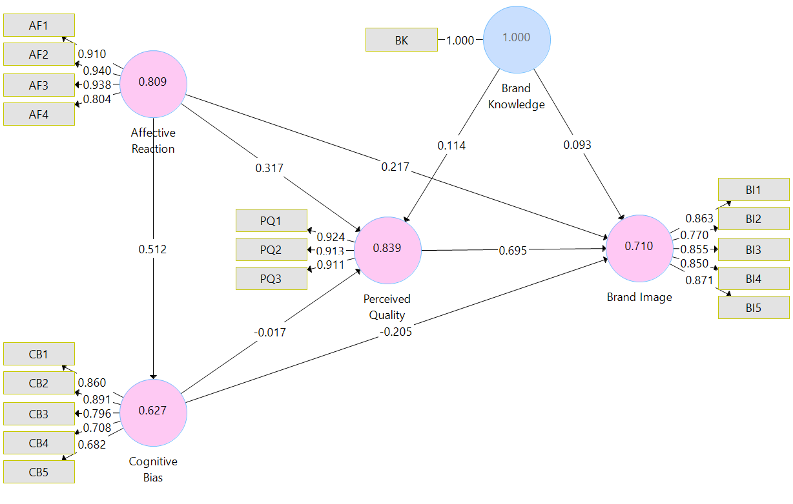

Fig. 3 - PLS-SEM estimates for Italy
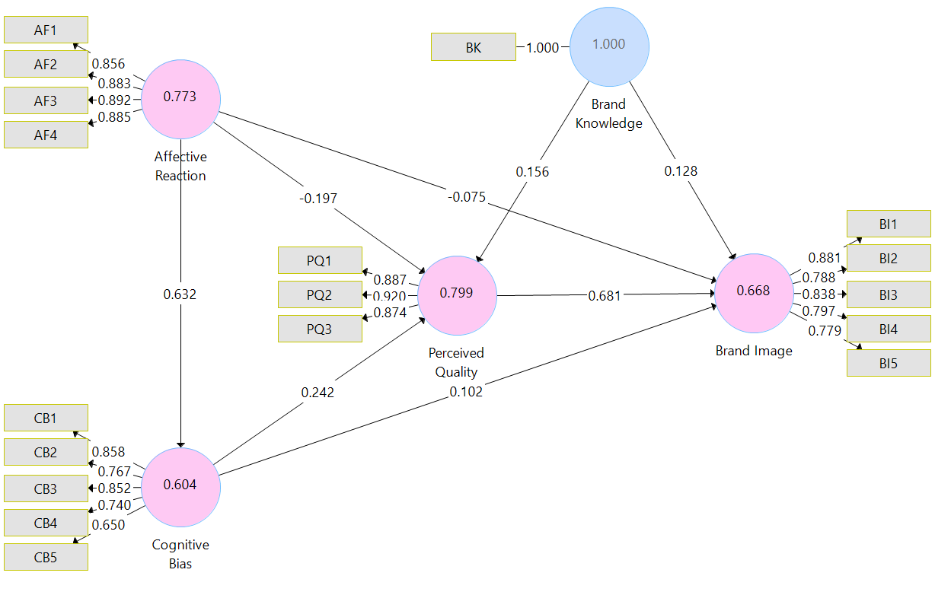
Table 4. Significance testing results of the structural model path coefficients
USA
HP | Path | Path coeff. | T-Statistic | P-Value | 2.5% Confidence interval | 97.5% Confidence interval | HP Testing
H1 | Affective Reaction→  Perceived Quality | 0.317 | 3.105 | 0.002** | 0.100 | 0.504 | H1 Supported
H2 | Affective Reaction →  Brand Image | 0.217 | 2.783 | 0.005* | 0.061 | 0.364 | H2 Supported
H3 | Cognitive Bias →  Perceived Quality | -0.017 | 0.174 | 0.862 | -0.196 | 0.182 | H3  Rejected
H4 | Cognitive Bias →  Brand Image | -0.205 | 3.609 | 0.000** | -0.314 | 0.089 | H4  Rejected
H5 | Perceived Quality →  Brand Image | 0.695 | 14.740 | 0.000** | 0.594 | 0.777 | H5 Supported
H6 | Affective Reaction →  Cognitive Bias | 0.512 | 8.174 | 0.000** | 0.384 | 0.629 | H6 Supported
Control variables |  | Path coeff. | T-Statistic | P-Value | 2.5% Confidence interval | 97.5% Confidence interval | Significance
Brand Knowledge → Perceived Quality |  | 0.114 | 1.554 | 0.120 | -0.025 | 0.260 | Not sig.
Brand Knowledge → Brand Image |  | 0.093 | 1.741 | 0.082 | -0.009 | 0.201 | Not sig.
ITALY
H1 | Affective Reaction→  Perceived Quality | -0.197 | 2.789 | 0.005* | -0.341 | -0.060 | H1 Supported
H2 | Affective Reaction →  Brand Image | -0.075 | 1.366 | 0.172 | -0.179 | 0.039 | H2 Supported
H3 | Cognitive Bias →  Perceived Quality | 0.242 | 2.922 | 0.003** | 0.080 | 0.407 | H3 Supported
H4 | Cognitive Bias →  Brand Image | 0.102 | 1.653 | 0.098 | -0.026 | 0.218 | H4  Rejected
H5 | Perceived Quality →  Brand Image | 0.681 | 20.807 | 0.000** | 0.616 | 0.744 | H5 Supported
H6 | Affective Reaction →  Cognitive Bias | 0.632 | 18.298 | 0.000** | 0.566 | 0.700 | H6 Supported
Control variables |  | Path coeff. | T-Statistic | P-Value | 2.5% Confidence interval | 97.5% Confidence interval | Significance
Brand Knowledge → Perceived Quality |  | 0.156 | 2.670 | 0.008* | 0.043 | 0.270 | Sig.
Brand Knowledge → Brand Image |  | 0.128 | 3.108 | 0.002** | 0.047 | 0.207 | Sig.
*p<0.10; **p<0.01.

5. Discussion and conclusions
The results of this study enhance available knowledge about the processes through which domestic and foreign consumers develop brand quality and image perceptions of the same global retail brand. First, this analysis confirms that for both domestic and foreign consumers perceived quality of a global brand is a strong antecedent of brand image (Xie et al., 2015). This is consistent with the trend of many retail brands towards an enhancing of perceived quality (Jara & Cliquet, 2012). Perceived quality plays a pivotal role in determining the success of a retail brand in terms of brand image and loyalty (Rondán Cataluña et al., 2006)
While this study confirms that the effect of perceived quality on brand image is consistent across countries, new evidence emerged regarding the impact of ethnocentrism. First, this research highlights that in the home country ethnocentrism directly influences both perceived quality and brand image. On the contrary, in a new foreign country where the retailer is going to enter ethnocentrism has significant direct impacts only on perceived brand quality but not on brand image. This finding extends previous knowledge regarding consumer elaboration of cues about the origin of a product, suggesting that in new countries ethnocentrism operates through a “halo effect” which is used as a proxy variable to infer perceived quality and, in turn, brand image (Nielsen & Spence, 1997).
Second, the adoption of the new conceptualization of ethnocentrism suggested by Sharma (2015) based on the distinction between the affective and cognitive components has revealed that the two dimensions have different and unexpected results on perceived brand quality and brand image. As expected, the affective component (affective reaction) has positive effects in the home country and negative effects in the new foreign country. However, the cognitive component (cognitive bias) positively influences perceived brand quality in the new foreign country and negatively affect the brand image in the home country.
This result may be to a certain extent explained by considering that previous research about ethnocentrism has largely focused on goods and not on services and available findings mostly refer to consumer attitudes toward consuming domestic versus imported goods. The case of services is different as they are not produced in the home country and then exported but they are provided locally in each foreign market, mostly by local employees, and the inputs (in this case mainly the coffee) may not be provided by the home country (in this case of Starbucks, the coffee beans are purchased in Latin America, Africa, and Asia). Therefore, when consumers apply cognitive efforts, the distinction between the home market and foreign markets may become blurred, and the retailer may be perceived less ‘domestic’ by domestic consumers and less ‘foreign’ by foreign consumers.
In sum, ethnocentrism may simultaneously have both positive and negative effects on brand outcomes through its affective and cognitive components. This result may also explain while previous research using the traditional unidimensional conceptualizations of ethnocentrism did not find significant effects. This may be a result of the co-existence of positive and negative effects, with similar magnitudes, exerted by the affective and cognitive components of ethnocentrism.
Finally, this research enriches previous research which has not considered that when a well-established global retail brand enters a new foreign market, local consumers may have already spontaneously developed attitudes toward that brand.
For companies, knowing the routes through which consumers develop the brand image in the domestic and a new foreign market is fundamental to design their branding strategies. For example, a global retailer may leverage the positive effects of the cognitive component in the foreign market, by communicating that it is creating new local jobs and wealth for the local community by purchasing from local suppliers. In fact, while it may be difficult to directly counteract the negative affective reactions, the firm could more easily act on the cognitive component of ethnocentrism.
Of course, branding strategies may need adjustments once local consumers gain more direct knowledge about the brand, as the significant effect of the control variable ‘brand knowledge’ seems to suggest. However, this study has adopted a cross-section approach, collecting data in a foreign market right before the market entry of the retailer. This represents a limitation of this research and an opportunity for future studies. Similarly, only consumers from two markets were compared and only one retailer was considered. Extending the analysis to other countries (and other retailers) is recommended to better evaluate the generalisability of this finding.

References
Aaker, D. A. (1992), "The value of brand equity", Journal of Business Strategy, Vol. 13 No. 4, pp. 27-32.
Acharya, C. and Elliott, G. (2003), "Consumer ethnocentrism, perceived product quality and choice—An empirical investigation", Journal of International Consumer Marketing, Vol. 15 No. 4, pp. 87-115.
Alexander, N. and Myers, H. (2000), "The retail internationalisation process", International Marketing Review, Vol. 17 No. 4/5, pp. 334-353.
Baker, J., Grewal, D. and Parasuraman, A. (1994), "The influence of store environment on quality inferences and store image", Journal of the Academy of Marketing Science, Vol. 22 No. 4, pp. 328-339.
Balabanis, G. and Diamantopoulos, A. (2004), "Domestic country bias, country-of-origin effects, and consumer ethnocentrism: a multidimensional unfolding approach", Journal of the Academy of Marketing Science, Vol. 32 No. 1, pp. 80-95.
Brettel, M., Engelen, A., Heinemann, F. and Vadhanasindhu, P. (2008), "Antecedents of market orientation: A cross-cultural comparison", Journal of International Marketing, Vol. 16 No. 2, pp. 84-119.
Burt, S., Davies, K., Dawson, J. and Sparks, L. (2008), "Categorizing patterns and processes in retail grocery internationalisation", Journal of Retailing and Consumer Services, Vol. 15 No. 2, pp. 78-92.
Burt, S., Dawson, J. and Sparks, L. (2003), "Failure in international retailing: research propositions", The International Review of Retail, Distribution and Consumer Research, Vol. 13 No. 4, pp. 355-373.
Burt, S. and Mavrommatis, A. (2006), "The international transfer of store brand image", International Review of Retail, Distribution and Consumer Research, Vol. 16 No. 4, pp. 395-413.
Carpenter, J. M., Moore, M., Alexander, N. and Doherty, A. M. (2013), "Consumer demographics, ethnocentrism, cultural values, and acculturation to the global consumer culture: A retail perspective", Journal of Marketing Management, Vol. 29 No. 3-4, pp. 271-291.
Cleveland, M., Laroche, M. and Papadopoulos, N. (2009), "Cosmopolitanism, consumer ethnocentrism, and materialism: An eight-country study of antecedents and outcomes", Journal of International Marketing, Vol. 17 No. 1, pp. 116-146.
Diallo, M. F. and Seck, A. M. (2018), "How store service quality affects attitude toward store brands in emerging countries: Effects of brand cues and the cultural context", Journal of Business Research, Vol. 86, pp. 311-320.
Evans, J. and Bridson, K. (2005), "Explaining retail offer adaptation through psychic distance", International Journal of Retail & Distribution Management, Vol. 33 No. 1, pp. 69-78.
Evans, J., Bridson, K., Byrom, J. and Medway, D. (2008), "Revisiting retail internationalisation: Drivers, impediments and business strategy", International Journal of Retail & Distribution Management, Vol. 36 No. 4, pp. 260-280.
Grewal, D., Baker, J., Levy, M. and Voss, G. B. (2003), "The effects of wait expectations and store atmosphere evaluations on patronage intentions in service-intensive retail stores", Journal of retailing, Vol. 79 No. 4, pp. 259-268.
Hair, J. F., Risher, J. J., Sarstedt, M. and Ringle, C. M. (2019), "When to use and how to report the results of PLS-SEM", European Business Review, Vol. 31 No. 2, pp. 2-24.
Hair, J. F., Sarstedt, M., Ringle, C. M. and Gudergan, S. P. (2018), Advanced Issues in Partial Least Squares Structural Equation Modeling, SAGE Publications, Thousand Oaks, CA.
Hair, J. F., Sarstedt, M., Ringle, C. M. and Mena, J. A. (2012), "An Assessment of the Use of Partial Least Squares Structural Equation Modeling in Marketing Research", Journal of the Academy of Marketing Science, Vol. 40 No. 3, pp. 414-433.
Henseler, J., Ringle, C. M. and Sarstedt, M. (2015), "A New Criterion for Assessing Discriminant Validity in Variance-based Structural Equation Modeling", Journal of the Academy of Marketing Science, Vol. 43 No. 1, pp. 115-135.
Henseler, J., Ringle, C. M. and Sarstedt, M. (2016), "Testing Measurement Invariance of Composites Using Partial Least Squares", International Marketing Review, Vol. 33 No. 3, pp. 405-431.
Henseler, J., Ringle, C. M. and Sinkovics, R. R. (2009), "The Use of Partial Least Squares Path Modeling in International Marketing", in Sinkovics, R. R. and Ghauri, P. N. (Eds.), Advances in International Marketing. Emerald Bingley, pp. 277-320.
Hyun, S. S. (2009), "Creating a model of customer equity for chain restaurant brand formation", International Journal of Hospitality Management, Vol. 28 No. 4, pp. 529-539.
Jara, M. and Cliquet, G. (2012), "Retail brand equity: conceptualization and measurement", Journal of Retailing and Consumer Services, Vol. 19 No. 1, pp. 140-149.
Jonsson, A. and Foss, N. J. (2011), "International expansion through flexible replication: Learning from the internationalization experience of IKEA", Journal of International Business Studies, Vol. 42 No. 9, pp. 1079-1102.
Kang, J.-W. and Namkung, Y. (2018), "The effect of corporate social responsibility on brand equity and the moderating role of ethical consumerism: The case of Starbucks", Journal of Hospitality & Tourism Research, Vol. 42 No. 7, pp. 1130-1151.
Keller, K. L. (1993), "Conceptualizing, measuring, and managing customer-based brand equity", Journal of Marketing, Vol. 57 No. 1, pp. 1-22.
Kirmani, A. and Zeithaml, V. (1993), "Advertising, perceived quality, and brand image", in Aaker, D. A. and Biel, A. L. (Eds.), Brand equity & advertising: Advertising's role in building strong brands. Psychology Press, pp. 143-161.
Kjeldgaard, D. and Ostberg, J. (2007), "Coffee grounds and the global cup: Glocal consumer culture in Scandinavia", Consumption Markets & Culture, Vol. 10 No. 2, pp. 175-187.
Kwon, W.-S. and Lennon, S. J. (2009), "Reciprocal effects between multichannel retailers’ offline and online brand images", Journal of Retailing, Vol. 85 No. 3, pp. 376-390.
Liu, S., Perry, P., Moore, C. and Warnaby, G. (2016), "The standardization-localization dilemma of brand communications for luxury fashion retailers' internationalization into China", Journal of Business Research, Vol. 69 No. 1, pp. 357-364.
Nielsen, J. A. and Spence, M. T. (1997), "A test of the stability of the CETSCALE, a measure of consumers’ ethnocentric tendencies", Journal of Marketing Theory and Practice, Vol. 5 No. 4, pp. 68-76.
Pappu, R. and Quester, P. (2006), "A consumer-based method for retailer equity measurement: Results of an empirical study", Journal of Retailing and Consumer Services, Vol. 13 No. 5, pp. 317-329.
Patterson, P. G., Scott, J. and Uncles, M. D. (2010), "How the local competition defeated a global brand: The case of Starbucks", Australasian Marketing Journal (AMJ), Vol. 18 No. 1, pp. 41-47.
Rigdon, E. E. (2012), "Rethinking Partial Least Squares Path Modeling: In Praise of Simple Methods", Long Range Planning, Vol. 45 No. 5–6, pp. 341-358.
Ringle, C. M., Wende, S. and Becker, J.-M. (2015), "SmartPLS 3", in. SmartPLS, Bönningstedt.
Rondán Cataluña, F. J., García, A. N. and Phau, I. (2006), "The influence of price and brand loyalty on store brands versus national brands", Int. Rev. of Retail, Distribution and Consumer Research, Vol. 16 No. 4, pp. 433-452.
Sharma, P. (2015), "Consumer ethnocentrism: Reconceptualization and cross-cultural validation", Journal of International Business Studies, Vol. 46 No. 3, pp. 381-389.
Shimp, T. A. and Sharma, S. (1987), "Consumer ethnocentrism: construction and validation of the CETSCALE", Journal of marketing research, Vol. 24 No. 3, pp. 280-289.
Shmueli, G. and Koppius, O. R. (2011), "Predictive analytics in information systems research", MIS Quarterly, Vol. 35 No. 3, pp. 553-572.
Siamagka, N.-T. and Balabanis, G. (2015), "Revisiting consumer ethnocentrism: review, reconceptualization, and empirical testing", Journal of International Marketing, Vol. 23 No. 3, pp. 66-86.
Singh, N., Fassott, G., Chao, M. C. and Hoffmann, J. A. (2006), "Understanding international web site usage: A cross-national study of German, Brazilian, and Taiwanese online consumers", International Marketing Review, Vol. 23 No. 1, pp. 83-97.
Supphellen, M. and Rittenburg, T. L. (2001), "Consumer ethnocentrism when foreign products are better", Psychology & Marketing, Vol. 18 No. 9, pp. 907-927.
Tingchi Liu, M., Anthony Wong, I., Shi, G., Chu, R. and L. Brock, J. (2014), "The impact of corporate social responsibility (CSR) performance and perceived brand quality on customer-based brand preference", Journal of Services Marketing, Vol. 28 No. 3, pp. 181-194.
Xie, Y., Batra, R. and Peng, S. (2015), "An extended model of preference formation between global and local brands: The roles of identity expressiveness, trust, and affect", Journal of International Marketing, Vol. 23 No. 1, pp. 50-71.
Zarkada-Fraser, A. and Fraser, C. (2002), "Store patronage prediction for foreign-owned supermarkets", International Journal of Retail & Distribution Management, Vol. 30 No. 6, pp. 282-299.

