CONCEPT FOR SELECTING AND INTEGRATING TRACEABILITY SYSTEMS IN THE CONTINUOUS IMPROVEMENT PROCESS OF SMEs

Christian Kern; Robert Refflinghaus, Tim Trostmann
University of Kassel; Department of Quality and Process Management;
Germany
kern@uni-kassel.de; refflinghaus@uni-kassel.de; trostmann@uni-kassel.de

Sigrid Wenzel, Nicolas Wittine, Florian Herrlich
University of Kassel; Department of Organization of Production and Factory Planning; Germany
s.wenzel@uni-kassel.de; nicolas.wittine@uni-kassel.de

Abstract

Industry 4.0 is characterized by digitization, globalized markets and a growing demand for individualized products. Therefore, the success of manufacturing companies heavily relies on innovative and customer driven products. However, the industrializing phase of such products is often characterized by the occurring of errors originating in a lack of experience. If errors are not detected prior to delivery, costs will increase considerably (e.g. expensive product recalls). Traceability systems can clearly identify the manufacturing processes causing the errors and have the potential to control quality and cost risks. However, they are only rarely used in small and medium-sized enterprises (SMEs).
This paper presents a concept that should enable SMEs to select the most appropriate traceability solution for their respective field of application. In this context, a procedure model based on a selection process is discussed, which empowers SMEs to map their products and processes to pre-defined reference products and processes. The corresponding selection process considers multiple criteria as well as user-specific weightings.

Keywords Expensive recalls; traceability of products; traceability systems; selection; continuous improvement; process optimization

- Introduction

Product recalls due to quality issues can lead to high costs and result in a massive loss of image for the company concerned. In literature, there are many examples regarding the topic of recalls. In this context, the websites produktrückrufe.de and recalls.gov provide a comprehensive overview of current recalls inside Germany and abroad (Pro, 2019; Rec, 2019).
An illustrative example is the airbag recall of the manufacturer Takata in 2015, which has been one of the biggest recalls in the history of the car industry (FAZ, 2015). So far, more than 50 million airbags have been recalled by Takata worldwide because the inflators could explode and propel metal fragments. Because the root cause could not be identified quickly enough, in connection with the poor quality of these airbags hundreds of injured persons and 10 deaths were recorded. Furthermore, the recall caused costs of at least 24 billion dollars (Handelsblatt, 2016).
There are indications that the number of recalls will rather increase than decrease in the near future. Shortened product life cycles and rapid development times as a result of growing competition amplify the risk of product launches that are not fully matured. Moreover, due to expanding interdisciplinary and company-wide cooperation between suppliers and manufacturers, the identification of root causes and the elimination of errors becomes increasingly complex. Thus, there is a high probability that, in the case of a systematic failure in the production process, both the causes and consequences of the failure cannot be detected quickly and accurately enough (Luft, 2010). The forecasted scenario has now occurred and from 2010 to 2017 recalls and RAPEX (Rapid Exchange of Information System) notifications have more than doubled (Baua, 2018).
In order to ensure zero-defect production and to strengthen their competitive position, it will be essential for manufacturing companies to limit the number of affected components as far as possible if errors occur. In order to be able to detect errors in the production process quickly and to minimize the warranty costs that the manufacturer has to pay in case of recourse, an intensification of quality assurance along the entire value added chain is required. This can be achieved, for example, by the use of traceability systems, which enable the manufacturer to trace and track the entire manufacturing process accurately. With the help of these systems, errors can be analyzed and eliminated directly at the point of origin in the future.
Through the use of traceability systems, a significant reduction of future errors and associated costs can be realized. In addition, a company-specific traceability system offers companies the opportunity to achieve a significant and sustainable optimization of their entire production processes. These both have a positive effect on the quality of the company's products and its image (Aiello, 2015).
Although SMEs could immensely benefit from the advantages outlined above, they seldom use those systems today unlike large companies. In this regard, an online survey on the dissemination and the application areas of traceability systems in business practice conducted by the authors of this paper in 2018 revealed a significant discrepancy between large enterprises and SMEs (Chaves, 2018).
89 percent of major companies participating in the survey used technical solutions to trace and track manufactured products and components, while only 33 percent of the SMEs applied the technology. In this context, financial obstacles like high costs and the challenge to overcome the technological gap between different systems as well as a lack of market transparency in terms of the available solutions represent the most frequently cited reasons for the low degree of utilization of traceability systems in SMEs. The questionnaire also revealed significant differences between large enterprises and SMEs in terms of the operational reasons. While large companies use traceability solutions to identify error-prone components of a product at an early stage of the production process, SMEs mainly use traceability systems to obtain a certification or to fulfil customer requirements. However, the identification of faulty components, the rapid limitation of errors and process improvements based on the collected data are not yet prioritized by SMEs.
The results of the online survey clearly showed that SMEs need support regarding traceability systems, especially due to the fact that SMEs use traceability systems mainly out of external constraints up to now. In order to overcome the identified obstacles this paper presents a concept that enables SMEs to select the most appropriate traceability solution for their specific business needs. Additionally, it demonstrates the benefits of traceability systems on an application-specific level.

- Traceability - definitions and drivers

DIN EN ISO 9001:2015, which describes the requirements for a quality management system, provides a comprehensive definition of traceability that is valid across several industry sectors. It states that organizations clearly have to identify their products and services with appropriate engineering tools as long as it is necessary to ensure their conformity with specified requirements. Furthermore, all information on quality checks and their results must be documented and stored in order to ensure traceability. Thus, traceability is the ability to identify the history, application and location of an object. In addition to products and services, the associated logistical processes must always be taken into account. When considering a product or a service, traceability can thus relate to the source of materials and parts, the history of processing and the distribution of a product or service after delivery (DIN 9000, 2015).
Depending on the analysis direction, a distinction can be made between forward traceability and backward traceability. Forward traceability (tracking) includes a documentation of production data and logistics data such as batch number, order lot and customer data in order to be able to identify problematic components in already produced products in the event of an error. In contrast, backward traceability (tracing) includes the documentation of the entire supply chain (e.g. suppliers, serial and part numbers, manufacturing date, production steps) and is mainly used to detect and evaluate the causes of errors in case of a product recall (Bosana, 2013). According to (Schwägele, 2005) traceability refers to both tracking and tracing, so traceability is not only a unidirectional activity in the supply chain (cf. Figure 1).

Figure 1: Conceptual representation of traceability types

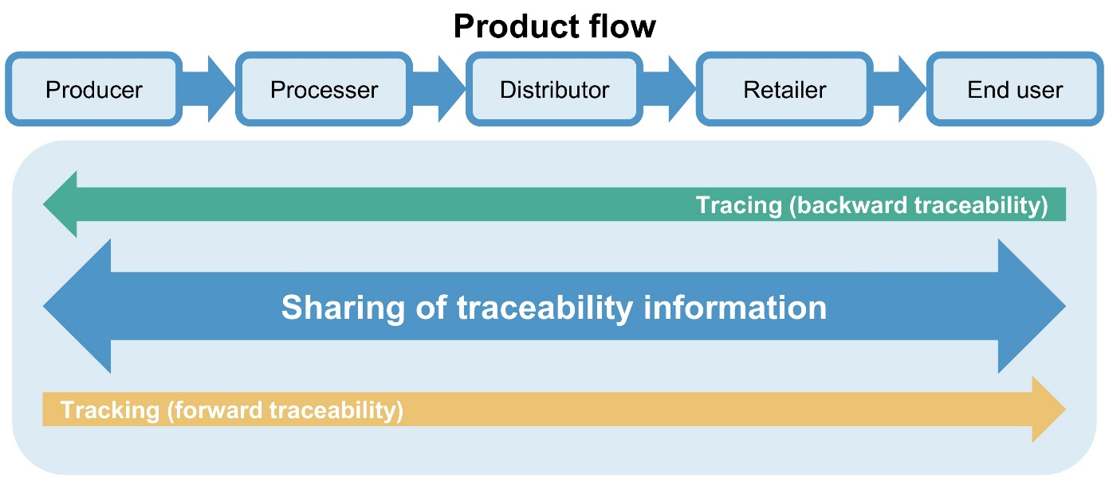

Source: (Bosona, 2013)

The need to ensure gapless and efficient traceability can arise from a variety of reasons (cf. Figure 2). Current supply chains are long and complex. They often intersect with a multitude of other supply chains, making traceability a multi-party challenge. For several industry sectors, there are sector-specific legal requirements that originate from EU directives and have been transposed into national law (Luft, 2010). In addition, traceability is also an essential element in certain certification standards. For example, there are industry-specific regulations for the feed and food chain as well as for medical devices. In this context, the standard DIN EN ISO 22005 describes the principles for the development and implementation of a feed and food traceability system and defines requirements for designing and implementing traceability solutions along the corresponding supply chain (DIN 22005, 2007). In contrast, the medical device industry standard DIN EN ISO 13485 formulates criteria for an organization to demonstrate that its quality management system is capable of constantly guiding and directing the life cycle of medical devices and related activities to meet customer needs and needs of relevant authorities (DIN 13485, 2016). Further industry-specific standards and guidelines exist for the aerospace industry and the automotive industry. In this context, DIN EN 4800 defines requirements regarding traceability for the aerospace industry, but does not specify how traceability should be regulated in detail (DIN 4800, 2011). For the automotive industry, VDA 5005 deals with traceability of vehicle parts by recommending and defining consistent processes throughout the supply chain (VDA 5005, 2005). Furthermore, DIN EN 16570 specifies basic requirements for a transport label that can be used across all industry sectors and which links products and information required for traceability purposes (DIN 16570, 2014).

Figure 2: Traceability drivers

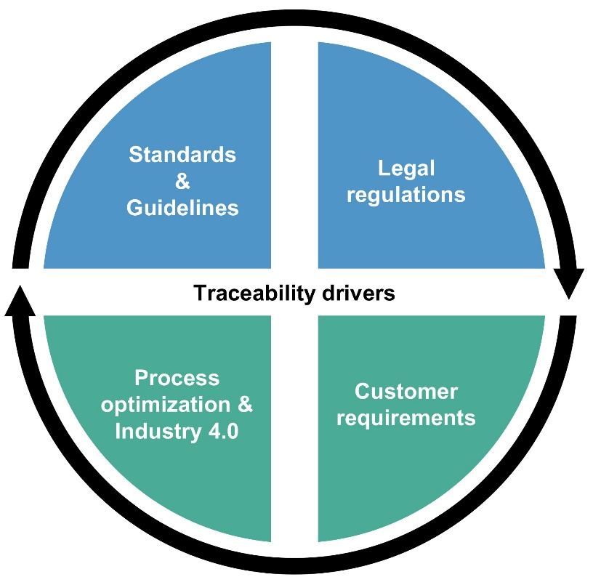

Source: Own Elaboration

Even if there are no legal requirements for some industry sectors and traceability is not always required for a desired certification, customers are increasingly demanding traceability systems. Market pressures and new regulations are among the drivers of traceability. Frequently changing customer requirements, however, hinder the introduction.
Furthermore, traceability solutions also play a major role in Industry 4.0. A digital product memory is one of the key requirement of Industry 4.0. Thereby, smart products can collect data continuously during the manufacturing process and then communicate it to the company's information systems (Stich, 2015). There is also a need to track workpieces and containers within Computer Integrated Manufacturing (CIM). Concerning this issue, traceability of material and visibility of information are fundamental aspects to achieve efficiency goals in the entire value chain while maintaining flexibility. It is mainly this flexibility that will be an important success factor for SMEs in the future because they predominantly manufacture according to the principle of workshop production. Therefore, they often produce only small quantities of a specific product variant (Huang, 2007).

- Traceability systems - structure and solutions

The functionality of a traceability system requires that the flow of information is linked to the physical flow of goods. This coupling is usually done by using access keys that include relevant information about the unit under consideration (e.g. batch, manufacturing date, employees involved). Although different variants of traceability systems exist, it should be noted that all systems essentially contain the core elements “identification”, “data collection and data recording”, “data linking” and “communication” (Luft, 2010) (cf. Figure 3).

Figure 3: Core elements of a traceability system

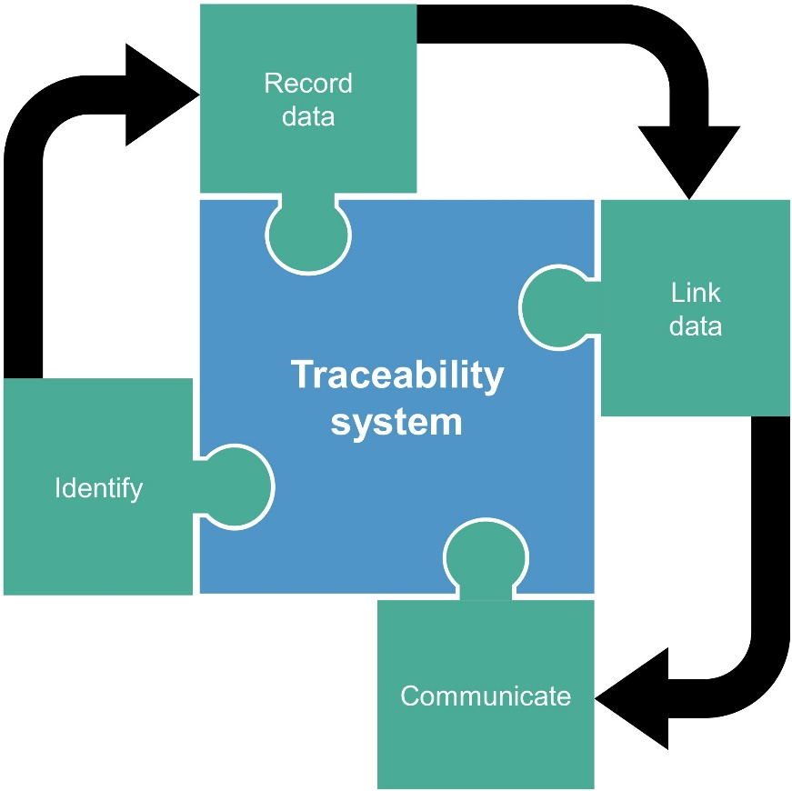

Source: Own Elaboration

In this context, the term identification describes the labeling of a unit for an effective traceability. Typically, the unit could be labeled with a batch number that marks a certain amount of products which were produced under exactly the same conditions (Alfaro, 2009).
For data collection and data recording numbering systems are used, which are usually implemented in so-called Auto-ID solutions (automatic identification solutions). Examples of Auto-ID solutions are barcodes and RFID chips (radio-frequency identification).
Once the relevant data has been recorded, it must be securely archived in order to guarantee fast and error-free access using previously defined identification information. In this context, it is very important that every company involved in the product development process exactly defines what data needs to be collected and recorded at all stages of the value chain (Hua, 2012; Wang, 2014). In this way, traceability enables the access to relevant data making substantiated decisions possible. Consequently, data accessibility is the key to achieve precision within the following data analysis. It involves gathering and reporting detailed information about every important event throughout the whole supply chain.
The core element “data linking” of a traceability system expresses that all previously collected and recorded traceability data must be linked in order to allow a continuous and complete traceability of a product. Data collected previously can be used in many different ways, e.g. to improve operations or to reveal seemingly unrelated phenomena (Luft, 2010).
In contrast, the last key element “communication” mainly affects the continuity of the information flow between all traceability partners within a supply chain. Once the data has been identified, recorded and linked, it must be purposefully communicated among the value-adding partners by transmitting all relevant data to the next company of the supply chain.
Overall, there are a multitude of providers in the traceability market both in the area of traceability hardware and in the area of software solutions for processing and evaluating the information collected by a traceability system. In the field of hardware RFID, data matrix codes and barcode systems, which enable capturing and processing production and logistics data over the entire value chain, become increasingly important. A current factor influencing the spread of these technologies is the steadily decreasing prices of procurement and maintenance (Bischoff, 2015).
In the field of traceability software, the traceability solutions from iTAC and Siemens/IBS represent the best-known and currently most widespread traceability systems. Owned by Siemens, IBS is a provider of Computer Aided Quality systems (CAQ). Also other CAQ providers like the market leader Böhme & Weihs Systemtechnik offer traceability modules or can integrate third-party traceability software into their software systems by using standardized interfaces. In addition, numerous vendors of ERP (Enterprise Resource Planning) systems and MES (Manufacturing Execution System) offer interfaces and modules for an easy integration of external traceability solutions (Kletti, 2015). The contributions of Lindemann and Theuer provide a good overview on traceability solutions freely available on the market (Lindemann, 2015; Theuer, 2014).

- Benefits of traceability and challenges for SMEs

Traceability has become a strategic goal for companies around the world. On the one hand, traceability systems support quality assurance by being able to track and trace quality defects. On the other hand, they provide valuable production data and material flow data that can be used both to improve production processes and logistics (Hua, 2012). In addition to an increase of supply chain quality, efficiency and transparency, the sharing of traceability data also enables the development of solutions that enhance supply chain security and safety. If individual products collect data and independently communicate with higher-level systems, production processes can be improved and controlled in real time. The condition of individual products can be monitored and optimized at each stage of the production process (Stich, 2015). Thus, the recording of production and process data will also lead to a continuous optimization of production processes in SMEs. Thereby, an increase of efficiency as well as a decrease of error costs can be achieved.

In conclusion, traceability solutions for large companies as well as for SMEs can
- provide transparency across all production processes
- improve the quality of products
- determine the exact cause of error (root cause analysis)
- enable more precise planning
- enable fault-free delivery
- make production independent of human error
- meet the growing demands of customers
- fulfill standards and regulations as well as legal requirements
- enable item-based recall campaigns and therefore reduce the recall quantity
- reduce product liability risk
- prevent loss of image (Itac, 2019).
This contribution assumes that each SME will have individual objectives and goals when establishing traceability tools. However, to succeed, each organization will need to ensure that their systems are interoperable with systems of other organizations across their supply chains. Consequently, every SME has to meet a multitude of internal and external technological and organizational traceability requirements.
Admittedly, in developing and implementing a traceability system SMEs are confronted with some barriers. An online survey on the dissemination and the application areas of traceability systems in business practice conducted by the authors in the run-up to this paper (cf. (Chaves, 2018) showed that these barriers can be attributed to four main problem areas (cf. Figure 4).

Figure 4: Problem areas when introducing a traceability system

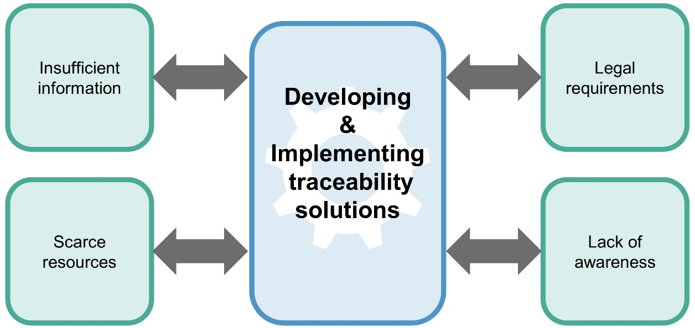

Source: Own Elaboration

One of the most important challenges that SMEs may face in adopting traceability schemes is the lack of resources and management capacity regarding technology, know-how, skilled labor and financial resources (Wadhwa, 2013). In view of the resource constraints of SMEs, developing and implementing traceability systems is an expensive and complicated task. Additionally, it also requires much administration and paper work, especially for companies implementing a traceability system for the first time (Kher, 2010).
The scarce resources of SMEs could also lead to a lack of awareness and initial resistance against the implementation of a traceability system in the relevant company or among some partners of the supply and value chain. Therefore, traceability solutions for SMEs have to be cost effective and user friendly both in implementing and operating (Salampasis, 2012).
Furthermore, for SMEs the challenges of traceability may include contractual requirements. In this context, traceability in the supply chain is becoming essential for the assurance of compliance with laws and regulations. Insufficient observance of these demands can adversely affect the financial and reputational standing of SMEs (Bonsana, 2013; Chaves, 2018).
With regard to information problems SMEs are often confronted with a lack of complete, accurate, timely, and easily accessible product and process information (Wadhwa, 2013). Moreover, due to the variety of solutions, SMEs are often unaware of the systems currently available on the market and how they differ from each other. Therefore, it is difficult for SMEs to select the most suitable traceability solution for their respective field of application as well as to identify the data needed for achieving robust traceability, especially regarding liability concerns (Chaves, 2018).

- SME-specific concept for selecting and integrating traceability systems

As shown before, traceability solutions represent an important and fundamental part of industrial production processes and should be implemented more consistently in SMEs in the future. This issue is supported by an industrial survey in 2010 studying the views on traceability systems of 38 risk management professionals in Europe. It turned out, that all experts finally agreed that the benefits of implementing a traceability system outweigh its disadvantages (e.g. initial investment cost and extra work load) also for SMEs (Kher, 2010).
When introducing a traceability system, companies usually have to decide which of the available systems on the market is the most suitable for their purpose. Regarding this selection process, (Jadhav, 2008) provides an overview of international scientific papers that address methods for selecting and evaluating software systems. In order to prepare the selection of an appropriate system, it is useful to create a company-specific requirements catalogue that contains all requirements on traceability and weights these requirements against each other (e.g. high system availability, high storage capacity, avoidance of redundant data). Depending on the identification technology decision-makers also have to consider possible risks and disruptive factors (e.g. robustness against environmental factors, interface problems between devices from different manufacturers).
SMEs tend to be more flexible by nature and even could have an advantage over larger enterprises with established hierarchies when introducing a traceability system. Nevertheless, an instrument tailored to the specific needs of SMEs to select and procure a suitable traceability system does not exist until now (Chaves, 2018). For this reason, the authors of this paper will develop and implement suitable solutions for SMEs within the framework of a research project funded by the German Ministry of Economics and Energy in the next two years.
By analyzing several products and processes of SMEs of the metalworking industry, it is intended to derive universal reference products and reference processes allowing SMEs to easily assign their own products and processes subsequently. On the basis of this classification, company-specific suggestions for suitable traceability solutions can then be derived automatically. The basic idea behind this is that the previously identified reference products can be compared with general criteria in order to select a traceability system within a software-based mapping process with little effort. It is expected that SMEs in future will be able to dispense on commercial advisory services for the selection and implementation of traceability systems through the developed selection tool. Thereby, in addition to the technical benefit, there will also be a significant economic advantage for SMEs.
In detail, the developed selection concept is divided into four subject areas, which in combination finally provide a methodology for selecting and integrating traceability systems in the continuous improvement process of SMEs (cf. Figure 5).

Figure 5: Selection process and tasks

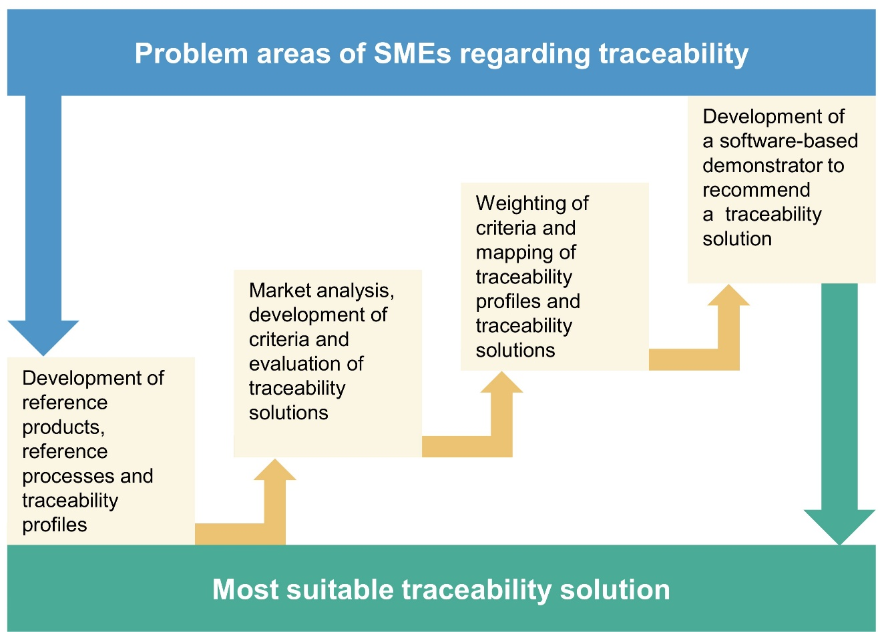

Source: Own Elaboration

In order to be able to evaluate traceability solutions with regard to their suitability for the products and processes in SMEs of the metalworking industry, a mapping of individual products and processes on a requirement profile for traceability (traceability profile) is required. Therefore, reference products and processes are derived from a multitude of case studies carried out in cooperation with industrial partners of the authors of this paper and their corresponding research institutions. For this purpose, the products and processes considered within the case studies are initially sorted in terms of their characteristics and properties. The derived reference products and processes will be characterized by common denominators (e.g. similar component geometry, similar production process, similar material flow).
In addition to the analysis of the identified references, suitable traceability profiles will be developed subsequently. A starting point could be the material that makes up a product, as it may affect the selection of the identification technology (e.g. barcode, data matrix code, RFID). On this basis, criteria for a suitable traceability solution are derived from the recorded characteristics and properties. Concerning the material of a product, an exemplary criterion could be the robustness of a traceability solution regarding metallic goods. Supplementary interviews and online surveys will finally lead to an in-depth substantiation and generalization of the identified reference products, reference processes and traceability profiles.
The second section of the selection process deals with the identification and evaluation of already existing traceability systems and solutions. After determining the corresponding systems or solutions by means of a market analysis, their properties will be analyzed. For this purpose, a subject-specific questionnaire divided into several chapters like “areas of application”, “technical implementation”, “scope of functions”, “extensibility”, “interfaces” and “costs” is currently in development. For each chapter, in reference to the developed traceability profiles, criteria for the goal-oriented evaluation of the identified traceability solutions will be developed (e.g. labeling technology, maintenance requirements and maintenance intervals, space requirements, integration into already existing processes). This also includes defining the ranges of values that different evaluation criteria can embrace. Within the market analysis, the identified traceability solutions will be examined regarding the degree of fulfillment of each individual evaluation criterion. Thus, the questionnaire and its evaluation will enable a differentiated comparative analysis of the functional range of traceability solutions available on the market. As the market for traceability systems is extensive, the market study will focus on the analysis of traceability modules of established CAQ systems and traceability solutions that offer innovative functionalities for improving internal and external logistical processes. Additionally, in order to keep the database up-to-date in the long term, in cooperation with the industrial partners of the research project a concept for periodic updates will be developed.
The next task of the proposed selection process deals with the mapping process and the associated suggestion of suitable traceability solutions. For this purpose, the selection tool queries specific information required for the execution of the following mapping process (e.g. type of products, material, transport containers, dimensions, process changes, upstream and downstream processes, interfaces to customers and suppliers). Subsequently, the collected information is automatically compared with the stored references and associated traceability profiles (cf. Figure 6).

Figure 6: Steps of the mapping process

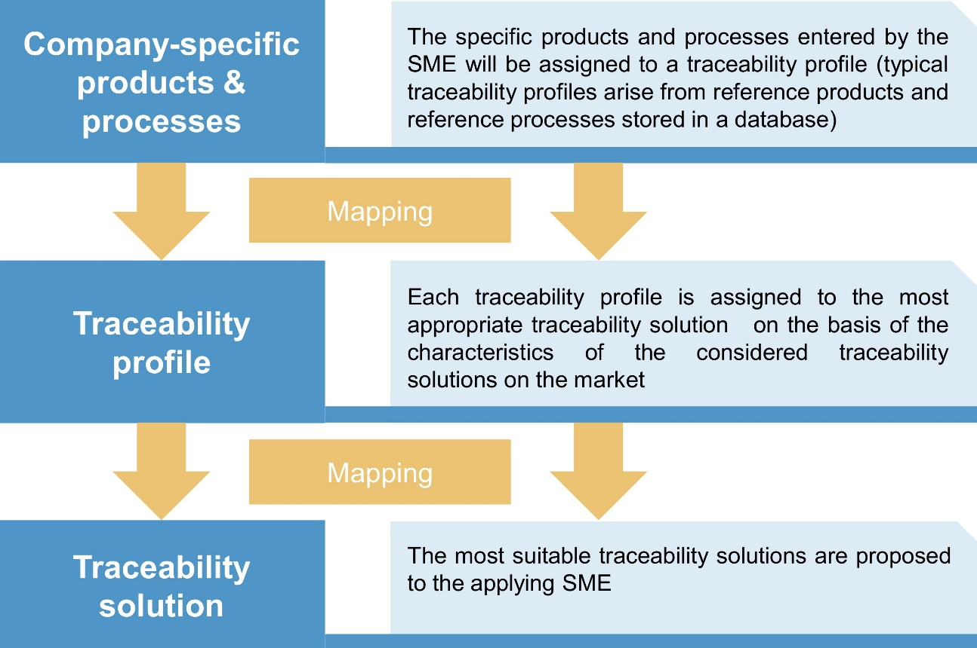

Source: Own Elaboration

The multi-stage algorithm illustrated in Figure 6 assigns the products and processes of any applying SME to a traceability profile. The appropriate traceability profile provides the foundation for the selection of the most suitable traceability solution. Thus, the mapping of available traceability solutions to the corresponding traceability profile bases on the fulfillment of all evaluation criteria summarized within the traceability profile.
Despite the assignment to reference products or processes each use case differs. For this reason, the methodology offers the opportunity to weight the individual criteria among each other and also to specify exclusion criteria (e.g. no weather resistance, high maintenance requirements). Finally, depending on the considered products or processes the mapping process can also result in assigning more than one suitable traceability solution. Furthermore, it might not be possible to fully match the criteria characteristics of the former identified reference products and processes adequately during the mapping process. In these cases the algorithm at least indicates the degree of correspondence with the most suitable traceability profiles. As a result, the proposed methodology provides the applying SME with the most appropriate traceability solution for its respective field of application.
However, SMEs can provide only limited human resources for introducing a traceability system in the enterprise and usually also do not have the appropriate expertise. They therefore have a special need for assistance when introducing traceability solutions. For this reason, case studies will demonstrate how the selected traceability solution can be both introduced and integrated into the company's process of continuous improvement. By incorporating traceability systems into the Continuous Improvement Process (CIP) of SMEs, a significant reduction of future errors and associated costs can be realized. This can subsequently reduce the damage of otherwise required extensive recalls. Consequently, a company-specific traceability system integrated into the CIP offers companies the opportunity to significantly improve their production processes as well as their problem-solving process. In this way they will be able to sustainably increase the quality of their manufacturing processes (Müller, 2015). Moreover, the data collected by a traceability system in SME could be used for improving internal and external logistic processes, for example by supervising stocks at different stations of the supply and value chain in real time from a central place.
After the concept for selecting and integrating traceability systems in the continuous improvement process of SMEs is fully developed and sufficiently tested, the developments will be incorporated into a software-based demonstrator. Starting with the definition of the processes, the software demonstrator provides support from weighting the selection criteria right up to the selection of the appropriate solution. Subsequently, it helps to implement the selected solution in the ongoing operations. Through consecutive modules the user is directed through the analysis (e.g. selection and specification of products and processes, weighting and excluding of evaluation criteria, monetary evaluation). For additional usability and for guidance the progress is visualized step-by-step. Regular updates will increase the number of case studies and add useful extension as well as expand the knowledge database regarding traceability solutions.
In the course of practical application, the software-demonstrator will be evaluated regarding its acceptance and suitability for an autonomous use by employees in SMEs of the metalworking industry. The feedback gained will then be used for enhancements and necessary adjustments on the way to a saleable software tool. The final aim is to design the methodology in such a way that it is able to replace commercial consulting services in the long term.

- Conclusion

This paper dealt with benefits and challenges of traceability systems for SMEs. In this context, it introduced a methodology that helps SMEs to select and implement traceability solutions that exactly fit their specific requirements. The concept designed within this article, even though exemplarily for the metalworking industry, can be universally applied across industries and products. The developed principles could be applied to supply chains across many sectors, including food and beverage, metalworking, pharmaceuticals, medical devices, technical equipment and components. Furthermore, the designed selection tool is also technology neutral. It is based on the foundational principles of a traceability system (identify, capture, share and communicate) and enables the consideration of a variety of data capture and data sharing technologies.
With the help of the developed concept the difficulties for SMEs previously associated with the introduction of a traceability system (e.g. confusing market situation, lack of know-how or personnel capacity) can significantly be mitigated or even eliminated. As a result, the introduced selection tool can help to increase the spread of traceability systems in SMEs by eliminating barriers and by reducing the need for human and financial resources. Furthermore, SMEs will be supported in the long term in achieving digital change and implementing Industry 4.0.

References

Aiello G., Enea M., Muriana C. (2015), “The expected value of the traceability information”, European Journal of Operational Research, Vol. 244, pp. 176-186.
Alfaro J.A., Rabade L.A. (2009), “Traceability as a strategic tool to improve inventory management”, International Journal of Production Economics, 118, 104-110.
Baua (2018), „Anzahl der deutschen Gefahrenmeldungen von Produkten in den Jahren von 2010 bis 2017“, URL: https://de.statista.com/statistik/daten/studie/783828/umfrage/anzahl-der-gefahrenmeldungen-von-produkten-in-deutschland/, last access on June 6, 2019
Bischoff J. (2015), “Erschließung der Potenziale der Anwendung von ‘Industrie 4.0’ im Mittelstand”, Agiplan: Mühlheim an der Ruhr.
Bosana T., Gebresenbet G. (2013), “Food traceability as an integral part of logistics management in food and agricultural supply chain”, Food Control, 33 (2013) 32-48.
Chaves D.P.F., Peter T. (2018), “Der Einsatz von Rückverfolgbarkeitssystemen in der Industrie - Ergebnisse einer Studie“, Kassel University Press: Kassel.
DIN EN ISO 4800-001:2011-06 (2011), “Aerospace series - Titanium and titanium alloys - Technical specification - Part 001: Plate, sheet and strip” Beuth-Verlag: Berlin.
DIN EN ISO 9000:2015-11 (2015), “Quality management systems - Fundamentals and vocabulary”, Beuth-Verlag: Berlin.
DIN EN ISO 13485:2016-08 (2016), “Medical devices - Quality management systems - Requirements for regulatory purposes”, Beuth-Verlag: Berlin.
DIN EN ISO 16570:2014-09 (2014), “Information technology - Notification of RFID - The information sign and additional information to be provided by operators of RFID application systems”, Beuth-Verlag: Berlin.
DIN EN ISO 22005:2007-10 (2007), “Traceability in the feed and food chain - General principles and basic requirements for system design and implementation”, Beuth-Verlag: Berlin.
Frankfurter Allgemeine Zeitung (FAZ) (2015), “Größte Rückrufaktion aller Zeiten”, URL: http://www.faz.net/aktuell/wirtschaft/unternehmen/rekord-rueckruf-wegen-takata-airbags-13602117.html, last access on May 14, 2019.
Handelsblatt (2016), “Airbag-Rückruf kann bis zu 24 Milliarden Dollar kosten”, URL: http://www.handelsblatt.com/unternehmen/industrie/takata-airbag-rueckruf-kann-bis-zu-24-milliarden-dollar-kosten/13380074.html, last access on May 14, 2019.
Hua J., Li X., Xia W., Liu Y. (2012), “Quality Traceability of MES Based on RFID”, Advances in Multimedia, Software Engineering and Computing, 129 (2), 649-654.
Huang G.Q., Zhang Y.F., Jiang P.Y. (2007), “RFID-based wireless manufacturing for real-time management of job shop”, International Journal of Advanced Manufacturing Technology, 36 (7-8), 752-764.
Itac Software Inc. (2019), “Complete traceability of products, components and lots”, URL: http://en.itac.de/pages/solutions/traceability/index.html, last access on May 20, 2019.
Jadhav A.S., Sonar R. M.: “Evaluating and selecting software packages: A review”, Information and Software Technology, 51 (2009), 555-563.
Kher S.V., Frewer L.J., De Jonge J., Wertholt M., Davies O. H., Luijckx, N. B. L. (2010), “Experts’ perspectives on the implementation of traceability in Europe”, British Food Journal, 112(2), 261-274.
Kletti J. (2015), “MES - Manufacturing Execution System. Moderne Informationstechnologie unterstützt die Wertschöpfung”, Springer Verlag: Berlin.
Lindemann M., Schmid S. (2015), “Manufactoring Execution Systems”, PPS Management, 10 (3), 55-67.
Luft T. (2010): “Traceability - Qualitätssicherung durch Rückverfolgbarkeit“, GRIN Verlag: München.
Müller S. (2015): “Manufacturing Execution Systeme (MES): Status Quo und Ausblick in Richtung Industrie 4.0“, Books on Demand: Norderstedt.
Produktrückrufe.de (2019), “Wissenswerte Informationen rund um Rückrufaktionen, Produktwarnungen, Sicherheitshinweise & mehr”, URL: http://produktrueckrufe.de/, last access on May 14, 2019.
Recalls.gov (2019), “The most recent recalls issued by federal regulatory agencies participating in recalls.gov”, URL: https://www.recalls.gov/recent.html, last access on May 14, 2019.
Salampasis M., Tektonidis D., Kalogianni, E. (2012), “TraceALL: a semantic web framework for traceability systems”, Journal of Systems and Information Technology, 14(4).
Schwägele F. (2005), “Traceability from a European perspective”, Meat Science, 71, 164-173.
Stich V., Lichtblau K., Bertenrath R., Blum M., Bleider M., Millack A., Schmitt K., Schmitz E., Schröter M. (2015), “Industrie 4.0 Readiness”, URL: http://www.impuls-stiftung.de/documents/3581372/4875823/Industrie+4.0+Readiness+IMPULS+Studie+Oktober+2015_eng.pdf/, last access on May 17, 2019.
Theuer H., Leo A.K. (2014), “Schlanke Produktion mit MES - 70 Systeme im Vergleich“, Productivity Management, 1 (2014), GITO: Berlin.

VDA 5005 (2005), “Traceability of vehicle components and identifiability of their technical design”, German Association of the Automotive Industry: Berlin.
Wadhwa R.S. (2013), “Traceability and Data Support in SME Manufacturing”, International Journal of Computer Science Issues, 10 (6-2), 69-77.
Wang K.S. (2014), “Intelligent and integrated RFID system for improving traceability in manufacturing”, Advances in Manufacturing, 2 (2014), 106-120.

This IGF Project 20205 N/1 of the Research Community for Quality (FQS), August-Schanz-Str. 21A, 60433 Frankfurt/Main is supported via AiF within the programme for promoting the Industrial Collective Research (IGF) of the German Ministry of Economics and Energy (BMWi), based on a resolution of the German Parliament.

