THE REASON LIES IN THE UNWILLINGNESS, THE INABILITY IS ONLY A PRETEXT (Seneca)
- DEVELOPMENT OF THE CREATIVE MODEL UGVOSS TO IMPLEMENTA SUCCESSFUL CHANGE MANAGEMENT –

Gabriele Hoeborn
University of Wuppertal, Interdisciplinary Center 3, Germany
ghoeborn@uni-wuppertal.de
Corresponding Author

Gerrit Hoeborn
RWTH Aachen
Gerrit.hoeborn@rwth-aachen.de

Petra Heinich
University of Applied Sciences Cologne, Germany
petra-heinich@t-online.de

Abstract
Changes need getting used to, changes trigger curiosity, changes are necessary, and changes trigger fear!
Change processes are very sensitive, but the methods used are often not. This article uses an example to describe the authors' approach to the introduction of a new project management system. The introduction of the new process system required major changes. These were not only within the processes, but also concerned the workplaces, the job descriptions and employee positions.
Because of these strong changes and the many fears associated with them, the authors went a very creative way to promote both the abilities and the will of those affected. The new process was learned with a serious game in a workshop. Through this playful framework and the development of a strong team spirit, the personal motivation was also strengthened at the same time as the ability to apply the new processes.
The following paper offers a description of the UGVOSS model and a well-done change management by using the model. The description and the results of a case study offer a verification of at the model and at the same time the possibility to evaluate the model.

Keywords
Change management, business transformation, creative methods, serious games

1 Introduction
In our private environment, as well as in our studies and profession, changes are always coming our way. In the professional context, changes are introduced that serve continuous improvement, the optimization of processes and procedures. These changes are usually indispensable for the orientation of the company and its competitive position on the market. These changes are introduced and implemented by a change management.
Change Management encompasses all tasks, measures and activities that must be carried out when introducing and changing processes, organizational structures, systems, strategies, values and behaviors/cultures in companies.
Changes cannot be prevented, the company needs a successful alignment and strategy, but they can be managed. And this is exactly where change management came in: realigning processes, structures, systems, strategies, values and behaviors/cultures/philosophy of a company or organization to the competitive environment. An adaptation has to take place. This adaption is usually carried out through a guided management process. To be successful includes being aware of all stakeholders affected by the change process.
For sure every change process always goes through similar change management phases, which are well documented by the theory and practice of change management. All tasks, measures and activities can therefore be planned in advance, the implementation accompanied and the success can be measured. Nevertheless, sometimes the change process is not as successful as expected.
The core objective of every change measure is always to permanently change human behavior. But behavior includes ability and willingness. For those affected, both the necessity of these changes is often not directly apparent and the effects on their own person are not tangible.

2 Change Management
Change management should make a significant contribution to ensuring that employees gain a positive attitude towards the necessary change. The employees need orientation towards the desired thinking and behavior that the company needs in the target state of change. In order for employees to be willing to learn new behavioral patterns that are better suited to the new circumstances, they must be integrated into the change process. Employees are given the opportunity to actively participate in the change and thus develop a higher level of involvement.
There are plenty of change management models in literature and practical application. Any change management model should include the two major points of empowerment/abilty and willingness of stakeholders. Those affected react with a process to the changes: first they react shocked to the planned changes, they reject these changes, sometime a rational insight will take place, emotional acceptance will follow, the changes will be learned, and there will be an awareness and an integration of the changes. This is a very general description of the change process. It is not ensured that it really will work that way, it is not clearly defined how the change process will take place, and the success evaluation process has to be defined as well. To get all these items included in a defined and guided change process the different steps and requirements have to be gathered and a deeper look will offer the possibilities to fulfil the different requirements. Kotter created his 8 phases model of change management which is explained in ‘Our iceberg is melting’ quite impressively (Kotter & Rathgeber 2011). The 8 phases are
- Establish a sense of Urgency
- Build a Guiding Coalition
- Develop a change (strategic) vision
- Communicate the vision
- Empower broad based action
- Generate Short term Wins
- Sustain Acceleration, never let up
- Institute Change, On-Going, incorporate changes into culture
This change management model has been applied for many times. It has been modified by different researchers. The UGVOSS model is based partly on the Kotter model as well, but phases are defined differently, methods being applied are out of the field of creativity. The main part of the model is the application of a serious game including the content of the change process. This gaming enables the stakeholders to apply the changes, on the one hand, and, on the other hand, it arises the volition, the willingness of the stakeholders to participate in the process and to apply the changes.

3 Participation
Change management means involving all employees and managers, all stakeholders, affected by change in the change process. Therefore, the participants (stakeholders) are an important cornerstone of a successful change management.
Willing to get involved with changing includes designing the changing process as a participant. Accompanied by the request of acceptance, appreciation, and tribute this leads to requirements towards management and leadership. Strictly pronounced levels of hierarchy in between the management and an authoritative leadership do not go along with these requirements. The participation of senior employees - mostly including a participative change management - concerning problem solution and decisions supports the required management and leadership.
Certainly it is nothing new that related to the enormous pressure by competition due to globalization economy considers lifelong learning, self-organized or even self-learning as a requirement on any kind of further training for any innovative company. According to this background self-organized learning or even self-learning offer the necessary circumstances to consider the individual requirement of learning of each employee.
The goal of this approach is to develop a new learning model/ training model which can be applied for self-organized and self-determined learning whereby this model supports especially the self-learning. It assures the appreciation of students by the participation of students on the one hand, and on the other hand it considers the individual way of learning of students.
The concept of participative change management developed and tested by Reiche requires that the participants are informed about the business processes and have the necessary decision-making authority, motivation and freedom of decision regardless of age (Reiche 2007). Such management ensures cooperation and the respect and esteem of all participants and thus also on an equal level of younger and older highly qualified professionals. This paper examines how participatory management can be used as an incentive to extend working life and its quality as a framework for future scenarios of innovation-promoting competence management with younger and older skilled workers.
Participation factors such as learning culture and work design that promotes learning as the basis for successful participative change management ensure that the necessary knowledge and skills for decision-making processes are acquired and implements learning culture and learning facilitation as fields of action regardless of age.
If the learning culture is based on the principles of self-organized learning or self-learning, this increases the motivation to participate in decision-making processes and to recognize the necessary learning objectives. On the one hand, older people's experiences offer good conditions for self-learning or for self-recognition of learning goals and successes, which they can also convey to younger people, on the other hand, there is a problem that self-learning does not necessarily happen by itself. Self-learning prevents discriminating moments in the institutional learning process. However, it is always important to identify and implement the necessary framework conditions that support self-learning. Here, mediation can be a possible approach to eliminating possible learning conflicts, especially since self-learning and mediation - regardless of alignment - are based on the same framework conditions. A learning model will be developed that uses tried and tested options for mediation to overcome specific barriers to self-organized and self-determined learning.

This approach offers the possibility to connect theoretical findings of participation and self-learning and to apply those in practice to develop successful tools on applying creativity to support self-organized and self-determined learning. Reiche developed a concept of a participative management concept and it turned out that the main conditions to make it run are a well-organized information flow concerning company processes –which is a company task- on the one hand, and on the other hand decision competence, motivation and freedom of decision as employee tasks. Figure 1 shows a model to design a participation-oriented change process according to Reiche. This kind of change management assures an efficient co-operation as well as the respect and consideration of all participants and, therefore, as well at an equal level of the senior experienced and high qualified employees. Usually a participative management already includes learning culture and learning conducive circumstances as a sphere of activity. This participative change management as being developed by Reiche has already been implemented and evaluated by an affiliated company of Deutsche Bahn AG DB.

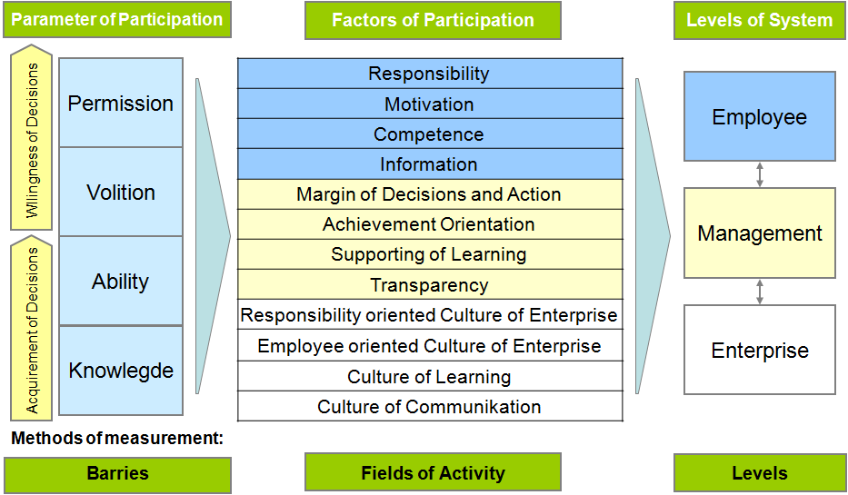
Figure 1: Participation according to Reiche
Against the background, that self-organized learning promotes creativity, in entrepreneurial teams in particular, the question arises as to the necessary conditions for implementing self-organized learning. In short, self-organized learning means creating the following conditions,
- Self-responsibility of the learners;
- Voluntariness of the learning process;
- Confidentiality of the learning process;
- Future orientation of the learning content;
- Agreement on learning content.
Practice has shown that game-based learning can be an important basis for developing such a new learning culture.

4 Creative Methodologies
Creative thinking, especially when performed collaboratively, is an engaging activity that fosters participation, discussion and deep reflection about real-world problems. These are all highly desirable characteristics in any learning process, and represent the core of the rapidly increasing academic effort towards using educational games to engage students in situated deep learning activities. We therefore aim to facilitate the application of creativity as part of the learning process.
Amongst the different 21st Century skills and competences that we wish to train and develop, creativity is one of the most important, yet more elusive to teach. We need new learning approaches to foster creativity, engage students in collaborative thinking and to promote innovative attitudes, in order to set the stage for the development of a creative workforce.
In this view, the main expected outcome of the research is to create a model to stimulate discussion and consensus-building amongst stakeholders of change process to ensure long-term sustainability of the change process. The methodologies of the creativity industry by increasing its operational efficiency, as well as facilitating the knowledge-capture and management mechanisms that will continuously support companies in their effort of developing tools to enhance the learning processes by fostering creative thinking will support the change management. It is even more than a support, it is the main idea, the basis of the entire implementation of the change process. This model will drive the intersection between creativity and change management towards sustainable collaboration models.
The application and implementation of serious games support the demands on individual further training, lifelong learning and learning concepts. Self-learning by serious games and mediation show comparable conditions in general (see Figure 2). Mediation offers the possibility to determine learning conflicts, to overcome the conflicts by not hurting the appreciation and respect at the same time. Therefore, this approach develops a learning model by using the well experienced activity options of mediation to lower the barriers of learning by serious games. At the same time the connection between mediation and participative management offers the chance to apply meditative principles in the field of a modern management.
The success of the European economy is to a large extent depending on the ability of European industry to foster innovation and to develop new product and services. Innovation is perceived to be Europe’s key to economic success in the current market environment with a quite strong competition requiring new alignments and changes.
A flourishing performance of any industry on today’s highly competitive, globalized markets depends centrally on its potential to innovate. To gain innovation-based competitive advantages, it has become necessary to empower the educational and working environments as to foster and enrich not only high-skilled people, but more importantly creative minds. This goal can be achieved by addressing specific educational issues, including measures on the need for and the nature of creativity in education, lifelong learning, and work.
Although initially creativity has been looked at as an artistic/ aesthetic phenomenon, in more recent times the approach has been broadened as to include creativity in professions such as architecture or engineering, or domains such as mathematics and natural science. By adopting a human capital approach, the discussions of creativity have become prominent in business and manufacturing, with creative people being seen as the vital resources needed to meet and conquer competition for markets and market shares, for instance through creative design and creative production or marketing.
Serious games are a creative methodology to support learning, innovation and creativity. Early non-entertainment games were often educational, but these have increasingly been used in different areas such as: edutainment and educational games, game-based learning, games for change, games for health and therapy and training simulations.
The power of games to immerse and motivate (Garris et al. 2002; Panzoli et al., 2010) and the capabilities of games to change perceptions and views (de Freitas, 2011) have created a more positive approach to games and new game genres. More use of games in non-entertainment contexts such as training (e.g. Mautone et al., 2008) are transforming everyday lives and multiplayer and social games communities are changing social interactions, leading to greater capabilities for social learning and interactions and importantly more fun in everyday contexts (e.g. McGonigal, 2011).
The development of a specific Serious Game to support a change process is depending on the topic of change. Within chapter 6 a short description of the serious games which applied for the case study is offered.

5 UGVOSS Model
In order for both sides, employer, company, and employee, to act together as a team, certain prerequisites must be fulfilled. In order to implement changes, there must be a clear definition of objectives. This must be communicated transparently. Information and communication must be transparent, complete and comprehensible. The participation of all parties concerned must be ensured. It must be clearly defined what the affected persons must be able to do after the changes (ability), what they should do, what they may do and the affected persons must be motivated within the framework of the change process to want all of this (willingness).
Willing to get involved with changing includes designing the changing process as a participant. Accompanied by the request of acceptance, appreciation, and tribute this leads to requirements towards management and leadership. Strictly pronounced levels of hierarchy in between the management and an authoritative leadership do not go along with these requirements.
The UGVOSS model is based on 6 steps called: Urgency, Guiding coalition, (strategic) Vision, Onboard the team, Short term wins and Sustainable integration.
Including the findings from change management in general, the participation and integration of creative approaches, the individual steps must be assigned requirements that must be fulfilled in order to carry out successful change management.
Urgency: All stakeholders must be made aware of the urgency of the change process, the market requirements must be clearly presented. Figures, data, facts, but also vivid representations must portray the situation vividly and address all stakeholders at their level and take them with them.
Methods: workshops, presentations, bad examples, mind set wake up
Guiding coalition: The selection of the leadership team depends very much on the organization that wants to carry out the change process. In any case, the team should be very diverse to reflect very different facets. The team should be trained in rhetoric and methodology and be tried and tested in the application of creative methods.
(strategic) Vision: The strategic vision goes hand in hand with the urgency of the change process. It shows the solution for the changes and outlines the roadmap on how to implement those.
Methods: workshops, description of new mind set, presentation

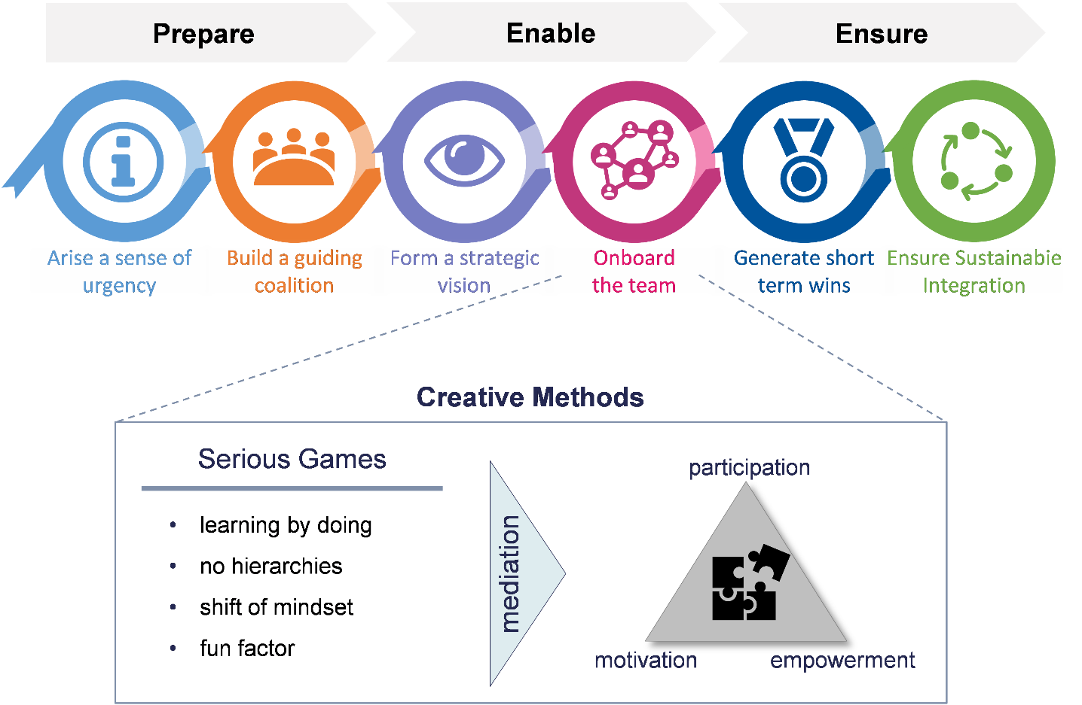
Figure 2: UGVOSS Model
Onboard the team: Stakeholders must go on board and learn about the changes. They have to be enabled – ability and knowledge. At this point, not only the ability is to be achieved, but also the process of wanting is to be promoted. A game will always not only promote learning, but also the willingness to engage in new things through the additional fun factor.
Method: Serious games
Short term wins: The learning process is usually very extensive because the changes are serious. It is therefore important to have a sense of achievement in between to show that you are on the way to implementing the necessary changes.
Method: Serious game
Sustainable integration: The change process must be integrated into the corporate culture. It must be clearly stated how, when, where and by whom changes must be implemented. Further more competences and tasks need to be redefined according to the new process.
Method: Serious game, message of board, change of job descriptions, workshops
Against the background that learning by gaming promotes creativity in entrepreneurial teams in particular, the question arises as to the necessary conditions for implementing game learning. In short, game learning means creating the following conditions,
- Self-responsibility of the learners;
- Voluntariness of the learning process;
- Confidentiality of the learning process;
- Future orientation of the learning content;
- Agreement on learning content. (Hoeborn and Heinich 2019/1)
Practice has shown that game-based learning can be an important basis for developing such a new learning culture. Of course, it remains to be seen how such a creativity and thus future-oriented learning culture can be developed. It is undisputed that conflicts that impede self-organized or creativity-oriented learning are certainly not in dispute.
Ultimately, it is important to identify the relevant barriers to learning and gaming. Experience has shown, however, that in practice such learning and gaming barriers appear to be learning conflicts.

trait  feature  Description | Lack of acquisition of the necessary professional knowledge | Lack of application of internal company knowledge | Lack of recourse to existing knowledge | Lack of interest in new knowledge and ideas
repercussions | personal  barriers | managerial  barriers | didactic  barriers | innovative  barriers
conflict  potentials | private | organizational | operative/  tactical | strategic
conflict level | personality | Company Organization | Personnel development | Strategic company orientation
examples | contrary social values,  congenital or acquired learning disabilities, | no qualification-appropriate deployment, overload, lack of personal responsibility, lack of scope for decision-making | situational continuing education practice, lack of learning environment, lack of personnel development plans | lack of long-term orientation, lack of recognition for new ideas, lack of freedom for creativity,
Table 1: Learning conflicts
But it is not only a matter of recognizing such learning conflicts; but above all of solving the recognized learning conflicts. On the conflict side, however, mediation has long since developed into a method of conflict resolution that can be expected to lead to creative solutions "without a judgement from above". Mediation is above all about putting commonalities in the foreground.
In short, the mediators' task is therefore to first establish a secure framework for the discussion, in which they agree on agreements with the parties to the conflict for the duration of the mediation process.
Within a change management process at the application of a serious games the role of mediator can be taken by a moderator.

6 Case Study
The case study was carried out within the field of engineering. An enormous change had to be carried out, the entire project management process was changed and standardized worldwide for all locations of the company. This included over 20 locations in more than 10 countries.

Urgency: All stakeholders were made aware of the urgency of the change process, the market requirements were clearly presented.
Methods: presentations, discussions, mind set wake up
Guiding coalition: The leadership team was well trained in rhetoric and methodology but did not have any idea of the application of creative methods. The creative input was offered by consulting team.
(strategic) Vision: The strategic vision went hand in hand with the urgency of the change process. It showed the solution for the changes.
Methods: workshops, description of new mind set, presentation
Onboard the team: Stakeholders went on board and learned about the changes. They have been enabled – ability and knowledge. At this point, not only the ability is to be achieved, but also the process of wanting has been be promoted.
Method: A workshop took place. A specific serious game was developed for the company. It included the entire project management process. All stakeholders had to play this game which lasted for more than two days within the workshop. This game did not only promote the ability, but also the willingness to engage in the new process through the additional fun factor.
Short term wins: The learning process was very extensive because the changes are serious. It is therefore important to have a sense of achievement in between to show that you are on the way to implementing the necessary changes.
Method: The serious game included many milestones which offered a short-term success.
Sustainable integration: The change process must be integrated into the corporate culture. It must be clearly stated how, when, where and by whom changes must be implemented.
Method: The serious game will be applied many more times at different locations.
The mediation was offered through moderators during the gaming.

7 Outlook
Even though just one case study was carried out to verify the UGVOSS model, it turned out that the application of creative tools, in this case the application of a serious game, lead to an enormous success by enabling the participating by creating knowledge and ability, and at the same, the serious games arises a volition, a willingness of the participants. The evaluation of the UGVOSS model, and thereby, of the game by the participants was extremely positive. The authors are therefore convinced that serious games and other creative methods will be a useful addition to change management processes in the future. Hence, the implementation of creativity methods in change management processes should be further promoted. The UGVOSS model needs to be validated by further case studies. Further research should focus on implementing on other creativity methods.

References
de Freitas, S. Game for Change. Nature. 470 (7334): 330-331. 2011

Garris, R., Ahlers, R. & Driskell, J. E.. Games, Motivation, and Learning: A Research and Practice Model. Simulation and Gaming, 33, 441-467. 2002

John Kotter and Holger Rathgeber. Das Pinguin-Prinzip, München 2011

Mautone, P.D., Spiker, V.A, and Karp, M.R. . Using Serious Game Technology to Improve Aircrew Training. Proceedings of the Interservice/Industry Training, Simulation and Education Conference (IITSEC) December 2008 Orlando, Florida 2008

McGonigal, J.. Reality is Broken: Why games make us better and how they can change the world. London. Jonathan Cape. 2012

Panzoli, D., et al.. Levels of Interaction (LoI): A Model for Scaffolding Learner Engagement in an Immersive Environment. Intelligent Tutoring Systems. Lecture Notes in Computer Science. 6095:393-395. 2010

Reiche, Markus. Partizipatives Veränderungsmanagement. Shaker: Aachen 2007

