**SELF-ORGANIZATION AND SELF-DETERMINATION VERSUS CREATIVITY**

**teaching creativity - learning creativity**

*Gabriele Hoeborn*

*University of Wuppertal, Interdisciplinary Center 3, Germany*

[*ghoeborn@uni-wuppertal.de*](mailto:ghoeborn@uni-wuppertal.de)

*Petra Heinich*

*University of Applied Sciences Cologne, Germany*

[*petra-heinich@t-online.de*](mailto:petra-heinich@t-online.de)

**Abstract**

Regardless of the various definitions of the term ‘CREATIVITY’, today no one denies that the economic power of a country or an economic community directly depends on the creativity of those involved - starting with the legislature, the executive branch, the management of companies and corporations and regions, and the research and development capacities through to the producers. Starting with Silicone Valley, and now hoping to build on the success of Silicone Valley, many regions around the world have strategically developed high-tech locations to attract such companies. ‘CREATIVITY’ is the key to success here!

But with our education system in the Federal Republic of Germany, we actually have ideal prerequisites for playing a part in the players in this competition: different educational paths. In particular, different educational paths to the same goal! BUT the question remains, of course, how the resources are used to encourage creativity.

Learning belongs to the process of life, playful learning, and learning by curiosity, learning prescribed by institutions. But also self-determined and self-organized learning as it is not necessarily promoted or offered by institutional learning at schools, universities and also in the professional sphere. Rather, there are fixed guidelines at these places how we have to learn and how the learning success is controlled.

Studies and observations underline that self-determined and self-organized learning is more successful than rigid institutional forms of learning. Self-determination and self-organization need, as well as creativity, freedom and a fearless atmosphere to practice. The following paper offers in a first step the definition of the items describing self-determined and self-organized learning and compares them with the items describing creativity. In a second step, the conditions and prerequisites for applying self-determined and self-organized learning are shown and compared with the conditions and prerequisites for using creativity. Thirdly, by taking the hindering and supporting factors into account, the requirements for the model to combine creativity and self-determined and self-organized learning are worked out. A model will be developed which on the one hand provides a pool of creativity and on the other hand uses this pool for self-determined and self-organized learning.

**1 Introduction**

This article brings together the two main themes of creativity on the one hand and self-determined and self-organized learning on the other. Already in Hoeborn and Heinich 2018/1 and in Hoeborn and Heinich 2018/2, the concept of creativity as well as its hindering and promoting factors were examined in more detail in an extensive scientific study. In a further step within the framework of this research project, self-organized and self-determined learning will be examined in more detail and their commonalities to creativity will be worked out. The aim is to create a model through which creativity supports self-organized and self-determined learning. Hereby, a pool is created, in which the participants give their knowledge, their understanding, their access, their application concerning creativity and thus generate a swarm knowledge creativity. Suitable boundary conditions that support self-determined and self-organized learning create a learning environment that offers ideal learning conditions.

* 1. **Scientific Background**

As part of a scientific study, the two authors conducted a large number of interviews and quantitative surveys on creativity. Already last year, the authors reported on their results concerning the definition of creativity and the item describing creativity as well as regarding the factors promoting and hindering creativity at this conference. A big, important question was whether we use our creativity also in our professional environment, even if we are not active in a so-called creative profession.

Creativity and business-driven innovation are an important topic of our time. But there are still many questions on this subject. What is creativity, how to get access to creativity? These questions were intensively discussed in Hoeborn and Heinich 2018/1, research results were presented.

But the question arises, which potentials e.g. of Aristotle, Gutenberg, Edison, Einstein, Watson or Hawkins are in a human being? Above all: Is creativity teachable or learnable? Is there a relentless struggle for the creative minds of this earth or is there the possibility to create a creative atmosphere?? What actually speaks against this is that people fear change and prefer to go their own way. Nevertheless, the history of human ideas shows that the development of ‘GENIUSES’ is not so easy to plan. Surely there are many people who, despite an immensely creative brain, had no chance, while others were particularly creative, to appropriate and impersonate the ideas of others as their own. The best example is one of the richest people in the world: Bill Gates.

Within the framework of a scientific study, the hindering and promoting factors in relation to creativity were worked out as presented in Hoeborn and Heinich 2018/2.

Creativity is often associated with chaos, with not being self-organized, with not being self-determined, at least in our prejudices about creativity. But is that the case? Or is it rather the other way around that creativity helps to organize itself and to determine when and how what is done?

Creativity and innovation are just one requirement of the producing environment, of our professional sphere as well as within a learning atmosphere at school, at university, at professional sphere or just at privacy.

But with our education system in the Federal Republic of Germany, and as the authors believe, all over the world, we actually have ideal prerequisites for playing a part in the players in this competition: different educational paths. In particular, different educational paths to the same goal! BUT the question remains, of course, how the resources are used to encourage creativity.

Learning belongs to the process of life, playful learning, and learning by curiosity, learning prescribed by institutions. But also self-determined and self-organized learning as it is not necessarily promoted or offered by institutional learning at schools, universities and also in the professional sphere. Rather, there are fixed guidelines at these places how we have to learn and how the learning success is controlled.

Studies and observations underline that self-determined and self-organized learning is more successful than rigid institutional forms of learning. Self-determination and self-organization need, as well as creativity, freedom and a fearless atmosphere to practice.

We are required to work interdisciplinary, this is applicable to the learning process as well. As written in Hoeborn and Heinich 2018/1 ‘the authors asked themselves, if we as mankind can learn from each other. And going one step further we express the hypothesis that interdisciplinary collaboration and innovative processes within all areas will just be really successfully if we offer our different definitions and knowledges about creativity to the working group. This mutual input leads to commonly lived creativity which enables us to take new perspectives, to go new ways of using creativity as a team. This kind of team work is an important founding, a basis to develop a collective competence.’

The three major objectives of the scientific study are listed here, with both goal 1 and goal 2 already discussed.

* goal 1: *to gather different definitions and understandings of creativity*, different perspectives , results are offered in Hoeborn and Heinich 2018
* goal 2: *to gather supporting and hindering factors of creativity*, results are offered in Hoeborn and Heinich 2018/2
* goal 3: *to gather* ***experiences of applications of creativity to other discipline, interdisciplinary team work to develop a collective competence,*** topic of this paper

The study is largely based on qualitative research methods such as short texts on given topics or qualitative interviews. Both expert interviews and more focus group interviews were conducted. Quantitative questionnaires were also evaluated.

The focus of this paper is the combination of creativity and self-determined and self-organized learning by developing a collective competence.

**1.2 Limitations and state of the research work**

This research work is based on qualitative data and the data was gathered within different disciplines and different stages of education, within higher education and professional sphere.

The results and questions presented have led to a very high level of interest among different groups. Further questions and ideas were raised and therefore the research project is still in process.

1. **Self-determined and self-organized Learning**
   1. **General Definition of Self-determined and self-organized Learning**

Self-organized and self-determined learning is becoming increasingly important in the discussion of individual learning processes. "Self-organized learning in pedagogy refers to a learning concept for individual and cooperative learning that can be implemented within the framework of educational institutions and is geared towards increasing self-organization of learners in the learning process. It is hoped that this will strengthen individual independence through the development of methodological and learning competences, the creation of a social learning structure in the coordination of individual and group work, a deepening of knowledge and skills through the networking of specialist and interdisciplinary competences, and an increase in self-responsibility for one's own learning process. (Stangl, 2019).

The discussion of self-organized and self-determined learning processes is playing an increasing role, especially in adult qualification, in order to focus attention on individual and ultimately creative achievements that bring decisive advantages in international competition. It is particularly important to identify the success factors that leading high-tech companies will produce. In particular, a change is seen in the prerequisites for achieving continuous team performance instead of individual ‘ivory tower successes’, which ensure entrepreneurial success over a long period of time.

In principle, the requirements for learning are changing from externally controlled to self-organized and self-determined - with decreasing degrees of external control. For the auto-runners, self-organized and self-determined learning is the recording of all foreign and self-experienced references to knowledge deficits with the aim of ultimately eliminating them independently with the help of ‘learning counsellors’ by choosing the place of learning, the learning time and the learning contents and methods.

In principle, learning changes from externally controlled to self-organized - with different degrees of external control. For the authors, self-organized learning is the recording of all foreign and self-experienced references to knowledge deficits with the aim of overcoming them independently with the help of ‘learning advisors’ or ‘learning mediators’ (solving learning conflicts - little angels versus little devils) by choosing the place of learning, the learning time and the learning contents and methods!

**2.2 Definition of Self-determined and self-organized Learning through the Project**

Chapter 2.1 has given us an overarching definition of self-determined and self-organized learning. In the context of the scientific study, the authors have described this topic in its entirety in focus group discussions. The picture in Figure 1 shows a collection of these ideas. But firstly, some quotations of the intensive discussions:

* *Self-determined and self-organized learning is something you might not apply in our educational system. Those responsible are afraid of so much creativity*./focus acad/
* *To learn self-determined and self-organized, children are driven out already in the kindergarten, at the latest in the primary school*./Focus2/
* *We should show creative solutions, but we must neither think creatively nor learn and work self-determined and self-organized.* Focus3/.
* *Why does the system destroy these positive abilities anchored in us and instead make us stupid idiots who work according to instructions and under control?* /Focus3/

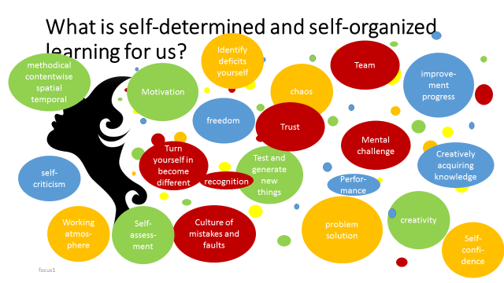

Figure 1: Brainstorming on the influencing factors and definition of self-determined and self-organized learning /Focus1/

The attitude of all participants was extremely positive towards the use of self-determined and self-organized learning. And surprisingly, the participants unanimously agreed that self-determined and self-organized learning is anchored in us humans and that it is driven out of us by the system.

In all discussions, a connection was drawn between self-determination and self-organization and creativity, without this being addressed by the authors. The focus group participants were different from those who had participated in the discussions on creativity.

In business, creativity has become essential, because everything else has become a commodity available to everyone/De Bono 2008/ therefor, creativity is essential for self-organized and self-determined learning as well. Information has become a commodity and so has become the current technology. How can an organization continue to be more competent than its competitors? Creativity has been advanced as a viable answer to this question, but not only creativity alone, but also self-determined and self-organized learning. The next question is how can people learn more self-determined and self-organized and more creatively and how can organization increase their learning and creativity quotient? And as a second step how can they apply their creativity towards self-organized and self-determined learning?

Creativity emerges from the synergy of many sources and not only from the mind of a single person as already discussed in Hoeborn and Heinich 2018/1. It turned out that it is easier to enhance creativity by changing the conditions of the environment than by targeting a specific individual, it is also important to consider that a genuinely creative accomplishment is not always a result of a sudden insight, but also of a constant exposure to knowledge and of the willingness to change/Galindo 2011/. And this includes a self-determined and self-organized learning. In order to be able to overcome already existing blocks, people need to be empowered to break out of their learning and thinking habits and learn and think differently.

Clustering the results of the brainstorming and carrying out more interviews lead to the main items of self-determined and self-organized learning as illustrated by figure 2:

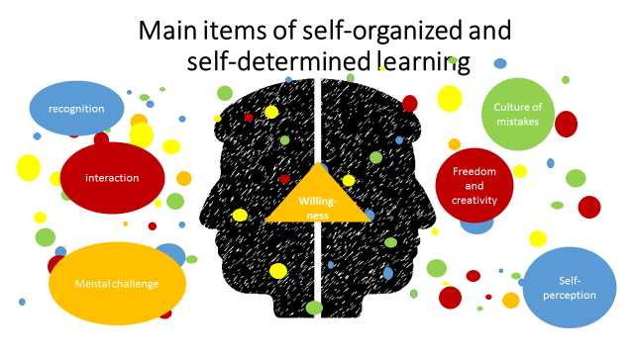

Figure 2: Main items self-determined and self-organized learning

This figure points out that the willingness of applying self-organized and self-determined learning is depending on mainly 6 items: recognition, interaction, mental challenge, culture of mistakes, freedom and creativity and self-perception. There are, on the one hand, items which are related directly to the individual and there are items which are related to the surrounding conditions. Both sides can be influenced. The individual can be targeted on but it is easier to target on the conditions as mentioned above. To discuss the detailed target goals each item has to be searched on deeper.

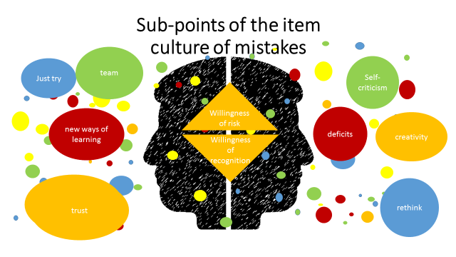

Figure 3: Sub-points of the item culture of mistakes

The item mistake culture shows the Janus-faced perception of self-responsibility. One side of Janus involves wanting something new, taking a risk, and the other side of Janus shows the need for recognition. Often we are sure that the application of a standardized technique will bring us recognition, at the same time we are afraid that going a new way will deny us this recognition. This denial can have various causes. Partial successes cannot be seen, evaluation criteria exist that cannot be applied to new paths or the evaluators are simply afraid of the new.

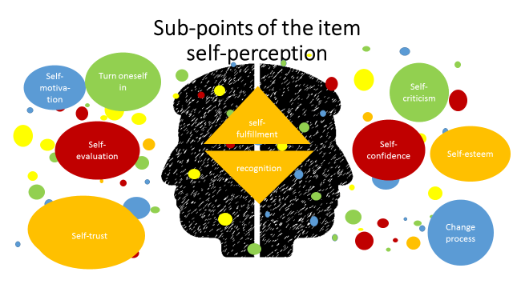

Figure 4: Sub-points of the item self-perception

This point is determined by the individual. Changes must always be aimed at the individual. Supporting the individuals goes hand in hand with accepting the individuals and their differences.

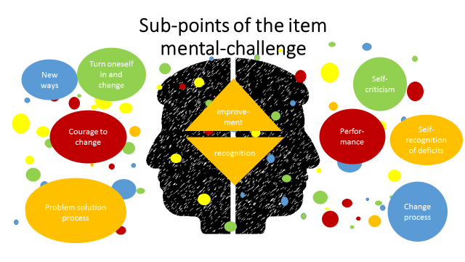

Figure 5: Sub-points of the item mental challenge

The item mental challenge is widely related to the change processes by going new ways. These processes are carried out by the individuals, but can be accelerated or decelerated by changing the boundary conditions. The recognition of the acceptance of thought challenges promotes this process, as does the creation of opportunities to accept these challenges. Here, institutions and companies are called upon to create the appropriate conditions. The target group is not the individual, although of course it must also have the will to engage in these processes.

In most cases, the individual wants to interact with others. Certain prerequisites such as communication and information structures must be fulfilled in order for interaction to function. The individual wants to work in a team, he wants to enrich the team as well as be enriched by the team. The individual shares his knowledge with others and benefits from the knowledge of others. This requires trust by the individual on the one hand and by the team on the other. If the team has learning conflicts, mediation is helpful. On the other hand, the individual, the individual learner, needs sufficient self-confidence to reveal himself to the team, to engage. In addition, the individual needs the willingness to contribute himself, to reflect in the team, to absorb new knowledge and thus to change.

Team creativity and innovation is a significant domain of interest in organizations. Group creativity can occur informally in interactions among friends or colleagues or in more structured groups such as scientific research laboratories and research and development teams. There are number of factors that limit the creative potential of groups such as a focus on being agreeable, concern about evaluation of ideas by others, and the difficulty of expressing one's ideas while others are expressing theirs. However, groups that vary in their expertise and perspectives should have great potential for creativity and studies have identified factors that are critical for tapping this potential, such as effective use of dissent, appropriate leadership, and interaction modalities that reduce group interference/Paulus 2011/.

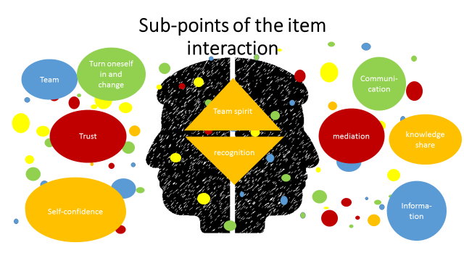

Figure 6: Sub-points of the item interaction

Team heterogeneity on factors such as creativity ability, cognitive style, and personality seemed to be related to improved team creativity and innovation. A review of team social processes revealed that effective social processes – especially those related to effective and open communication – are associated with improved team creativity and innovation/Reiter et al.2012/. In addition, complex relationships among the social process variables have emerged, such that the effects of one social process variable may influence the emergence of another, or may interact with other social processes in explaining team creativity and innovation.

The sub-points that have been worked out in the freedom and creativity section are very similar to those that have been defined in the creativity section for the freedom item. This is certainly also due to the fact that self-defined and self-organized learning is inconceivable without creativity. Again and again it is about freedom in all areas such as time, space, finding solutions, setting priorities. Certainly a task that has to be mastered by the individual. But here are boundary conditions in the focus of the target group.

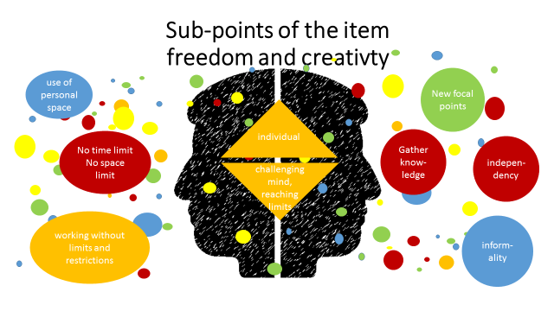

Figure 7: Sub-points of the item freedom and creativity

Creativity is positively related to daily planning behavior, confidence on long-range planning, perceived control of time and tenacity and negatively related to preference for disorganization/Zampetakis et al. 2010/. Teachers play a crucial role in the development of students’ creative potential in either a positive or a negative way/Zampetakis et al. 2010/. Therefore, it is necessary to consider that the creative workforce of tomorrow it is built today.

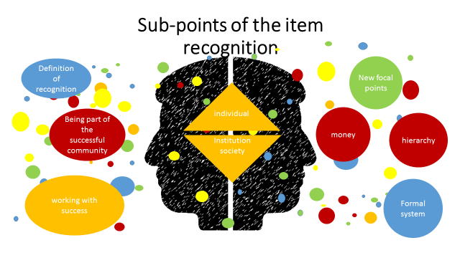

Figure 8: Sub-points of the item recognition

Recognition is one of our most important demands on life in society. Learners as well as professionals strive for recognition, we do not get recognition, so this has far-reaching consequences. Recognition is shown in very material things such as money, position within the hierarchy or pure learning through good grades. But recognition also manifests itself in non-material values such as position and prestige within the working or learning community. Recognition must be defined, both in terms of its material and non-material significance. If this process is actively changed and controlled from the outside, changes can be introduced in a targeted manner.

* 1. **Results**

Self-organization, self-determination and creativity represent a form of performance of organizations such as learning institutions or companies. Also, the organizational climate characteristics might be stimulants or inhibitors of self-organization, self-determination and creativity. Strategies to nurture this atmosphere by organizations need to be outlined, in order to identify the elements in the organizational environment that may act as incentive or obstruction to the expression of individuals’ and work teams’ creativity.

While creativity has been a subject of research since decades, its application to learning is relatively new and thus an emerging, unexploited field. Learning takes place in quite different situations and fields, e.g. during education at universities, but also in organizations and organizational networks. For the stimulation of creativity a large set of methods and tools is available, but most of them do not take learning aspects and knowledge management into account.

Therefore, a couple of challenges exist when introducing creativity to self-organized learning concepts. A new model needs to be developed, new methods need to be developed to bring creativity and self-organized learning together. These concepts and methods have to be cross-disciplinary.

New models need new tools, tools like intelligent systems, agents, special interfaces, spaces etc. supporting the user(s) in the creative learning process need to be developed. These tools should support non-linear, non-standard thinking and problem-solving; they should be coupled with environments that reflect and that are able to comprise the dimensions the new social interactions that drive effective knowledge exchange. The learners should be able to exchange and share creativity to support their self-learning to generate creative momentums and maintain a sustainable creative flow. This flow of creativity will create a collective creativity that will support self-determined and self-organized learning. One main objective should be to create a kind of platform to stimulate discussion and consensus-building amongst main learning stakeholders, market players and researchers in creativity domain in order to facilitate and accelerate the creativity driven learning process.

**3 Requirements for the learning Model Gape**

Ultimately, the question arises as to which decisive framework conditions characterise self-organised and self-determined learning in order to ultimately develop a methodology relevant to practice. Self-organised learning naturally begins with the self-responsibility of the learner. This means in principle that the learner determines his or her learning scope and learning level in a self-determined way - without having to carry out external analyses of his or her level of knowledge and without prescribing what is to be learned at what level and scope. It is precisely the individual interest of the learner in the subject matter and level of learning that leads to individual ideas and unique problem solutions.

Although many people get excited about the prescribed learning in connection with the current Bachelor's and Master's degree programmes, the voluntariness of the learning process with regard to one's own motivation or the objectives of the study programme does not really play a role in the learning content. Rather, the survival of one's own department or teaching chair is in the foreground. Whether, with increasing knowledge, subject areas also ‘survive’ or become obsolete, so to speak, is obviously always only a matter of "the others".

But there is another important requirement for the learning process: it must meet the current requirements of time! From today's perspective, this means that modern media such as smartphones, laptops or notebooks must not be banned from the learning process. Learning with the feeling of missing something doesn't work! Only if a certain trust can be built up in the learning process, that it is up-to-date, so to speak, or that the learner - just like the client to learn - can himself plan when and where he learns, does it not work. How is someone supposed to learn if he permanently has the feeling that he is missing out on real life - including in the company? Every entrepreneur must ultimately face up to the digitalisation of the economy!

In addition, it is very important that the learning content is future-oriented for the company and the learner. The basic prerequisites for the drive to learn in a self-organised and self-determined way are the orientation towards a sustainable corporate strategy instead of working through an incomprehensible qualification plan and a fixed personnel development plan instead of periodic qualification measures. It is quite a coincidence that job profiles are advertised with their prospects, but then hardly any prospects are offered.

In short, self-organised and self-determined learning means creating the conditions of

- learners' self-responsibility

- voluntary nature of the learning process

- confidentiality of the learning process

- future orientation of learning content

- agreement on learning content



Figure 9: general condition of self-organized and self-determined learning

If we place these listed boundary conditions and requirements additionally over the points which were worked out by the participants as relevant, then the following further boundary conditions can be specified:

* working without fear
* tolerance towards mistakes and failure
* enterprise culture (philosophy) based on trust, esteem, confidence, recognition, and equal value
* high value of creativity and innovation
* confidence and trust in employees
* freedom
* open information and communication system
* openness towards associative thinking processes, no requirements towards linear thinking processes
* team work, really shared knowledge
* participation management

Self-organised learning as a basis for creative action in the professional and private environment. No one will deny that a decisive basis for creativity is a comprehensive basic knowledge. This is the only way to identify problems, connections and possible solutions. On the one hand, it has never been so easy to acquire up-to-date knowledge thanks to electronic media, and on the other hand the demand for lifelong learning or the permanent acquisition of new knowledge has never played such an important role. This ultimately also changes the demands on the learning process itself. Increasingly, the learner has to shape his own learning or the teacher becomes a learning consultant.

Self-organised learning takes place against the background of the need to recognise time and again, out of one's own interest, the need to acquire new basic knowledge in order to question existing knowledge again and again, to grasp possible problems and to generate solutions.

**4 Outlook**

The requirements and conditions for the Gape model are defined. They are free from the technology or task to be applied, they are generally valid. In a next step, the aim is to select appropriate application examples, adapt the model to them, verify them and evaluate them.

**References**

De Bono, E. 2008. *Creativity Workout: 62 Exercises to Unlock Your Most Creative Ideas*, Ulysses Press, CA; Berkley.

Galindo, J.W. 2011. *The Power of Thinking Differently: An imaginative guide to creativity, change, and the discovery of new ideas*, Hyena Press. CA: Los Altos.

Hoeborn, Gabriele and Heinich, Petra. *Definition of Creativity and Access to Creativity,* Toulon Verona Conference, 2018/1

Hoeborn, Gabriele and Heinich, Petra. *Supporting and Hindering Factors of Creativity,* Toulon Verona Conference, 2018/2

Kampylis, P., Berki, E., Saariluoma, P. 2009. *In-service and prospective teachers’ conceptions of creativity. Thinking Skills and Creativity*. Volume 4, Issue 1, pp. 15–29.

Paulus, P.B. 2011. *Group Creativity, Encyclopedia of Creativity (Second Edition),* pp.575-580.

Reiter-Palmon, R., Wigert, B., de Vreede, T. 2012. *In Handbook of Organizational Creativity,* Ed. Mumford, M.D. Elsevier Inc, pp. 295-326.

Stangl, W. (2019). Stichwort: 'selbstorganisiertes Lernen'. Online Lexikon für Psychologie und Pädagogik.  
WWW: <https://lexikon.stangl.eu/7015/selbstorganisiertes-lernen/> (2019-07-19)

Zampetakis, L.A., Bournanta, N., Moustakis, V.S. 2010. *On the relationship between individual creativity and time management, Thinking Skills and Creativity*

Volume 5, Issue 1, pp. 23–32.