EXTROVERT INTEGRATED MANAGEMENT SYSTEMS

Maria Gianni
Business Excellence Lab, Department of Business Administration
University of Macedonia, Thessaloniki, Greece
email: giannima@uom.edu.gr
Corresponding Author

Katerina Gotzamani
Business Excellence Lab, Department of Business Administration
University of Macedonia, Thessaloniki, Greece
email: kgotza@uom.edu.gr

Abstract:

Purpose of the paper: This research aims at operationalizing the integration of management systems and corporate sustainability performance (CSP) by drawing on resource, institutional and stakeholder theories. The adopted approach measures how far internalized the integration of multiple management systems is in terms of integration resources and integration level.
Methodology: The measuring instrument has been designed and administered to Greek organizations certified to two or more management system standards. Collected data from 280 respondents has been processed using exploratory factor analysis.
Main findings: The extracted internalization factors are human resources, strategic resources, information systems, integration tools, outsourcing, internal processes integration level and audits' integration level. The extracted CSP factors are customer-supplier relationship, employees, financial institutions, the environment, state and society.
Practical implications: Findings may be used by management professionals, certification bodies and governmental authorities in order to foster the implementation of multiple management systems.
Originality/value: To the best of the authors’ knowledge this research is one of the first attempts to understand the internalization of integrated management systems and its relationship with corporate sustainability within a wide context, far beyond the boundaries of a single enterprise, assimilating the perspectives of the stakeholders.
Type of paper: Research paper
Keywords: integrated management system; corporate sustainability; performance; stakeholder theory; resource theory; internalization

- Introduction

Proliferation of management system standards and systems has produced complexities difficult for organizations to cope with. The need for concurrent development and monitoring of multiple management systems has lead to the creation of integrated management systems. In the last decade a wide literature spectrum has evolved covering many aspects of integrated management systems (Nunhes et al., 2019), starting from the mere paragraph matching of multiple discipline-specific or sector-oriented standards, followed by the merging of processes and procedures of isolated management systems and, recently, addressing more sophisticated management topics, such as diffusion (Cabecinhas et al., 2018) and maturity (Domingues et al., 2016). In this maturing stage, integration of management systems is stressed to influence corporate sustainability (Poltronieri et al., 2019). In this theoretical framework integration is addressed by adopting the evolutionary, ‘mature’ topic of internalization, i.e. the degree of pervasiveness and assimilation of management system standard principles and practices by the organizations.
Despite the absence of an international standard dedicated on integrated management systems, International Organization for Standardization has recently updated its guide to integrating management system standards (ISO, 2018) and is lately using a common high-level structure (Will et al., 2019) for all new versions of standards enabling and somehow institutionalizing integration. In other words, management system experts embrace the notion of integration and they continuously seek for ways to formalize it considering it equally important to the certification of discipline-specific management systems. In this context, the long-lasting debate on the legitimacy of certification versus the actual impact of substantive implementation of individual management systems (Escrig-Tena et al., 2019; Testa et al., 2015) cannot be ignored in the case of integrated management systems. Similarly to the symbolically certified individual management systems, integrated management systems are often only by name “integrated” and are not actually embedded or intertwined within the functional fabric of business operations. Hence, the two different perspectives of management systems’ implementation, i.e. the ‘institutionalist’ and the ‘functionalist’ (Escrig-Tena et al., 2109; Nair and Prajogo, 2009), apply in the case of integrated management systems, as well. In this context, the purpose of this research is to delve into the particular IMS aspects that may distinguish the substantive (internalized) from the superficial (ceremonial) integration by measuring the level achieved and the resources used when integrating. Following this line of thought, this research aims to operationalize the internalization of integrated management systems and corporate sustainability performance.
The remainder of this manuscript is structured as follows. Literature on internalization and corporate sustainability performance is reviewed in the following section. Next, research method is described. The empirical results are summarized in the fourth section. Finally, the findings are discussed and conclusions are drawn.

- Literature review

Internalization
Internalization can be defined as the substantial rather than superficial integration of specific practices and principles as stated in management system standards within organizations’ daily activities (Testa et al., 2018a). Internalization is considered as the means against ‘symbolic’ (superficial) implementation of management systems (MS), e.g. against mere certification or even ‘greenwashing’ in the case of environmental management systems (Testa et al., 2018a) and ‘bluewashing’ in the case of corporate social responsibility practices (Testa et al. 2018b; Will et al., 2019). External institutional pressures usually drive organizations to certify just to ‘exhibit’ compliance. However, when MS standards are intertwined within corporate strategy and enterprises allocate resources and absorb knowledge - both tacit and explicit - to actually comply by the standards expecting to benefit from this compliance, then the principles and guidelines of those standards motivate and drive internal change (Nair and Prajogo, 2009; Nunhes et al., 2016).
Long-term effectiveness and value addition of management system standards do not depend on the standard requirements themselves but on the way that companies adopt and implement these standards or otherwise the depth to which a company decides and commits to meet their requirements (Gotzamani and Tsiotras, 2002). Level of internalization of management system standards’ requirements is measured through management planning (policy, objectives), training and employee involvement (motivation, teams, identification of needs), operational activities (work instructions, risk management procedures), monitoring and checking (performance, non-compliance, audits) (Testa et al., 2018b). Internalization of management system standards has a positive impact on operational, environmental and social performance (Heras-Saizarbitoria, 2011; Ketokivi and Schroeder, 2004; Qi et al., 2012).
In this context, integration of multiple management systems is considered as substantive implementation or otherwise internalization of multiple management systems and draws on resource and institutional theories (Gianni et al., 2017) to be operationalized (see Annex I).

Corporate Sustainability Performance

Business sustainability and corporate social responsibility are jointly considered in literature in the wider term “corporate sustainability” (Will et al., 2019). Moreover, corporate social responsibility is often used interchangeably with corporate sustainability (Dyllick and Muff, 2016). In this sense, corporate social performance generally reflects how well a company transforms stakeholder orientation, a managerial attitude, into stakeholder satisfaction (Luk et al., 2005). Literature emphasises the dual role of stakeholders providing both inputs (requirements) and outputs (satisfaction) for the management systems (Rocha et al., 2007). Hence, academics and practitioners seek ways of meeting stakeholder expectations in a wider management framework driven by accountability and social responsibility (Maletič et al., 2014). Recent research stresses the importance of integration for the successful linking of corporate social responsibility with existing management systems (Will et al., 2019).
From the standardization perspective, certain attempts have partially addressed the complexity of corporate sustainability management (Maletič et al., 2016). The certifiable social accountability (SA 8000) standard is incompatible with the ISO standards structure and fails to address other stakeholders apart from employees and suppliers/subcontractors. Complementary, the non-certifiable ISO 26000 social responsibility guidance encourages firms to communicate with stakeholders and local communities (Botta et al., 2013). The triple-bottom line approach of corporate sustainability (Elkington, 1997) outlines three dimensions that need to be addressed. Drawing upon stakeholder theory corporate sustainability performance can be analysed as perceived by stakeholders depending on their involvement and contribution to firm performance (Gianni et al., 2017; Wiengarten et al., 2017). Following this line of thought, this research operationalizes corporate sustainability performance reviewing relevant literature (see Annex I).
- Methods and tools

The theoretically established model has been tested through a field survey. Questionnaire filling has been standardized by holding constant as many attributes of questionnaire administration as possible, particularly the wording of items. In survey research standardization aims to expose each respondent to the same question experience and to assure the identical recording of the response so, that any differences in the responses may be attributed to differences between respondents rather than differences in the responding process (Fowler and Mangione, 1990).

Measuring Instrument
A thorough literature review identified the questionnaire items that are presented in Annex I. The questionnaire consists of four parts. The first part includes questions on the demographic profile of a company. Second part refers to resources allocated for planning, implementing and monitoring multiple management systems. Third part addresses the integration level of management systems corresponding to distinct operations. Fourth part aims at evaluating the impact of resource allocation and integration level on corporate sustainability performance. A seven-point Likert response scale was used. Certain questions were reversely stated so that “automated” responses would be avoided. Three probe questions at the end of the questionnaire were posed in order to assure comprehension of the questions in the three subsections referring to resources, integration level and corporate sustainability performance.
Two methods were used in order to validate the content of the measuring instrument; firstly, the theoretical foundation of the items was established in the literature (see Annex I) and, secondly, the opinions of domain experts were incorporated during the questionnaire pre-testing phase (Malhotra and Grover, 1998). More particularly, a pilot study was conducted in order to pre-test the questionnaire (Oksenberg et al., 1991). The measuring instrument was sent to three companies that were known to have multiple management systems fully or partially integrated. The selected managers were expected to be informants rather than respondents. Their comments and suggestions were taken into account to improve the questions (clarity of expression) and the response process (explanation of terms, items, research purpose and expected outcome) and confirm face validity of the survey instrument. Draft version of the questionnaire was also revised by three researchers/experts (Yan et al., 2012).
Survey questionnaire was addressed to the management systems responsible persons and it was administered by university students. Students took part in a training session dedicated to the purpose of the research, the items included and the interaction with the companies. In the cover letter managers were assured about the confidentiality of the submitted information and they were advised to provide their contact details in case they wished for a summary of the survey results.

Common method bias
Common method bias may arise when variations in responses are caused by the instrument rather than the actual predispositions of the respondents that the instrument attempts to uncover. In other words, the instrument introduces a bias, hence variances, that might contaminate results by the 'noise' stemming from the biased instrument. Common method bias may arise by a common rater, a common measurement context, a common item context, or from the characteristics of the items themselves. Obviously, in any given study, it is possible for several of these factors to be operative. Therefore, it is important to carefully evaluate the conditions under which data is obtained in order to assess the extent to which method bias may be a problem. Method bias is of higher importance in studies in which data for both the predictor and criterion variable is obtained from the same person in the same measurement context using the same item context and similar item characteristics. These conditions are often present in behavioral research. Most often, Harman's single factor test of bias is applied (Podsakoff and Organ, 1986; Podsakoff et al., 2003). Items are all loaded into one common factor. Unless total variance for a single factor exceeds 50%, common method bias is not an issue.
In this survey the questionnaire was administered to the management system managers. In most of the participating companies the same person is assigned the monitoring of all management systems and, hence, there is a single respondent for each company. In the remaining companies of the sample - where more than one person is responsible for more than one management systems – again the questionnaire is to be filled once since the questions address all management systems concurrently. Thus, since a single questionnaire was completed by each participating company, common method variance is of concern. Harman’s single factor test is used for testing common method bias. When testing internalization for common method variance (performing Harman’s test), i.e. loading all items on a single factor, total variance explained is 30.602%, a value quite lower than 50% assuring absence of common method bias. Similarly, when testing corporate sustainability performance for common method variance (performing Harman’s test), i.e. loading all items on a single factor, total variance explained is 33.067%, which is far less than 50% safely leading to the conclusion that there is not any concern for common method bias.

- Results

The questionnaire has been administered to Greek organizations of different activities, sizes or locations. The requirements for the firms to participate in the survey were to be certified at least to two standards, i.e. ISO 9001 and ISO 14001 certified or ISO 14001 and OHSAS 18001 or any other combination of standards. Data banks of Hellastat and certification bodies were used to draw an initial sample of 787 companies. Responses have been collected in two stages: the first starting from November 2016 and ending in February 2017 and the second starting from March 2017 and ending in June 2017. By the end of the field survey there were collected 280 completed questionnaires corresponding to a response rate of 36.5%.
Statistical processing of data and factor analysis were performed using IBM SPSS Statistics Version 21.0. The extraction method used for the exploratory factor analysis was Principal Component Analysis.

Data testing
Non-response bias refers to failure of estimating a population behavioral feature based on a sample of survey data in which certain types of survey respondents are under-represented. In this case, to test any effects by non-respondents, late vs early responses are t-tested, based on the assumption that the opinions of late respondents are representative of the opinions of the theoretical non-respondents (Armstrong and Overton, 1977) and no significant differences are found.
The Bartlett test of sphericity is a statistical test for the presence of correlations among the variables. A statistically significant Bartlett’s test of sphericity (sig. < .05) indicates that sufficient correlations exist among the variables to proceed. The measure of sampling adequacy ranges from 0 to 1, reaching 1 when each variable is perfectly predicted without error by the other variables. Kaiser-Meyer-Olkin (KMO) values higher than 0.80 are considered ‘meritorious’ (Hair et al., 2014). KMO value for internalization is 0.890 and for CSP is 0.888. Sphericity values are 7142.583 (df: 666) and 5587.103 (df: 465) for internalization and CSP (sig. < 0.001), respectively.

Factor analysis
Varimax rotation is applied on the internalization items. Seven latent factors are revealed and labeled as internal processes integration level, human resources, audits integration level, strategic resources, information systems, outsourcing, integration tools (see Fig.1). Rotated component matrix is shown in Table 1a.

Table 1a. Internalization - Rotated Component Matrix

 |  | Component
Factors | Items | 1 | 2 | 3 | 4 | 5 | 6 | 7
Internal processes integration level | Records | .870
 | non_Compliance | .866
 | Risk | .860
 | Production | .858
 | Design | .840
 | Purchasing | .816
 | Assessment | .763
 | Sales | .757
 | Training | .740
 | Policy_goals | .637
Human resources | Employee_benefits |  | .816
 | Engagement |  | .753
 | Managers_benefits |  | .750
 | MS_training |  | .665
Audits integration level | Ext_audit_report |  |  | .877
 | Ext_audit_plan |  |  | .865
 | Int_audit_report |  |  | .864
 | Int_audit_plan |  |  | .581
Strategic resources | TopM_engage |  |  |  | .745
 | TopM_commit |  |  |  | .665
 | TopM_assess |  |  |  | .635
Outsourcing | IntAudit_outsource |  |  |  |  | .863
 | ExtAudit_outsource |  |  |  |  | .845
 | MS_outsource |  |  |  |  | .830
Information systems | Big_Data |  |  |  |  |  | .873
 | DSS |  |  |  |  |  | .785
 | ERP |  |  |  |  |  | .708
Integration tools | Common_elements |  |  |  |  |  |  | .758
 | Common_frame |  |  |  |  |  |  | .725
 | Process_map |  |  |  |  |  |  | .553
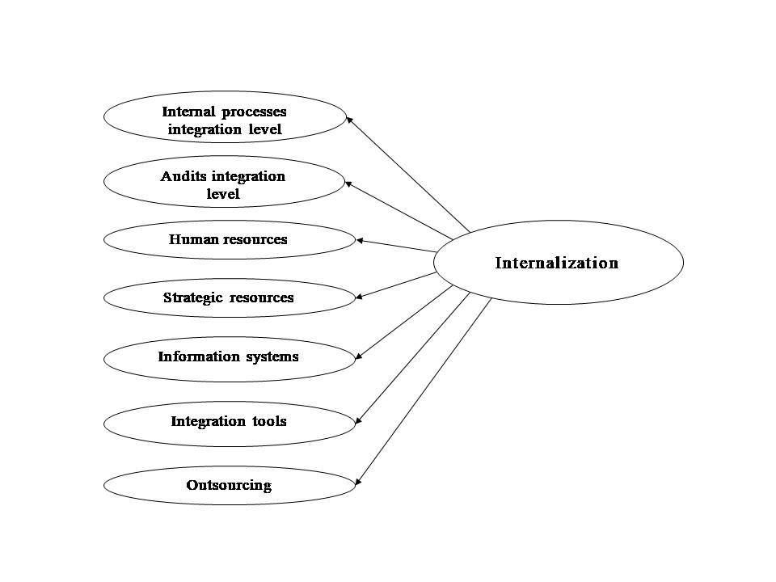
Figure 1. Internalization factors

Respectively, for corporate sustainability performance varimax rotation identified six latent factors that may be labeled customer-supplier relationship, employees, environment, financial institutions, society and state (see Fig. 2). Rotated component matrix is shown in Table 1b.
Table 1b. Corporate Sustainability Performance - Rotated component matrix

Factors | Items | Component
 |  | 1 | 2 | 3 | 4 | 5 | 6
Customer-Supplier relationship | Customer_complaint_rate | .745
 | Products | .737
 | Raw_materials | .735
 | Supplier_relationship | .720
 | Customer_comm | .657
 | Purchasing_management | .594
 | Supplier_turnover | .565
Employees | Absenteism |  | .840
 | Employee_turnover |  | .812
 | Employee_engagement |  | .651
 | Employee_initiative |  | .642
 | Employee_decision_making |  | .640
Environment | Renewables |  |  | .757
 | Water |  |  | .739
 | Env_impacts |  |  | .682
 | Energy |  |  | .643
 | Recycling |  |  | .567
 | Env_authorities |  |  | .503
Financial institutions | Loans |  |  |  | .899
 | Interest_rate |  |  |  | .829
 | Insurance |  |  |  | .799
Society | Sponsoring |  |  |  |  | .709
 | Community |  |  |  |  | .679
 | Image |  |  |  |  | .543
State | State_collaboration |  |  |  |  |  | .866
 | State_control |  |  |  |  |  | .798
 | Research |  |  |  |  |  | .569

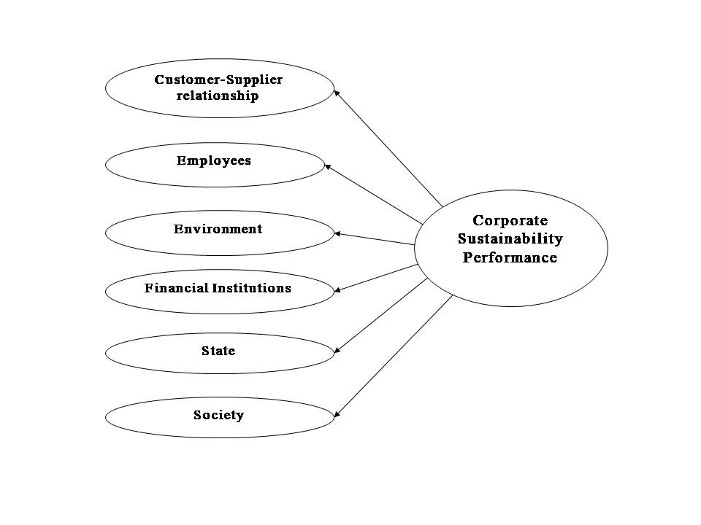
Figure 2. CSP factors

Model Reliability and Validity
A reliability analysis is performed to test the internal consistency of the constructs. Literature suggests 0.6 as the minimum acceptable value for Cronbach’s alpha (Cronbach, 1951) reliability coefficient (Hair et al. 2014; Nunnally and Bernstein, 1994). In this research, the internalization and corporate sustainability performance Cronbach’s alpha coefficients are found significantly high (0.909 for internalization and 0.935 for CSP).
For the identified composite factor named “Customers-Suppliers relationship”, which includes items of both factors (suppliers and customers), a comparison of Cronbach’s Alpha coefficients is conducted (prior and post exploratory factor analysis). Prior EFA alpha coefficient was equal to 0.838 for suppliers and 0.775 for customers, whilst post EFA alpha coefficient for Customer-Supplier relationship was found as high as 0.871.

Discriminant validity and average variance extracted
Discriminant validity reflects the extent to which a construct is truly distinct from other constructs both in terms of how much it correlates with other constructs and how distinctly measured variables represent only this single construct. Thus, high discriminant validity provides evidence that a construct is unique and captures some phenomena other measures do not. The results of factor analysis do support discriminant validity, since the items of each identified component load strongly on a single factor or - in other words - all individual measured items represent only one latent construct with the absence of cross-loadings (Hair et al., 2014: 624-625).
Average variance extracted (AVE) is a summary measure of convergence among a set of items representing a latent construct. It is the average percentage of variation explained (variance extracted) among the items of a construct. AVE values are presented in the following table (see Table 6).

Table 6. Convergent validity

Constructs | CR | AVE
Internalization
Internal processes integration level | 0,948 | 0,646
Audits integration level | 0,879 | 0,650
Human Resources | 0,835 | 0,559
Strategic Resources | 0,723 | 0,467
Information Systems | 0,833 | 0,627
Outsourcing | 0,883 | 0,716
Integration tools | 0,722 | 0,469
Corporate Sustainability Performance
Customers-Suppliers Relationship | 0,858 | 0,466
Employees | 0,843 | 0,522
Environment | 0,815 | 0,429
Financial institutions | 0,881 | 0,712
Society | 0,682 | 0,419
State | 0,795 | 0,570

Average Variance Extracted (AVE) should generally be higher than 0.5 yet values between 0.4 and 0.5 are accepted when composite (or construct) reliability is higher than 0.6, the convergent validity of the construct is still adequate (Fornell and Larcker, 1981)

- Discussion and conclusion

The exploratory factor analysis revealed seven factors that reflect internalization and six factors that ‘measure’ corporate sustainability performance. Two of the internalization factors reflect the integration level of the internal processes and the audits indicating the depth of the integration i.e. the degree of merging and penetration of multiple management systems within the organizational fabric. The remaining five factors represent resources that contribute to the integrated implementation of multiple management systems. These resources are mostly tacit and refer to gained experience and awareness based on information and knowledge. Thus, by their identity and function all seven factors serve internalization addressing its key features, i.e. the development of firms’ human, organizational and social capital (Ataseven et al., 2014).
Regarding the performance factors that are identified by EFA those that reflect the closest external stakeholders, i.e. the customers and the suppliers, seem to be strongly interrelated. This observation may be attributed to the former, less extrovert perspective of the quality management standard that included only the supplier and the customer within its scope. Firms with multiple management systems usually implement a quality management system first and, since the stakeholder approach was introduced only a few years before (2015), it can be expected that those two principal stakeholders are primarily and jointly considered by the majority of the firms both in the sample and in the general population. Statistical analysis of data identified five more factors contributing in corporate sustainability performance, that represent firm interactions with the employees, the environment, the financial institutions, the state and society at large. The involvement of both primary and secondary stakeholders is thus assured. The pressure of primary and secondary stakeholders has already been emphasized on internalization (Castka and Prajogo, 2013). In this research framework, the dual role of stakeholders is reflected by including primary and secondary stakeholders in the performance construct, as well.
It is evident that corporate sustainability performance is a wide and multidimensional construct that needs a broad and holistic approach, like the stakeholder spectrum. In their latest version (2015) the two flagship standards, i.e. the quality and environmental management system standards, have evolved and are now understood within their context (political, economic, social, technological, ethical and legal) taking into account the requirements and perceptions of relevant stakeholders. Following this evolution, this research is useful for practitioners that in close collaboration with top management and the employees of enterprises may use integrated management systems as leverage for all individual management systems to improve enhancing corporate sustainability performance.
This research aims to emphasize that integrated management systems are not a mere addition of management systems or a simple alignment of paragraphs of different standards. Integrated management systems are not generally certifiable, after all. Certifying compliance to several standards by yearly third-party audits is not what the standards’ are made for. For instance, there are certain guidelines that are non-certifiable, yet provide firms with useful management principles and practices (Will et al., 2019). Even for those management systems (quality, environmental, health and safety etc.) that abide by certifiable standards, certification is not obligatory. Moreover, in the case of certifiable management system standards the audits are usually ‘paragraph oriented’, meaning that they focus on the detailed, formal adoption of specific requirements of the standards leaving out the real meaning, the principles and the objectives of the standards, as originally perceived by their creators. Thus, irrespective of whether certification is an option or not, the debate between ceremonial and real implementation remains an issue, since there is always the underlying risk of ‘bragging’ or rather manifesting for a quality management system or a CSR management system or an IMS without actually benefiting from one. Putting an end to this interplay between the façade and the backstage internalization focuses on the essentials bringing together the necessary means for the exploitation of management systems to the benefit of the firm and its stakeholders.

References
Abad J., Dalmau I., Vilajosana J. (2014). “Taxonomic proposal for integration levels of management systems based on empirical evidence and derived corporate benefits”. Journal of Cleaner Production, 78, 164-173.
von Ahsen A. (2014). “The Integration of quality, environmental and health and safety management by car Manufacturers – a long-term empirical study”. Business Strategy and the Environment, 23(6), 395-416.
Armstrong J.S., Overton T.S. (1977). “Estimating nonresponse bias in mail surveys”. Journal of Marketing Research, 14, 396-402.
Asif M., Fisscher O.A.M., de Bruijn E.J., Pagell M. (2010). “An examination of strategies employed for the integration of management systems”. The TQM Journal, 22(6), 648-669.
Ataseven C., Prajogo D.I., Nair A. (2014). “ISO 9000 Internalization and organizational commitment- Implications for process improvement and operational performance”. IEEE Transactions on Engineering Management, 61(1), 5-17.
Bernardo M., Gotzamani K., Vouzas F., Casadesus M. (2016). “A qualitative study on integrated management systems in a non-leading country in certifications”. Total Quality Management & Business Excellence, 29(3-4), 453-480.
Bernardo M., Gianni M., Gotzamani K., Simon A. (2017). “Is there a common pattern to integrate multiple management systems? A comparative analysis between organizations in Greece and Spain”. Journal of Cleaner Production, 151, 121-133.
Bou-Llusar J.C., Escrig-Tena A.B., Roca-Puig V., Beltrán Martín I. (2009). “An empirical assessment of the EFQM excellence model: Evaluation as a TQM framework relative to the MBNQA model”. Journal of Operations Management, 27(1), 1-22.
Bourlakis M., Maglaras G., Aktas E., Gallear D., Fotopoulos, C. (2014). “Firm size and sustainable performance in food supply chains: insights from Greek SMEs”. International Journal of Production Economics, 152, 112-130.
Bozbura F.T., Beskese A., Kahraman, C. (2007). “Prioritization of human capital measurement indicators using fuzzy AHP”. Expert Systems with Applications, 32(4), 1100-1112.
Cabecinhas M., Domingues, P., Sampaio, P., Bernandes, M., Franceschini, F., Galetto, M., Gianni, M., Gotzamani, K., Mastrogiacomo, L., Hernandez-Vivanco, A. (2018). “Integrated management systems diffusion models in South European countries”. International Journal of Quality and Reliability Management, 35(10), 2289-2303.
Castka P., Prajogo, D. (2013). “The effect of pressure from secondary stakeholders on the internalization of ISO 14001”. Journal of Cleaner Production, 47, 245-252.
Cronbach L.J. (1951). “Coefficient alpha and the internal structure of a test”. Psychometrika, 16, 297-334.
Domingues P., Sampaio P., Arezes P.M. (2016). “Integrated management systems assessment: a maturity model proposal”. Journal of Cleaner Production, 124, 164-174.
Dyllick T., Muff K. (2016). “Clarifying the meaning of sustainable business: Introducing a typology from business-as-usual to true business sustainability”. Organization & Environment, 29(2), 156-174.
Elkington J. (1997). “Cannibals with forks: the triple bottom line of 21st century business”. Capstone Publishing Limited, UK.
Epstein M.J., Roy, M.-J. (2001). “Sustainability in action: Identifying and measuring the key performance drivers”. Long Range Planning, 34(5), 585-604.
Escrig-Tena A.B., Garcia-Juan B., Segarra-Ciprés M. (2019). “Drivers and internalisation of the EFQM excellence model”. International Journal of Quality & Reliability Management, 36(3), 398-419.
Fornell C., Larcker, D. (1981). “Evaluating Structural Equation Models with Unobservable Variables and Measurement Error”. Journal of Marketing Research, 18(1), 39-50.
Fowler F.J., Mangione T.W. (1990). Standardized Survey Interviewing Minimizing Interviewer-Related Error. Thousand Oaks, CA: Sage.
Fresner J., Engelhardt, G. (2004). “Experiences with integrated management systems for two small companies in Austria”. Journal of Cleaner Production, 12(6), 623-631.
Garengo P., Biazzo S. (2013). “From ISO quality standards to an integrated management system: an implementation process in SME”. Total Quality Management & Business Excellence, 24(3-4), 310-335.
Gianni M., Gotzamani K. (2015). “Management systems integration: lessons from an abandonment case”, Journal of Cleaner Production, 86, 265-276.
Gianni M., Gotzamani K. (2016). “Integrated Management Systems and Information Management Systems: Common Threads”. In P. Papajorgji, F. Pinet, A. Guimarães, & J. Papathanasiou (Eds.) Automated Enterprise Systems for Maximizing Business Performance, IGI Global, pp. 195-214.
Gianni M., Gotzamani K., Linden, I. (2016). “How a BI-wise responsible integrated management system may support food traceability”. International Journal of Decision Support System Technology, 8(2), 1-17.
Gianni M., Gotzamani K., Tsiotras G. (2017a). “Multiple perspectives on integrated management systems and corporate sustainability performance”. Journal of Cleaner Production, 168, 1297-1311.
Gianni M., Gotzamani K., Vouzas F. (2017b) “Food integrated management systems: dairy industry insights”. International Journal of Quality & Reliability Management, 34(2), 194-215.
Gotzamani K., Longinidis P., Vouzas F. (2010). “The logistics services outsourcing dilemma: quality management and financial performance perspectives”. Supply Chain Management: An International Journal, 15(6), 438-453.
Gotzamani K.D., Tsiotras G.D. (2002). “The true motives behind ISO 9000 certification: Their effect on the overall certification benefits and long term contribution towards TQM”. International Journal of Quality & Reliability Management, 19(2), 151-169.
Hair J.F., Black W.C., Babin B.J., Anderson R.E. (2014). Multivariate Data Analysis. 7th Ed. - Pearson New International Edition, Pearson Education Limited, Harlow, Essex, England.
Heras-Saizarbitoria I. (2011). “Internalization of ISO 9000: an exploratory study”. Industrial Management & Data Systems, 111(8), 1214-1237.
ISO (2018). The Integrated Use of Management System Standards (IUMSS) ISO HANDBOOK. 2nd ed., Switzerland.
Ketokivi M.A., Schroeder, R.G. (2004). “Strategic, structural contingency and institutional explanations in the adoption of innovative manufacturing practices”. Journal of Operations Management, 22(1), 63-89.
Luk C.-L., Yau O.H.M., Chow R.P.M., Tse A.C.B., Sin, L.Y.M. (2005). “Stakeholder orientation and business performance: The case of service companies in China”. Journal of International Marketing, 13(1), 89-110.
Maletič M., Maletič D., Gomišček, B. (2016). “The impact of sustainability exploration and sustainability exploitation practices on the organisational performance: a cross-country comparison”. Journal of Cleaner Production, 138, Part 2, 158-169.
Maletič, M., Maletič D., Dahlgaard J., Dahlgaard-Park S.M., Gomišcek B. (2015). “Do corporate sustainability practices enhance organizational economic performance?”. International Journal of Quality and Service Sciences, 7(2/3), 184-200.
Malhotra M.K., Grover V. (1998). “An assessment of survey research in POM: From constructs to theory”. Journal of Operations Management, 16 (4), pp. 407-425
Nair A., Prajogo, D. (2009). “Internalisation of ISO 9000 standards: the antecedent role of functionalist and institutionalist drivers and performance implications”. International Journal of Production Research, 47(16), 4545-4568.
Nunnally J.C., Bernstein, I.H. (1994). “The Assessment of Reliability”. Psychometric Theory, 3(1), 248–292.
Nunhes T.V., Bernardo M., Oliveira, O.J. (2019). “Guiding principles of integrated management systems: Towards unifying a starting point for researchers and practitioners”. Journal of Cleaner Production, 210, 977-993.
Oksenberg L., Cannell C., Kalton, G. (1991). “New Strategies for Pretesting Survey Questions”. Journal of Official Statistics, 7(3), 349-365.
Podsakoff P. M., MacKenzie S. B., Lee J.-Y., Podsakoff N. P. (2003). “Common method biases in behavioral research: A critical review of the literature and recommended remedies”. Journal of Applied Psychology, 88(5), 879-903.
Podsakoff P.M., Organ D.W. (1986). “Self-Reports in Organizational Research: Problems and Prospects”. Journal of Management, 12(4), 531–544.
Poltronieri C.F., Ganga G.M.D., Gerolamo M.C. (2019). “Maturity in management system integration and its relationship with sustainable performance”. Journal of Cleaner Production, 207, 236-247.
Poltronieri C.F., Gerolamo M.C., Dias T.C.M., Cesar L., Carpinetti, R. (2018). “Instrument for evaluating IMS and sustainable performance”. International Journal of Quality & Reliability Management, 35(2), 373-386.
Qi G., Zeng S., Li X., Tam C. (2012). “Role of Internalization Process in Defining the Relationship between ISO 14001 Certification and Corporate Environmental Performance”. Corpopare Social Responsibility and Environmental Management, 19, 129-140.
Rebelo M.F., Santos G., Silva, R. (2016). “Integration of management systems: towards a sustained success and development of organizations”. Journal of Cleaner Production, 127, 96-111.
Savino M.M., Batbaatar, E. (2015). “Investigating the resources for Integrated Management Systems within resource-based and contingency perspective in manufacturing firms”. Journal of Cleaner Production, 104, 392-402.
Savino M.M., Shafiq, M. (2018), “An extensive study to assess the sustainability drivers of production performances using a resource-based view and contingency analysis”, Journal of Cleaner Production, 204, 744-752.
Simon A., Bernardo M. (2014). “How does human resources management influence the implementation of integrated management systems?”. 1st International Conference on Quality Engineering and Management, Proceedings Book, 291-302, 14th-16th September, Guimarães, Portugal.
Simon A., Karapetrovic S., Casadesús, M. (2012a). “Evolution of integrated management systems in Spanish firms”, Journal of Cleaner Production, 23(1), 8-19.
Simon A., Karapetrovic S., Casadesús M. (2012b). “Difficulties and benefits of integrated management systems”. Industrial Management & Data Systems, 112(5), 828-846.
Simon A., Bernardo M., Karapetrovic S., Casadesus M. (2011). “Integration of standardized environmental and quality management systems audits”. Journal of Cleaner Production, Vol. 19, pp. 2057-2065.
Simon A., Yaya L.H.P., Karapetrovic S., Casadesús M. (2014). “An empirical analysis of the integration of internal and external management system audits”, Journal of Cleaner Production, 66, 499-506.
Simon A., Douglas, A. (2013). “Integrating management systems: does the location matter?”. International Journal of Quality & Reliability Management, 30(6), 675-689.
Singh V., Kumar A., Singh T. (2018). “Impact of TQM on organisational performance: The case of Indian manufacturing and service industry”. Operations Research Perspectives, 5, 199-217.
Sousa R., Voss, C.A. (2008). “Contingency research in operations management practices”. Journal of Operations Management, 26(6), 697-713.
Tarí J.J., Heras-Saizarbitoria I., Pereira J. (2013). “Internalization of quality management in service organizations”. Managing Service Quality, 23(6), 456-473.
Testa F., Boiral O., Iraldo F. (2018a). “Internalization of Environmental Practices and Institutional Complexity: Can Stakeholders Pressures Encourage Greenwashing?”. Journal of Business Ethics, 147(2), 287-307.
Testa F., Boiral O., Heras‐Saizarbitoria I. (2018b). “Improving CSR performance by hard and soft means: The role of organizational citizenship behaviours and the internalization of CSR standards”. Corporate Social Responsibility and Environmental Management, 25(5), 853–865.
Wagner M. (2015). “The link of environmental and economic performance: Drivers and limitations of sustainability integration”. Journal of Business Research, 68, 1306-1317.
Wagner M. (2011). “Corporate performance implications of extended stakeholder management: New insights on mediation and moderation effects”. Ecological Economics, 70(5), 942-950.
Will M., Brauweiler J., Zenker-Hoffmann A., Delakowitz B. (2019). “An Inquiry to Consider CSR in Integrated Management Systems”. In: Leal Filho W. (eds) Social Responsibility and Sustainability. World Sustainability Series. Springer, Cham.
Yan T., Kreuter F., Tourangeau, R. (2012). “Evaluating Survey Questions: A Comparison of Methods”. Journal of Official Statistics, 28(4), 503-529.
ANNEX I

Operationalization of Research Constructs
 | Items | Pertinent literature
 | PDCA (Plan-Do-Check-Act) | Bernardo et al. (2009); Garengo & Biazzo (2013)
 | Process map | Bernardo et al. (2009)
 | Standards’ common elements | Bernardo et al. (2009)
 | Tailored framework | Bernardo et al. (2009); Garengo & Biazzo (2013)
 | MS embeddedness in corporate culture | Savino & Batbaatar (2015)
 | Managers’ awareness of MS potential benefits. | Savino & Batbaatar (2015)
 | Employees’ awareness of MS potential benefits. | Savino & Batbaatar (2015)
 | Corporate experience in multiple MS implementation | Asif et al. (2009); Oliveira (2013)
 | MS operation is the exclusive task of MS managers. | Simon & Bernardo (2014)
 | Employees receive regular training in MS implementation. | Bernardo et al. (2010); Nunhes et al. (2019); Simon et al. (2014)
 | Employees are engaged in MS implementation | Savino & Batbaatar (2015)
 | IT tools | Garengo & Biazzo (2013); Savino & Batbaatar (2015)
 | ERP | Savino & Batbaatar (2015)
 | Business Intelligence | Gianni et al. (2016); Gianni & Gotzamani (2016)
 | Decision support systems | Savino & Batbaatar (2015)
 | Top management MS commitment | Savino & Batbaatar (2015)
 | Top management MS engagement | Gianni & Gotzamani (2015); Savino & Batbaatar (2015); Simon & Bernardo (2014)
 | Top management MS assessment | Garengo & Biazzo (2013)
 | MS operation subcontracting | Bourlakis et al. (2014); Gianni et al. (2017b); Gotzamani et al. (2010)
 | Internal audits subcontracting | Bourlakis et al. (2014); Gianni et al. (2017b); Gotzamani et al. (2010)
 | Documentation for external audits subcontracting | Bourlakis et al. (2014); Gianni et al. (2017b); Gotzamani et al. (2010)
 | MS policies and objectives | Asif et al. (2010), Simon et al. (2012b)
 | MS planning based on common standard | Simon and Bernardo (2014), Von Ahsen (2013)
 | MS operation by a single person or department | Simon and Bernardo (2014)
 | MS performance is evaluated in a unified mode. | Abad et al. (2014)
 | MS preventive and corrective actions are performed in a unified mode. | Abad et al. (2014), Simon et al. (2012a)
 | MS non-compliance is monitored in a unified mode. | Abad et al. (2014), Simon et al. (2012a)
 | MS documents and records control are monitored in a unified mode. | Simon and Bernardo (2014), Von Ahsen (2013)
 | Product design and development are supported by multiple MSs in a unified mode. | Abad et al. (2014), Simon et al. (2012a)
 | Production is supported by multiple MSs in a unified mode. | Savino & Batbaatar (2015)
 | Training is supported by multiple MSs in a unified mode. | Tarí & Molina-Azorín (2010)
 | Purchasing is supported by multiple MSs in a unified mode. | Savino & Batbaatar (2015)
 | Sales are supported by multiple MSs in a unified mode. | Savino & Batbaatar (2015)
 | Internal audits are simultaneously conducted in a unified mode. | Abad et al. (2014); von Ahsen (2013); Savino & Batbaatar (2015); Simon et al. (2011)
 | External audits are simultaneously conducted in a unified mode | Abad et al. (2014), von Ahsen (2013), Simon et al. (2011)
 | A single, unified report is issued for MSs internal audits. | Simon et al. (2011)
 | A single, unified report is issued for MSs external audits. | Simon et al. (2011)

Corporate Sustainability Performance
 | Items | Pertinent literature
 | Nonconforming raw materials rate has decreased. | Tarí & Molina-Azorín (2010); Wagner (2015)
 | Nonconforming products rate has decreased. | Tarí & Molina-Azorín (2010)
 | Relationships with suppliers have improved. | Wagner (2015)
 | Suppliers’ turnover rate has decreased. | Garengo and Biazzo (2013)
 | Purchasing management has improved. | Wagner (2011)
 | Customer complaint rate has decreased. | Bou-Llusar et al. (2009); Maletič et al. (2015); Savino & Shafiq (2018)
 | Communication with customers has improved. | Simon et al. (2012b)
 | Market share has increased. | Epstein & Roy (2001); Luk et al. (2005); Wagner (2011)
 | Sales have increased. | Luk et al. (2005); Wagner (2011; 2015)
 | Earnings have increased. | Luk et al. (2005)
 | Interest rates have decreased. | Wagner (2011)
 | Access to loans has improved. | Epstein & Roy (2001); Wagner (2011)
 | Insurance terms have improved. | Wagner (2011)
 | Employee turnover rate has decreased. | Bou-Llusar et al. (2009); Poltronieri et al. (2018)
 | Absenteeism rate has decreased. | Gianni et al. (2017)
 | Employee initiatives have increased. | Bou-Llusar et al. (2009)
 | Employee engagement in MS implementation has increased. | Simon et al. (2012b)
 | Employee participation in decision making has increased. | Gianni et al. (2017)
 | Health and safety measures have improved. | Maletič et al. (2015)
 | Communication with environmental authorities has improved. | Bozbura et al. (2007); Fresner & Engelhardt (2004); Poltronieri et al. (2018)
 | Environmental impacts of business activities have decreased. | Maletič et al. (2015) ); Poltronieri et al. (2018)
 | Water saving has increased. | Maletič et al. (2015); Poltronieri et al. (2018)
 | Energy saving has increased. | Maletič et al. (2015); Poltronieri et al. (2018); Savino & Shafiq (2018)
 | Use of recycled materials has increased. | Maletič et al. (2015); Poltronieri et al. (2018); Savino & Shafiq (2018)
 | Recycling rate has increased. | Maletič et al. (2015); Savino & Shafiq (2018)
 | Communication with state authorities has improved. | Bozbura et al. (2007); Fresner & Engelhardt (2004)
 | Collaboration with public bodies has increased. | Bozbura et al. (2007); Fresner & Engelhardt (2004)
 | Collaboration with academic and research institutes has increased. | Bozbura et al. (2007)
 | Sponsoring and other measures to support local community have increased. | Gianni et al. (2017); Poltronieri et al. (2018)
 | Rewarding by local authorities, NGOs etc. has increased. | Gianni et al. (2017)
 | Corporate image has improved. | Maletič et al. (2015); Rebelo et al. (2016); Savino & Batbaatar (2015)

