EFFECTS OF PACKAGING IN THE PERCEPTION OF DIETETIC COOKIES

Modesto De Luca
Email mod.deluca@gmail.com

Raffaele Campo
Phd
Email raffaele.campo@uniba.it
Corresponding Author

Oronzo Trio
Department of Economics
University of Salento (Italy)
Email oronzo.trio@unisalento.it

Felipe Reinoso Carvalho
PhD
Universidad de los Andes School of Management
Bogotá, Colombia
Email f.sound@gmail.com

Abstract
Food packaging represents a powerful sensory tool for food marketers. As a matter of fact, it could be considered as the “visiting card” of a product. Besides protecting and preserving the product, through its connotative elements, packaging also plays a communicative function, becoming fundamental for product positioning. Moreover, the consumer-package interaction plays a strategic role for marketers. A notable body of literature has shown, e.g., how the perception of flavor is not only a question of actual taste, but it is the result of a combination of sensations and emotions that starts with expectations elicited even before the product’s experience. Hence, this research looks for to empirically verify how different type of packages impact the perceived healthiness of food.
An experiment was conducted, where participants divided into two groups rated – using scales – the perceived healthiness of packed dietary cocoa biscuits. All the data were analyzed through the ANOVA model.
These results show that the cookies were perceived as “lighter”, but not necessarily more healthful, in their original packaging. Interestingly, the cookies were rated as more caloric in a traditional glass presentation. Finally, the packaging itself has no influence on the perception of attributes such as "crumbly".
Implications and future are also discussed.

Keywords
consumers; cross-modality; dietetic food; packaging; perception; quality
Introduction

For a long time, food/drink packaging represents a fundamental tool for marketers. In 1967, Guss already wrote a book entitled “Packaging is marketing” (Guss, 1967). Indeed, packaging can be framed as playing two principal functions. The first one is merely physical, and the second one more communicative. On the one hand, and from the physical point of view, a package has to protect the content from the external environment, while guaranteing the facility of usage, storage (Vaclavik and Christian 2008), transport, and disposal (even if sometimes it has been projected to be potentially reused, as in glass jars). On the other hand, a package’s communicative perspective is particularly relevant from the marketing point of view, since it helps consumers to identify the content, and/or to gather information about the product, prior its consumption. Moreover, through packaging, different strategic characteristics and/or attributes of a product can also be delivered to the consumer (think of health benefits, or authentic/traditional aspects).
Essentially, the connotative elements of packaging are shape, size, material, color and graphic/illustrative elements. Shape is often imposed by content, material, and way of consumption (as in ergonomics). However, at the same time, it might represent a distinctive feature of a brand (e.g., Coca-Cola and its well-known bottle). According to Folkes and Matta (2004), shape can also influence the perception of a product’s volume. Through a series of experiments, they showed how a package’s shape, considered as more attractive, leads towards the perception of a greater volume, when compared to a ‘less attractive’ same-sized package. Salgado-Montejo et al. (2015) also found that symmetrical shapes are more easily associated with sweetness and a taste’s pleasantness.
Besides playing a crucial role in handling and preservation, the choice of materials can be of great importance concerning a product’s positioning. Kadoya (1991) analyzed some of the most used materials in packaging, highlighting their main features. For example, paper and paperboard are printable, stiff, lightweight, easy to dispose, and cheap. Tinplate is heavy-duty and recyclable, but certainly more expensive. Glass is recyclable, reusable, hygienical, and often used to communicate greater quality and elegance. While being often perceived as a low quality type of material, plastic is framed as cheaper, very practical, but recently also as a main source of environmental pollution.
Colors and graphics also represent an influential tool for marketers for visual and semantic communication purposes. In particular, colors can create a strong association with a specific brand (Silayoi and Speece 2007) – e.g., think of Milka chocolate and its typical lilac package. Regarding typography, Ampuero and Vila (2006) underline that bold, large, roman, and upper case letters, are used for elegant products, while serif and sans serif typographies are more specific to popular products.
Packaging, in summary, embodies a strategic tool for marketers. From such a perspective, this study aims at analyzing a consumers’ attitude towards different types of food packaging, in order to better comprehend its marketing implications.

- Theoretical background

Research on the effect of packaging on the consumer’s experience includes a variety of studies, some of which are based on the analysis of its multiple aspects as a whole, while others tend to be more focused on a single element (e.g. color). Adam and Ali (2014), for example, analyzed the influence of different elements of milk packaging on consumers. 384 participants were involved in an experiment in which they had to express their level of agreement with a series of sentences related to some of the connotative elements of the package. Here, the correlation between the purchase intention and the glass package was positive, as compared to the negative associated to tetra-pack and plastic. While analyzing the graphical aspects, a positive correlation was found in favor of perceived good quality of characters and graphics. Interestingly, the correlations associated to the package’s design, material, color, and size, were not significant. Particularly relevant was also the positive correlation between nutritional information and their presence on the package. Similarly, the specification of the country of origin seemed to draw more attention than other visual components present in the package.
A focus on the relationship between the perceived healthiness and the presence of information on package, according to adolescents, characterizes the study carried out by Vila-Lopez and Kuster-Boluda (2016). In this study, it was found that adolescents who pay attention to food-related issues (e.g., weight control and/or nutritional factors), are mainly attracted by the explicit informative content printed clearly on the package - rather than the visual decorative elements - where teenage women show a more evident tendency towards this behavior.
Interestingly, in some cases, the presence of a package might result useless or even detrimental. In a study involving children from 4 to 11 years-old, Baldassarre and Campo (2014) verified how elder children (in particular those aged 9-11) mistrust the freshness and the quality of packaged fruit and vegetable, while kindergartners and early primary school children are actually more indifferent to the presence of a package. These findings are similar to those of Koutsimanis et al. (2012), who showed that the most important attributes to influence consumers in purchasing fresh products are price, shelf-life, container size, disposal method and, to a lesser extent, material, package integrity, and stem on/off.
A branch of research has also assessed the crossmodality of package on taste as a driver during decision-making (van Rompay, Fransen and Borgelink, 2014; Velasco & Spence, 2019). For example, Raudenbush et al. (2002) proved how the taste of a beverage can be perceived differently depending on the material of its container, as well as Spence and Carvalho (2019). As a matter of fact, in an experiment involving 61 participants, Raudenbush et al. (2002) demonstrated that hot chocolate was perceived tastier if served in a ceramic cup, rather than a glass one. Similarly Tu, Yang and Ma (2015) found that the perception of the sweetness of cold tea was influenced by the material of the cups. In particular, participants perceived such a tea as sweeter when served in a glass cup, when compared to when served on a paper, or plastic, cup. Sourness and bitterness ratings, on the other hand, were less conditioned by the cup’s material. Similarly, the icy and cold taste ratings were higher in the case of the glass cup, confirming that the tactile sensation due to the contact with the material had a significant effect on taste perception (cf., Chen et al. 2009; Schifferstein, 2009). According to Maggioni et al. (2015) the weight of a drink’s vessel also plays an important role while influencing the perception of taste. Here, they found that water is perceived less likable if served in a heavier vessel. Furthermore, Wan et al. (2015) demonstrated how the glassware influences the experience of alcoholic drinks.
A further element of influence is the shape of packaging. In a literature review on this matter, Velasco et al. (2016) introduced extensive evidence proving, e.g., that bitterness and sourness are usually associated with angular shapes, whereas sweetness tends to be associated with round shapes.
The effect of package shape was also analyzed by Ares and Deliza (2010) with 105 consumers. Their findings revealed that shape and color conditioned consumers’ liking and willingness to purchase ratings of milk desserts. Becker et al. (2011) studied the impact of shape (angular vs. rounded), curvature, and color saturation (low vs. high) of yogurt packaging on its tasting experience. Findings pointed out the fact that consumers sensitive to package design rated the yoghurt contained in the angular shaped package as more expensive, and as having a more intense taste, than the yogurt presented in rounded shape packaging.
A cross-modal interaction between the visual cues and the gustatory component is further illustrated in some studies relative to a container’s colors. Piqueras-Fiszman and Spence (2012) showed that participants preferred a hot chocolate beverage served in a red cup, as compared to served in white, orange, or dark cream-colored ones (probably because this color conveys towards the idea of heat). Furthermore, such chocolate flavor was considered as more intense when served in the orange cup (which was white inside), whereas the chocolate’s aroma was rated as being more intense in the dark cream cup. Similar results were reached by Risso et al. (2015), who demonstrated that water is perceived more sparkling when served into a red or blue cup, when compared to served in a white one. Harrar et al. (2011), on the other hand, showed that sweet popcorn tasted saltier and that salty popcorn tasted sweeter when served in a colored bowl, when compared to served in a white one.

3. Influence of some attributes present on package: an experiment

The objective of this new study was analyzing how particular attributes present on package can influence a consumers’ expectations of food content. In particular, the researchers wanted to explore how the information relative to healthiness and lightness present on packaging could affect the perception of healthiness and pleasantness of cookies, which were presented in two different ways (in the original commercial packaging, vs in a transparent jar which did not contain any data related to the product).

Figure 1. The ways the cookies were presented (transparent jar vs original package)

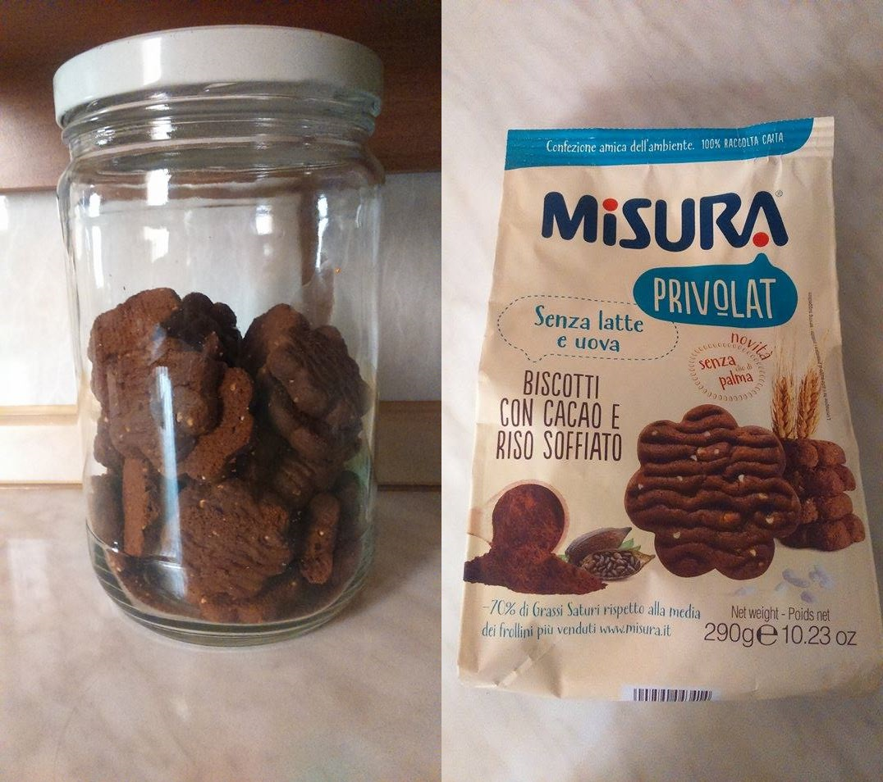

Source: Our photo

Considering this theoretical framework, we hypothesized the following:
H1: The original package of a healthy food makes the consumers perceive it as lighter and healthier.
H2: A jar makes the consumers perceive the product as more delicious and more caloric, when compared to the original packaging.
H3: The original package of a healthy product makes the consumer perceive it as crumblier.

3. Methodology and results
31 participants (12 females and 19 males), subdivided into two groups, with an average age of 29.65 years joined the experiment.
Researchers used "Privolat" dietary cookies by Misura (an Italian brand of Colussi Group, which focuses on consumers who pay attention to wellness). Privolat are chocolate cookies based on puffed rice (without milk, eggs, neither palm oil). The product’s formula is stated as it follows: wheat flour - sugar - vegetable sunflower oil 16% - 6% puffed rice - fat cocoa powder 4% - raising agents (ammonium hydrogen carbonate, sodium hydrogen carbonate, disodium diphosphate) - emulsifiers: lecithin soy - aromas - salt.
The first group (namely ‘T’) had the cookies offered in a glass jar, while the second group (namely ‘S’), had the product served in its original package. Table 1 shows the main feature of the two groups.

Table 1. Features of the two groups involved in the experiment
 | Group T | Group S
Cookies container | Glass jar | Commercial original package
Numerosity | 15 | 16
Average age | 29,4 | 29,88

Source: Our elaboration

Participants were told to take a cookie from the corresponding jar. If the participants belonged to S, they were explained to take the time they needed to observe the packaging prior tasting. After tasting, the participants were asked to answer basic demographic information, followed by their own evaluation concerning the specific characteristics of the product, based on a 9-point rating scale (being 1 ‘not at all’, and 9 ‘very much’). The following attributes were inquired: crumbliness, healthiness, greediness, lightness, caloric content.
The obtained data was analyzed by means of ANOVA (the ANOVA test was passed when F* was higher than F-critical value, with F* representing the value F-value that was actually found). Note that, while initially comparing the average means of the obtained data (MS and MT), it was arbitrarily decided to proceed with the statistical analysis only for the variables for which the average difference between the attributes was higher than 0.5 points. The choice was made for two reasons. The first one concerns to the fact that the study of variance is necessary to validate the actual differences between averages (e.g., if the difference is poor, the corresponding validation becomes useless). Secondly, during empirical pre-tests, it was noticed that two small groups of participants would hardly exceed the critical Fisher index, when the differences between means are less than 1-1.5 points).

The differences in the obtained ratings for the attribute “light” where significant at 90% confidence (MS-MT= 1.35), where MS participants rated the cookies as lighter when compared to MT ones.

Table 2. Anova test
 | Sum of squares | Degree of freedom | Mean square | F-critical value | Alpha value
SSB | 14,20 | 1 | 14,20 | 2,89 | 0,1
SSW | 98,77 | 29 | 3,41 | F*
SST | 112,97 | 30 | 3,77 | 4,17

Source: Our elaboration

The differences in ratings for the attribute “caloric” (MS-MT = -1.47) where significant at 95% confidence, where MT participants rated the cookies as more caloric when compared to MS ones.

Table 3: Anova test
 | Sum of squares | Degree of freedom | Mean square | F-critical value | Alpha value
SSB | 16,65 | 1 | 16,65 | 4,18 | 0,05
SSW | 97,73 | 29 | 3,37 | F*
SST | 114,39 | 30 | 3,81 | 4,94

The ratings related to crumbliness, healthiness, and greediness didn’t achieve statistical significant differences between both groups, at 90% confidence.
• "crumbly" (MS-MT = 0.81), F critical = 2.89 vs F* = 2.17;
• "healthy" (MS-MT = 1.00), F critical = 2.89 vs F* = 1.57;
• "greedy" (MS-MT = -0.64), F critical = 2.89 vs F* = 0.93.

4. Discussion
Hypothesis H1 was partially confirmed since, in their original packaging, the cookies were rated as lighter but not necessarily more healthful. This contradiction is comprehensible since the package could communicate lightness, but the concept of healthiness could be somehow misunderstood, as industrial cookies are hardly regarded as healthy food. As a matter of fact, during the experiment, many of the participants stressed their confusion in associating an adjective like “healthy” with an industrial cookie.
Hypothesis H2 was also partially confirmed. Here, consumers rated the same cookie as more caloric when presented in a glass jar, and in the absence of information relative to packaging. In this context, ratings related to greediness did not trigger any significant differences. Contrary to what was expected, the researchers initially supposed a reduction of greediness and caloric perception in the case of the original package (which provides information concerning the healthiness of these cookies). However, it appears that a product can be considered as tasty despite its aura of dietary product, and this may be due to the massive advertising campaigns through which companies inform consumers that lightness does not necessarily contradict taste. A different - but plausible - interpretation of these results could be the fact that a glass jar without any product information resembles a non-industrial traditional crafted-made type of product, which would perhaps make it be perceived as more caloric, since it was probably made without industrial care.
Finally, Hypothesis H3 was not confirmed, since the original packaging did not influence the perception of the attribute "crumbly".

4. Practitioner implications
Following these results, companies could effectively use packaging to communicate healthiness without the risk to make the product being perceived as less sweet and/or less greedy. Like this, the product would be potentially perceived as lighter, when compared to competitors that do not follow similar marketing strategies. However, results suggest that it would not be useful to make industrial cookies appear as healthier, since consumer seem to be able to make a clear distinction between what is low in calories and lighter, and what is actually healthy.
When thinking about those consumers who pay careful attention to the healthiness of what they eat, rather than focusing on communicating healthiness in packaging, food companies could emphasize on the lightness of the product. For example, claims such as “light like a cloud” or “easily digestible”, could be effectively used to position dietary cookies. This would be a way to strategic to stress the low caloric content feature of such type of confectionary products. In future similar studies, this could be further enhanced by, e.g., using a particular color, font, or size, and/or by assessing comparisons along with the competition. Actually, these findings are also consistent with the strategic choice of one of the most important companies in the world, Coca Cola. These dietetic beverages are commercialized emphasizing the aforementioned two attributes, such as the lightness of a ‘Diet Coke’, and the low caloric content of a ‘Coke Zero’. As suggested by Vila-Lopez and Kuster-Boluda (2016), companies could further consider a gender differentiation as well. When they are looking to purchase dietetic food, women usually pay more attention than men to information printed on packaging. Hence, on the one hand, companies could improve their informative cues based on lightness and low caloric content on packaging, when directing their marketing strategies on a female target. On the other hand, they could focus on persuade men about the importance of weight control and health. Actually, Coca Cola introduced its Coke Zero aiming at male consumers, after launching its Diet Coke, that was aimed towards the female market (Walsh, 2011).

5. Limitations
It is necessary to extend this sample-size in order to obtain more robust evidence on the effects here observed. Such extension would also allow, e.g., to assess the effect of gender and age in results. Moreover, other kinds of food and beverage categories may be tested, in order to provide a wider overview and applicability. A better control on how the information vs no information present in the different types of packaging, along with more package materials, could also be explored (i.e., plastic vs glass, and so on).

References

Adam, M.A., Ali, K. (2014). How packaging elements impact consumer’s buying decisions. Lap Lambert Academic Publishing: Saarbrucken.
Ampuero, O., Vila, N. (2006), “Consumer perceptions of product packaging”, Journal of Consumer Marketing, 23(2): 102-114.
Ares, G., Deliza, R. (2010). “Studying the influence of package shape and colour on consumer expectations of milk desserts using word association and conjoint analysis”, Food Quality and Preference, 21(8): 930-937.
Baldassarre, F., Campo, R. (2014). “L’influenza del brand, del packaging e dei character sulle preferenze dei bambini: confronto tra ortofrutta ed altri alimenti”, Mercati e Competitività, 2: 129-149.
Becker, L., van Rompay, T..J.L., Schifferstein, H.N.J., Galetzka, M. (2011). “Tough package, strong taste: The influence of packaging design on taste impressions and product evaluations”, Food Quality and Preference, 22(1): 17-23.
Chen, X., Barnes, C. J., Childs, T. H.C., Henson, B., Shao, F. (2009). “Materials’ tactile testing and characterisation for consumer products’ affective packaging design”, Materials & Design, 30(10): 4299-4310.
Folkes, V., Matta, S.(2004). “The Effect of Package Shape on Consumers' Judgments of Product Volume: Attention as a Mental Contaminant”, Journal of Consumer Research, 31(2): 390-401.
Guss, L.M. (1967), Packaging is marketing. American Management Association: New York.
Harrar, V., Piqueras-Fiszman, B., Spence, C. (2011). “There’s no taste in a white bowl”, Perception, 40(7), 880-892.
Kadoya, T. (1991). Food Packaging. Academic Press: San Diego.
Koutsimanis,, G., Getter, K., Behe, B., Harte, J., Almenar, E. (2012). “Influences of packaging attributes on consumer purchase decisions for fresh produce”. Appetite, 59 (2): 270-280.
Maggioni, E., Risso, P., Olivero, N., Gallace, A. (2015), “The effect of a container weight on the perception of mineral water”, Journal of Sensory Studies, 30(5): 395-403.
Piqueras-Fiszman, B., Spence, C. (2012), “Do the color of the cup influence the consumer’s perception of a hot beverage?”, Journal of Sensory Studies, 27(5): 324-331.
Raudenbush, B., Meyer, B., Corley, W.E.N., Patterson, S. (2002). “Rating of pleasantness and intensity for beverage served in containers congruent and incongruent with expectancy”, Perceptual and Motor Skill, 94(2): 671-674.
Risso, P., Maggioni, E., Olivero, N., Gallace, A.(2015), “The association between the colour of a container and the liquid inside: An experimental study on consumers’ perception and choices regarding mineral water.”, Food Quality and Preference, 44: 17-25.
Salgado-Montejo, A., Alvarado, J.A., Velasco, C., Salgado, C. J., Hasse, K., Spence, C. (2015), “The sweetest thing. The influence of angularity, symmetry, and number of elements on shapevalence and shape-taste matches” Frontier in Psychology, 6: 1382.
Schifferstein, H. N.J. (2009). “The drinking experience: cup or content?”, Food Quality and Preference, 20(3): 268-276.
Silayoi, P., Speece, M. (2007), “The importance of packaging attributes: a conjoint analysis approach”, European Journal of Marketing, 41(11/12): 1495-1517.
Spence, C., & Carvalho, F. M. (2019). Assessing the influence of the coffee cup on the multisensory tasting experience. Food Quality and Preference, 75: 239-248.
Tu, Y., Yang, Z., Ma, C. (2015), “Touching taste: the haptic perception transfer of liquid food packaging materials”, Food Quality and Preference, 39: 124-130.
Vaclavik, V.A., Christian, E. W. (2008), Essential of Food Science, Springer: New York.
Van Rompay, T.J.L., Fransen, M.L., Borgelink, B.G.D. (2014), “Light as a feather: Effects of packaging imagery on sensory product impressions and brand evaluation”, Marketing Letters, 25(4): 397-407.
Velasco, C., Spence, C. (2019). “Multisensory Product Packaging: An Introduction”. In Multisensory Packaging (pp. 1-18). Palgrave Macmillan: Cham.
Velasco, C., Woods, A.T., Petit, O., Cheok, A.D., Spence, C. (2016). “Crossmodal correspondeces between taste and shape, and their implication for product packaging: a review”, Food Quality and Preference, 52: 17-26.
Vila-Lopez, Natalia, Kuster-Boluda, Ines (2016). “Adolescents’ food packaging perceptions. Does gender matter when weight control and health motivation are considered?”, Food Quality and Preference, 52: 179-187.
Walsh, John (2011). “Case study: Coca-Cola”, available at https://www.ft.com/content/aad28ad0-2417-11e0-a89a-00144feab49a.
Wan, X., Zhou, x., Woods, A.T., Spence, C. (2015). “Influence of the glassware on the perception of alcoholic drinks”, Food Quality and Preference, 44: 101-110.

