Empowering internal customers by developing their engagement – The case of CCE Ltd.

Anže Bizjan
CCE Commissioning & Consulting Engineers Ltd., Slovenia
Email: anze.bizjan@cce.si

Jure Jovanović
CCE Commissioning & Consulting Engineers Ltd., Slovenia
Email: jure.jovanovic@cce.si

Marko Kiauta
Tangram TQC Consulting & Engineering Ltd., Slovenia
Email: kiauta.marko@amis.net

Ivan Rahelić
CCE Commissioning & Consulting Engineers Ltd., Slovenia
Email: ivan.rahelic@cce.si

Abstract:
CCE Ltd. is a company of 26 that grew organically to its current size. Company’s vision is to stay and lead the market for 100 years and more. The importance of not only staying in the market means that a new approach is needed.
As we cannot foresee everything that will change in the course of next 3 years, not to mention anything beyond, a need for openness to switch from prescribe and control approach to coordinate and support approach; from obligatory quality rules to open source knowledge system.
To identify general attitude of our employees as internal customers two questionnaires were designed and applied. Their conclusions are presented in this paper. Further strategy was developed based on input obtained from the results.
Firstly, a series of internal training sessions were conducted in order to form a base for further communication. This served also as a non-formal data gathering process and initial step for encouraging further engagement.
Secondly another round of same questionnaires was applied to check for possible improvements.

Keywords
Work environment, knowledge management, work, change, development
- CCE Ltd.
CCE is an engineering firm (currently 26 employees) which provides consulting and commissioning services world-wide. CCE specializes in protection, control and SCADA systems used in generation, transmission and distribution of electricity (Figure 1).
CCE’s mission is to provide technical requirements for quality and reliable power supply. By supplying sophisticated secondary systems that allow optimal control, safe protection and effective communication, CCE has successfully attained this mission (Figure 2).
Figure 1: Secondary systems made by CCE
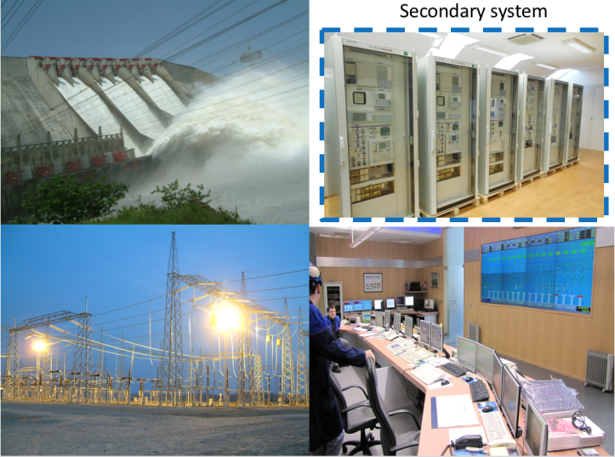
Source: CCE
Figure 2: CCE projects worldwide
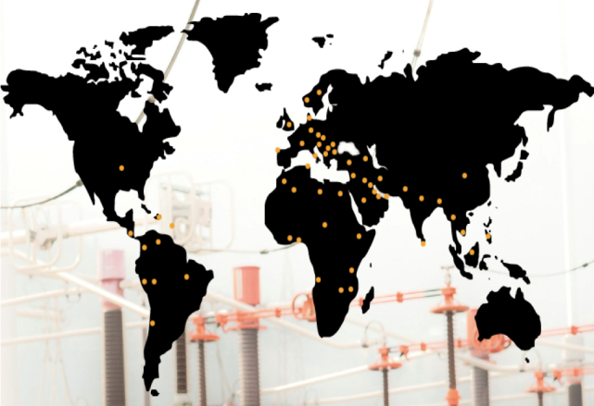
Source: CCE
Vision of CCE Ltd. is to consolidate its position as one of the leading integrators of secondary systems in the world. CCE will achieve this by strengthening its business connections and partnerships and professional execution of its services.
- The vision QMS development in CCE
We recognized CCE’s engineers as “internal customers” of QMS. Last year we made a picture of CCE’s QMS as a technical drawing representing the network of six interrelated processes: Managing the company, Getting a contract, Execution of a project, Cooperation, Supply chain and New colleague. And, we named this picture System of managing the organizational energy of CCE (figure 3). This we find appropriate, since CCE’s engineers for customers build technical systems for managing electrical energy - Control systems for power plant management.
Figure 3: Processes of CCE - System of managing the organizational energy of CCE
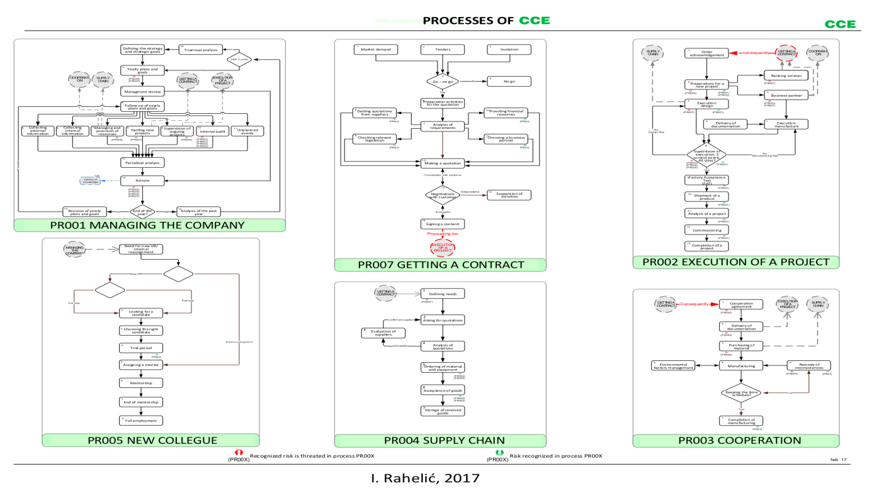
Source: CCE
  - Organizational Energy Quality Management System – OEQMS
In Verona, 2017, we presented the vision to develop QMS of CCE into a tool for managing Organizational Energy – OE. Now we call it an Organizational Energy Quality Management System - OEQMS.
Let us compare our vision with the development of the idea of QMS in the last decades. This development was supported by the development of ISO 9000 family. To assure not only quality of products and services, but also a sustained success, QMS scope in the last decades grew from quality of activities to quality of processes and finally to quality of organization. ISO 9004:2018 introduces a new concept – Quality of an organization, defined as a degree to which the inherent characteristics of the organization fulfil the needs and expectations of its customers and other relevant interested parties, in order to achieve sustained success.
In figure 4 examples of interested parties and their needs and expectations are presented (ISO 9004:2018). From that we took our focus of needs and expectations of employees, which are here defined as quality of work life.

Figure 4: Examples of interested parties and their needs and expectations (ISO 9004:2018)
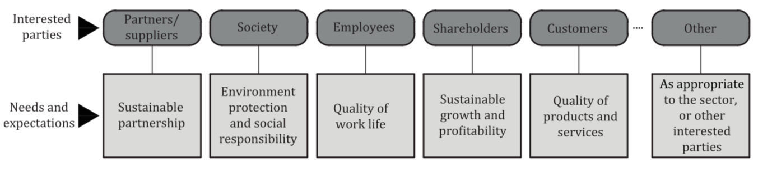
Source: ISO 9004:2018
  - Creative Work Environment
The first interested party relevant to our vision is the employees and their needs and expectations, which are on Figure 4 defined as “Quality of work life”. So, our first goal is to develop our OEQMS as a system supporting work environment for safe and efficient work in which our employees are growing professionally and personally. Let us call it Creative Work Environment - CWE.

OUR FIRST GOAL:

To develop Creative Work Environment - CWE
which is a function of
Organizational Energy Quality Management System – QEQMS.

Or expressed in formula:
CWE = f(OEQMS)

Let us see, what standard (ISO 9004: 2018) in chapter 9.5.3 says about work environment: “The organization's work environment should encourage productivity, creativity and well-being for the people working in or visiting its premises (e.g. customers, external providers, partners). In addition, depending on its nature, the organization should verify that its work environment complies with applicable requirements and addresses applicable standards (such as those for environmental and occupancy health and safety management). “
  - Organizational Energy – OE
For the purpose of representing organizational energy we made an analogy to the first law of thermodynamics which explains that internal energy of a closed system can neither be created nor destroyed, it can only be transformed (Wikipedia, 2018). Or in other words the internal energy ($dU)$ is equal to the amount of heat Q supplied to the system, minus the amount of work W done by the system.
dU = Q -W
Below (Figure 5) we present our analogy where we define dU as energy supplied into our work environment. Outcome is total amount of work-done A that equals to the supplied energy minus losses. The losses are defined as the energy needed to move forward different types of employees.
Figure 5 Organizational energy and work environment
Source: Anže Bizjan, 2018
This presented a rigid system in the scope of physical explanation of our universe. However, when it comes to organizational energy, the physical model fails (Autrey, 2018). An individual employee can create or destroy energy thus the total level of energy enclosed in a system can change. There are several methods of increasing individual energy level. We will focus on the idea that the main role of leadership is serving employees to develop themselves (Sun, 2017).
- Development of situation
In 2018 we decided that in order to manage our effort we need to measure what we are trying to improve. Before implementing any changes to our system, we evaluated the measured results of our organization. For that purpose, we made two questionnaires. The first one is about subjective quality of work environment (an indication of organizational energy) and the second one is about the employees’ perception of QMS quality. Responses of these two questionnaires gave us a benchmark.
  - Measurement of QMS quality
We measured QMS quality using interpretation of the Kano model (Kiauta, Rahelić, Jovanović, 2017) and its two dimensions of quality:
- Objective quality of QMS, defined as fulfilling ISO 9001 requirements, verified by external institution certifying QMS of CCE.
- Subjective quality of QMS, defined as fulfilling needs and expectations of customers of QMS, validated by employees. For validation we used the second questionnaire.

    - Objective measurement of QMS Quality
Objective quality of QMS of CCE was verified by Slovenian institute for quality – SIQ and is ISO 9001:2015 re-certified.
For managing processes, we recognized maturity level towards sustained success by using self-assessment tool from ISO 9004:2018:
Table 1: Self-assessment tool from ISO 9004:2018
Subclause | Maturity level
8.1 Process management – general (Table A.9) | Level 2: Key processes are managed. Interactions between processes are not well managed.
8.2 Determination of processes (Table A.10) | Level 2: Key processes are determined. Interactions between processes are not well determined.
8.3 Process responsibility and authority (Table A.11) | Level 2: A Process owner is appointed for each process. The competences required for the people associated with the individual process are nor defined.
8.4 Managing Processes (managing alignment/linkage between the processes) (Table A.12) | Level 3: The network of processes, their sequences and interactions are visualized in a graphic.
8.4 Managing Processes (attaining a higher level of performance) (Table A.13) | Level 1: Processes and their interactions are improved in an informal or ad hoc manner.
8.4 Managing Processes (managing the level attained) (Table A.14) | Level 2: Procedures are determined for relevant processes  but not well followed.
Source: ISO 9004 standard
    - Subjective measurement of QMS Quality
Subjective quality of QMS of CCE was validated by employees of CCE by means of the second questionnaire in 2018. The results helped us to recognize the fields which we must improve.
There is high awareness of the need and importance of QMS but poor knowledge of our formal documented rules.
The level of knowledge of the processes’ formal procedures of CCE is a big challenge to be improved. Comments on the assertion “I know the processes which are marked from PR001-07.” were: I agree (14%), I partially agree (37%), I partially disagree (13%), I disagree (36%). People feel that they have an option of co-creating and shaping the environment they work in. The employees know how to use applications and tools offered to us by the system but we are not using its full potential. One of the most important measurements we got from our survey is the validation of our QM department. The employees recognize QMS as very important for our organization.

    - Subjective measurement of work environment (as indication of organizational energy)
The current state is good foundation for further development. Environment: High creative energy and quality work environment. Relaxed atmosphere. Favorable for implementing innovations. Task management: Good task management. Tasks imposed on employees by the QMS are crude and outdated but functional. (Must be quality). The employees accept the established processes and procedures how to achieve something. Support offered by the QMS and organization is good, but has room for improvement. Relations: It’s not hard to cohabitate. Conflicts are rare, but present and the employees can feel them even if they are not in a direct conflict with someone.
On the basis of answers, we evaluated the amount and quantity of positive and negative organizational energy in CCE (Figure 6).
Figure 6: Organizational energy - CCE June 2018
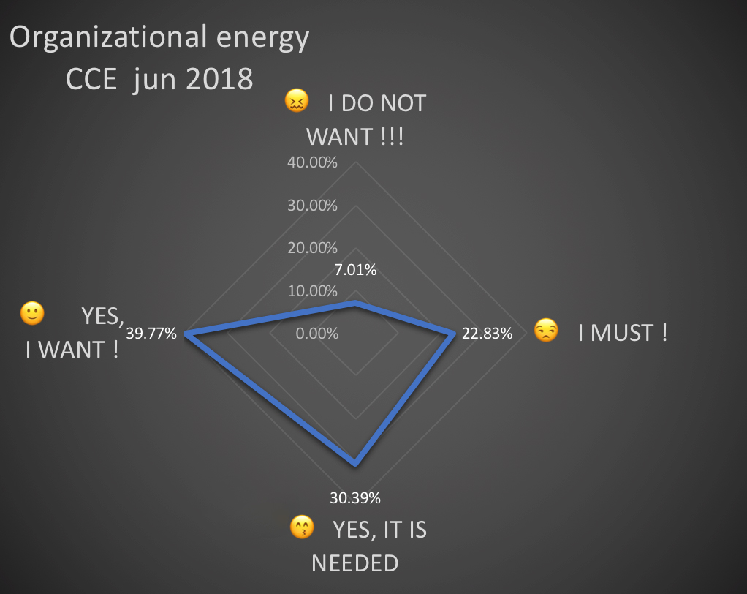
Source: CCE
- Next step
Autumn of 2018 and spring of 2019 were quite uneventful business wise because of conditions on the market and we used that as an opportunity. In 2019 there were not that many active projects in the work at that time, we used that time window and we prepared and implemented the next phase of activities regarding our QMS and its path to attractive quality.
As elaborated in the previous chapter we have done our measurements via two questionnaires, that were conducted in late spring and early summer of 2018. That results gave us a bench mark and helped us identify areas and fields we need to address in our future steps of improving our QMS. We recognized those fields as such:
- Change management
People are creatures of habits and routines and changing their work environment can be very stressful if not conducted gradually and especially if they are excluded from the process. Change is quite scary if somebody else is behind the wheel but if you give the people option to co-create the change to their environment its much less stressful.
- Emotional intelligence and motivation skills
We are big enough that we must accept that not everyone is for every position and so we have to recognize those different profiles so we can plan on their strengths.
- Bureaucracy balance
To ensure quality of an activity or a process one must document it and too many documents are a clear sign of aging organization, which is encumbered by the quantity of bureaucracy. Goal is to achieve such level of bureaucracy to not only to document activities for analysis reasons but to implement such documentation that it serves as an active fail safe. While still realizing the threat that too much bureaucracy poses to the organization.
- Documentation of successes and failures
Same way a mistake that was only made once and was not repeated because of good documentation, can be considered a win. A success or a new technique that has to be reinvented every time we face a specific problem can be considered a loss. Because we are losing energy on a problem that already had a solution it was just “forgotten”.
- Communication
Basis for human interaction, we are a SME and we are venturing further and further in open waters of business, that means bigger fish in our immediate vicinity. Which means our internal cooperation is one of the keys to our success and a competitive edge.
At this point we had our situation measured and also, we realized that organizational energy is being lost or better put spent on the wrong activities due to poor knowledge about our QMS and what it can provide to its users. Armed with this knowledge we had an idea what we want to accomplish in the next phase in development of our QMS.

So, we set up two goals for our next phase:
- Raising the awareness and knowledge about our QMS.
- Empowering of our internal customers
Now the question remains how to achieve that. How to raise the awareness of our QMS and how to empower our internal customers via the fields we recognized as critical for our further development? The first thought was a classical lecture where a presenter basically gives out instructions how things are to be done in the future, but immediately we saw that would be counterproductive because it would induce stress from changes in their work environment, communication would be only one way, there would be no feedback or any other indicator on the level of soft skills within our organization and if we implemented new documents, more bureaucracy without any explanation it would probably be considered as oppression and even more work. Which is direct opposite from our wishes to develop the system from control (prescribing and inspecting) to support (connecting and supporting) system.
Then we came to a conclusion that we need something more than a classical lecture with only one-way communication, what we need is an internal training where every attendee can give his input. That is why we decided for a revolutionary approach that has never been attempted in our organization. We used 4-MAT model, which was developed by Bernice McCarthy in the 1980 and is a learning tool that was synthesized from accumulation of findings from different learning styles which also considers the effect of left or right brain dominance.
4MAT four phases of learning cycle (McCarthy, 2005):
- Experiencing
- Conceptualizing
- Applying
- Refining
This model is excellent for us because it is also built on principles of process approach (Finite, repeatable, flexible and it adds value to our actions). Because as an organization we are in transition from knowing about process approach to embracing it as our own.
- Internal training sessions – assessment of what to do
We used internal training session for various reasons discussed earlier. Firstly, as means to develop and educate our employees in the field of QMS and its tools.
Secondly, as tool to support reintegration of employees and to lift their engagement.
Thirdly to receive an insight how to further develop our QMS (by listening to what our employees-our customers have to say).
Thus, we divided the topics to fit a 4-week program. Each week we started with theoretical lecture for all employees (including management). A practical session consisting of groups 2-5 people followed.
Various levels of engagements and inputs were monitored during practical sessions. Methodology comprised minutes writing, taking observational notes and debriefing.
At the end of each week additional material was distributed to our employees. Any direct questions were addressed either during or after the session. In case a question could not be answered immediately, an answer was given as soon as possible and sent to all employees.
After completing the 4-week program we sent a questionnaire asking for personal feedback and general inputs/feedback about training session and QMS.

  - No activity in current system leads to its degradation
After the company’s QMS was thoroughly established and tested the company grew. Due to channeling resources to tackle more pressing matters the knowledge of QMS and its application for employees gradually diminished.
In spite of constant improvements of the QMS there were not enough efforts to involve and engage a broader team of employees. What was implemented and developed was not enough to make the QMS more user friendly. At the same time not enough activities for employees were made to promote and develop the knowledge about the QMS.
For an average employee the QMS was what it was. They knew about it what they knew.
Lack of awareness about the importance of engaging all employees to accept the QMS as a useful tool led to the state where the QMS was treated as a sub-system and not as a partial system.
We can tackle the same issue from the point of view of entropy. The QMS was perceived as a static system slowly decaying from the lack of usage. In this way it could come to complete degradation. Documents could become outdated and laws could change. The amount of used and useful material could slowly grow smaller and smaller. To prevent this from happening a systematic solution for activities managing time limited validity of documents was introduced (according to ISO 9001:2015; 7.4 – documented information).
Only by pushing our boundaries or actually going into an unknown place (in our case a place where QMS is more integrated, more user friendly) can we learn something new and improve (Peterson, 2018). Hence a need for moving into the unknown was recognized.
After the conference in Paris 2018 we started to address this issue by providing a loop to change the company culture and working environment, which meant going into the unknown. In the first place, we challenged the status quo of internal communication by providing 4MAT structured training sessions.
  - Sacrifice of belief in the current system
The current state map of QMS in general was in the strong belief of the employees who perceived it as a rigid system. A set of rules written down and fixed. Unchangeable.
Internal training sessions served to change that. We decided to move from prescribe and control approach to coordinate and support approach.
Development from current state map to future state map comprises many changes which do not happen at once. As the organization evolves and learns it must reevaluate the future state to see if it still meets the expectations. Organizational learning takes place during the transformation (Hines, Found, Griffiths, Harrison 2011).
The process of changing thus involves many iterations. The final number must not be final since we are living in ever changing environment where staying still and not moving equals falling back. Only by constantly moving forward in pushing towards the future state map the organization grows and adapts (Peterson, 2018).
Therefore, we needed to ‘’sacrifice’’ something to obtain momentum to change. In our last year’s survey, we found out that organizational energy exists, we just needed to channel it. In order to do so we needed to sacrifice the belief that QMS is rigid and unquestionable or even unchangeable. We put it on display, through our training sessions, exposed it to criticism, in order to see what employees think about it and to harness their engagement (organizational energy) to move forward. By doing so we directly addressed the risk management approach through recognizing the risk of losing engagement and falling behind the industry. Formally we can say, that we employed risk-based thinking (according to ISO 9001:2015; 6.1 – Actions to address risks and opportunities), analyzing changes of relevant external and internal issues (according to ISO 9001:2015; 4.1) to understand how they would influence the needs and expectations of interested parties (according to ISO 9001:2015; 4.2).
  - System supporting our customers
At the conference in Verona 2017 we proposed a definition that we have a QMS which serves our customers who are actually our employees. Through training sessions, we addressed our working environment. We invited our employees to actively participate in improving and using our QMS. After listening to their thoughts and ideas both during and after training sessions we obtained valuable input about our QMS. Only by obtaining this feedback we possess the vision of what we can and should improve. And only by improving it we can truly define it as a system supporting our customers. In doing this we will use the wisdom of continual improvement (according to ISO 9001:2015; 10.3).
- Internal training sessions – outcome
As mentioned, various aspects were checked by the means of the questionnaire. For the purpose of this article we present only the most relevant one, which is the answer of the employees when asked to assess if their general knowledge about QMS was improved.
  - Results of internal training sessions
Figure 7: Results of questionnaire

Source: CCE
In Figure 7 Level of Agreement value 1 means Completely disagree and 5 Completely agree. We were pleased to see that more than 80% answered that their knowledge increased.
  - Future actions
After obtaining employees’ answers we presented the report to the management. One of the important issues recognized was a need for increased bureaucratization. With bureaucratization the complexity of our QMS might grow.
Bureaucracy and/or QMS complexity, if not tackled correctly, can lead into entropy of organizational energy.
- Entropy
In physics work is obtained from order and the amount of entropy is also a measure of disorder, or randomness, of a system (Encyclopedia Britannica, 2019).
  - Entropy as decay
If not in use any system decays. Entropy of such system increases.
In our case the system is QMS and the knowledge of it.
  - Entropy as source of chaos – source of the unknown
As discussed earlier, in the case of not increasing our knowledge about QMS and just standing still we realized we were actually falling behind. The world is moving forward. New tools were developed and methods that we did not use, nor were we familiar with them. The amount of unknown increased.
Through entropy of our QMS and losing knowledge of it we moved from the known into the unknown. The unknown can be perceived as chaos. From here we can corelate increased level of entropy as source of the unknown. Only by being there we can build something new to support our customers of QMS (our employees). But the unknown as such is not bad. By moving into the unknown and reintegrating engagement of employees we can emerge from this chaos and realize new knowledge by developing engagement of our employees (which was one of the goals of training sessions) (Peterson, 2018).
  - Lowering Entropy
In chapter Future actions 6.2 we stated that bureaucracy can lead into increased entropy. However, after closely looking into theory of sociology about principles of the bureaucracy development, we made a proposition to increase attractive quality of our QMS. By smartly using bureaucracy (user friendly user interfaces for searching documents etc..) we envision bureaucracy as a driving force to lower the amount of entropy and to bring order back into otherwise chaotic system (Haralambos, 1999).
Of course, we realize, that only by high level of employee engagement the company nurtures resources needed to actively drive the organizational energy to a higher level. With high organizational energy we can tackle entropic chaos with engaged employees who are in return empowered to work more efficiently and thus the circle turns.

- From ‘’Doing by design’’ to ‘’Design by doing’’
Innovating internal audit approach in CCE we introduced internal training sessions about the QMS combined with SWOT workshops about processes. The aim was to rise the engagement of employees in process design.
We follow three steps:
- Step: Discussion about existing practice of processes (Getting a contract, Supply chain, Execution of a project, Cooperation, New colleague)
- Step: Recognition of possible improvements. Editing processes on the basis of discussion findings by agreement about some activities (E.g: Getting travel orders)
- Step: Integrating new agreement in QMS. New emerging documentation is aligned with existing documentation (e.g Process Descriptions), which can either be abandoned, or adapted, or replaced with a brand new one.
The management of new documentation should follow three principles:
- Each document should have its own holder responsible for the area covered by the documentation
- Each document should be issued for a limited period of time after which the holder has to assess its suitability and adapt it to new circumstances, if necessary, before renewal of validity
- All documents should be integrated into a whole, e.g. Quality Manual. Each document should be included in the system - it contains the documentation of the wider context (for example, the order form - is included in the supply chain process documentation) from the wider context documentation, all relevant subdocuments can be found (e.g. from the Quality Manual we find a purchase document and the process from it is the purchase order form)
- Conclusion
One-year development of QMS inside CCE was observed. Analogy with physics was made to measure organizational energy and to assess it from entropy point of view. Although usually perceived as a threat, bureaucracy was recognized as an opportunity to tackle entropy of our QMS and to empower our employees.
Essential will be the transition:
- from QMS as sub-system, where majority of employees passively more or less follows instructions (doing by design) of ISO 9001 translated into organization reality and by doing so employees do not accept responsibility for QMS effectiveness and efficiency and indirectly also refuse the responsibility for the success of the firm
- to QMS as partial-system, where engaged employees assume joint responsibility for the QMS and for the company with re-engineering of processes followed by changes of documented procedures (design by doing).

References

Sun A. J (2017). “How to Help Someone Discover Work that Excites Them”, Harvard Business Review, No.9/2017
Autrey T. (2018). “LEADERSHIP: The First Law of Organizational Thermodynamics”,
https://www.ppiweb.net/leadership-the-first-law-of-organizational-thermodynamics/
Hines P., Found P., Griffiths G., Harrison R. (2011). “Staying Lean: Thriving, Not Just Surviving, Second Edition
Wikipedia: First law of Thermodynamics (2019),
https://en.wikipedia.org/wiki/First_law_of_thermodynamics
Encyclopedia Britannica (2019), Entropy:
https://www.britannica.com/science/entropy-physics
Peterson B. J. (2018). “Biblical Series IX: The Call to Abraham”,
https://www.youtube.com/watch?v=GmuzUZTJ0GA&t=5191s
ISO 9004:2018 Quality management – Quality of an organization – Guidance to achieve sustained success
ISO 9000:2015; Quality management systems — Fundamentals and vocabulary
McCarthy B. (2005). “Teaching Around the 4MAT Cycle: Designing Instruction for Diverse Learners with Diverse Learning Styles”, Corwin, 1st edition

Biographical sketch

Anže Bizjan, B.Sc., graduated in electrical engineering from University of Ljubljana, Slovenia; MBA, System engineer in CCE

Jure Jovanović, student of economics, Institute for education Erudio, Slovenia, Sales assistant in CCE

Ivan Rahelić, B.Sc., graduated in electrical engineering from University of Ljubljana, Slovenia; Quality manager in CCE

Marko Kiauta, B.Sc., graduated in electrical engineering from University of Ljubljana, Slovenia; Consultant, applying quality in practice

